Portland, Maine
The Hub of the North
⚓ Working Waterfront · 🦞 Lobster Culture · 🎨 Artsy Vibe · 🚢 Casco Bay
✍️ MY DAY IN PORT (FILL IN)
Ship / Date
In port | arrive ______ · all aboard ______
Booked excursion
Notes / meeting point
GETTING ASHORE
- Currency: US Dollar (USD)
- Language: English
- Climate: Maritime / Humid Continental
- Key Attraction: Portland Head Light
GETTING AROUND
- 🚕 Taxi: Metered (varies) — Traditional taxis are available at the terminal. Useful if you prefer a guaranteed vehicle without app-based booking.
- 📱 Rideshare: ✅ Uber, Lyft
- 🚌 Hop-on hop-off: ✅ Gray Line Portland (Big Pink Trolley)
TOP THINGS TO DO
- Old Port District Exploration — Wander the historic cobblestone streets that once formed the city's trading hub.
- Portland Head Light & Fort Williams Park — Visit America's most photographed lighthouse at Fort Williams Park.
- Casco Bay Island Hopping — Take the Casco Bay Ferry to Peaks Island.
- Foodie Tour of the Old Port — Sample fresh Maine lobster rolls and local oysters.
BEST WALKS
- The Waterfront Walk: Easy — A flat, scenic walk along Commercial Street, watching fishing boats and lobster traps.
- Old Port Cobblestone Wander: Moderate — A loop through historic brick-paved streets, visiting local shops and cafes.
- Cape Elizabeth Coastal Path: Easy — A gentle walk around the lighthouse and surrounding preserve.
WEATHER · DAYLIGHT · MONEY
Month | High °F | Low °F | Rainy days
May | 62 | 47 | 9
Jul | 77 | 64 | 10
Sep | 71 | 57 | 8
Daylight: May 5:15AM–7:59PM · Jul 5:13AM–8:19PM · Sep 6:20AM–6:50PM
cruiseports.org/portland-me · Confirm terminal & all-aboard time with your ship

Portland, Maine — Port Map
Red = walkable sights · Amber = excursions farther out · P = cruise terminal
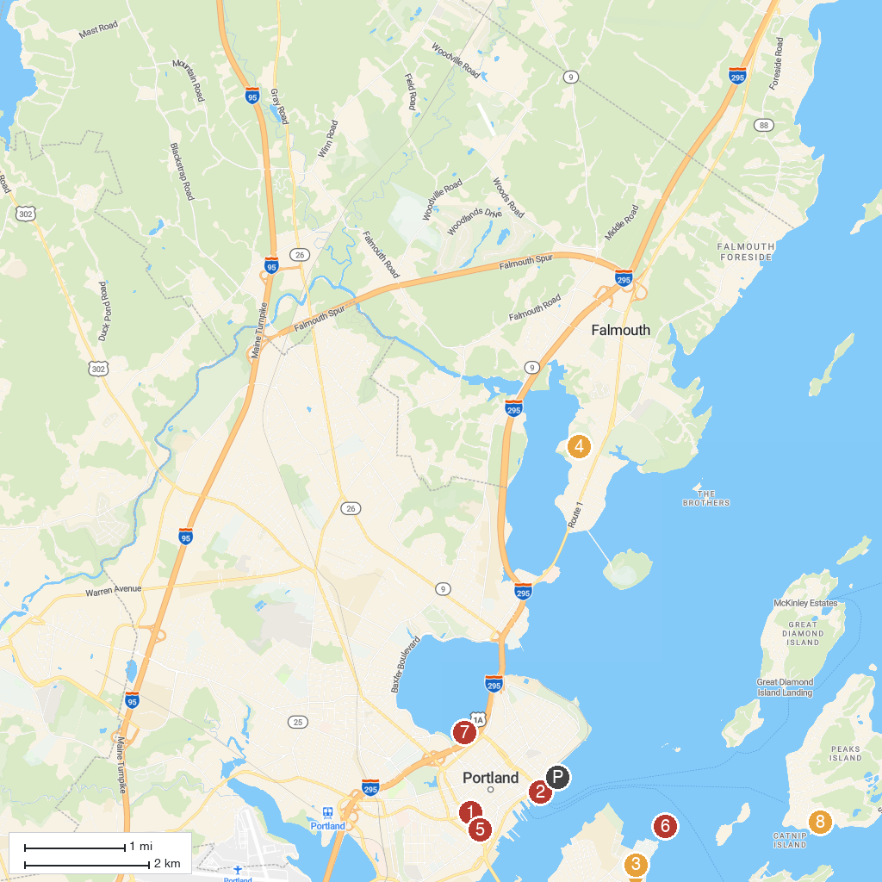
MAP KEY
1. Portland Museum of Art | 5. Victoria Mansion
2. Casco Bay Lines | 6. Spring Point Ledge Lighthouse
3. Crescent Beach State Park | 7. Back Cove Park
4. Maine Audubon | 8. Fifth Maine Museum
P. Cruise port / terminal
Map © MapTiler © OpenStreetMap contributors · cruiseports.org

