Port Townsend, Washington, USA
One of only three Victorian seaports in the US on the National Register of Historic Places, Port Townsend is a living museum of 1880s brick storefronts and ornate mansions — with wild beaches and whale-watching just up the road.
⚓ Docked at Union Wharf · 🚢 Small ships only (American Cruise Lines, UnCruise, Lindblad) · 🕒 Typical call: 6-8 hrs · 💵 USD · 🗣️ English
✍️ MY DAY IN PORT (FILL IN)
Ship / Date
In port | arrive ______ · all aboard ______
Booked excursion
Notes / meeting point
GETTING ASHORE
- Docking: Pier — Union Wharf, foot of Taylor Street (walk-off into downtown)
- Walk to center: 0 min — you step off the gangway onto Water Street
- Best For: Victorian architecture, maritime history, Fort Worden, whale watching
- Don't Miss: Fort Worden State Park & the filming location for An Officer and a Gentleman
GETTING AROUND
- 🚕 Taxi: Meter/minimum fare — A Taxi Cab Company serves Jefferson County. Useful for longer trips or airport transfers, but given the walkability of d
- 📱 Rideshare: ❌ not available
TOP THINGS TO DO
- Fort Worden Historical State Park — A 433-acre former Army base built starting in 1897, famous as the filming location of An Officer and a Gentleman.
- Victorian Historic District Walk — Water Street's 1880s Romanesque brick blocks and the residential uptown bluff hold one of America's finest collections of intact…
- Jefferson Museum of Art and History — Housed in the stunning 1892 City Hall on Water Street, this museum covers Port Townsend's Victorian boom, Native Klallam history…
- Whale Watching Cruise — The Salish Sea around Port Townsend is prime territory for orcas, humpbacks, gray and minke whales, plus seals and sea lions.
- Point Wilson Beach & Lighthouse (Fort Worden) — Where the Strait of Juan de Fuca meets Puget Sound — a dramatic, windswept beach with views of Mount Baker, Whidbey Island, and…
BEST WALKS
- Water Street & Uptown Victorian Loop: 1.5 miles | 45-60 min | Easy with one steep hill — Start at Union Wharf and head north along Water Street through the historic commercial district.
- Downtown to Point Hudson: 0.8 miles one way | 15 min | Flat — A pleasant flat stroll north from Union Wharf along the waterfront to Point Hudson Marina — home of…
WEATHER · DAYLIGHT · MONEY
Month | High °F | Low °F | Rainy days
May | 61 | 49 | 11
Jul | 70 | 57 | 7
Sep | 65 | 54 | 11
Daylight: May 5:31AM–8:43PM · Jul 5:27AM–9:06PM · Sep 6:48AM–7:22PM
cruiseports.org/port-townsend-wa · Confirm terminal & all-aboard time with your ship

Port Townsend, Washington, USA — Port Map
Red = walkable sights · Amber = excursions farther out · P = cruise terminal
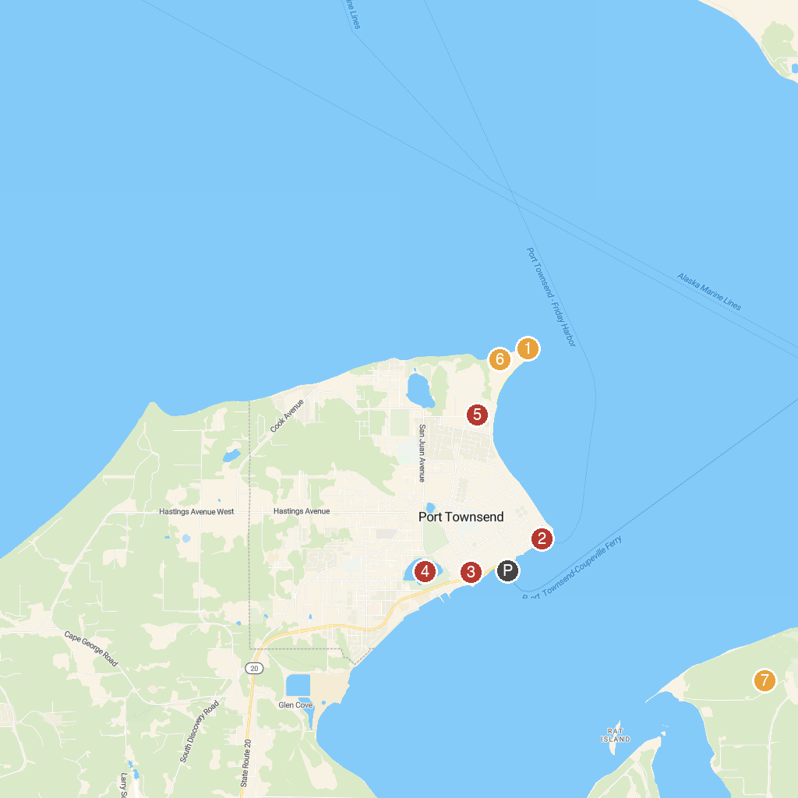
MAP KEY
1. Point Wilson Lighthouse | 5. Kah Tai
2. South Whidbey State Park | 6. Puget Sound Coast Artillery Museum
3. Northwest Maritime | 7. Battery Kinzie
4. County Courthouse Park | 8. Fort Flagler Historical State Park
P. Cruise port / terminal
Map © MapTiler © OpenStreetMap contributors · cruiseports.org

