Port-Saint-Louis-du-Rhône, Provence, France
Where the Rhône meets the Mediterranean, Port-Saint-Louis is the raw, windswept gateway to the Camargue — Europe's greatest river delta, roamed by white horses, black bulls, and thousands of pink flamingos.
⚓ Docked (pier) · 🕒 Typical call: 8-10 hrs · 💶 Euro (€) · 🗣️ French · 🌿 Nature & Wildlife
✍️ MY DAY IN PORT (FILL IN)
Ship / Date
In port | arrive ______ · all aboard ______
Booked excursion
Notes / meeting point
GETTING ASHORE
- Docking: River cruise ships dock at Bassin Central; small ocean/expedition ships use industrial quay — shuttle to town
- Walk to center: River dock: 5 min walk to town. Commercial port: not walkable; shuttle provided
- Best For: Camargue wildlife safaris, cycling, wild beaches, Provençal seafood
- Don't Miss: Plage de Napoléon wild beach, Tour Saint-Louis panorama, tellines clams
GETTING AROUND
- 🚕 Taxi: €5–€10 — Local taxis can take you from the port to the town center in just a few minutes. For longer trips to Marseille, expect f
- 📱 Rideshare: ✅ Uber
TOP THINGS TO DO
- Camargue Wildlife Safari — 4WD or boat tour into the delta to spot flamingos, white Camargue horses, black bulls, and hundreds of bird species in their…
- Arles — Roman Amphitheatre & Van Gogh — UNESCO-listed Arles is 40 minutes north.
- Aigues-Mortes Medieval Walled City — A perfectly intact 13th-century walled city rising from pink salt marshes about 1.5 hours west.
- Plage de Napoléon Wild Beach — One of the Camargue's last largely undeveloped beaches — 10 km of sand backed by flamingo-filled lagoons, directly south of town.
- Kitesurfing & Windsurfing at Carteau Beach — The strong Mistral wind makes Carteau Beach a world-class kitesurfing spot.
BEST WALKS
- Town Centre & Marina Stroll: 1.5 km • 30 min • Flat — From the river dock, walk to Tour Saint-Louis for the panoramic terrace and bird collection (€3-5)…
- ViaRhôna Cycle Path to Napoléon Beach: 12 km one-way • 45 min by bike • Flat paved path — Rent a bike from the Tourist Office and follow the ViaRhôna cycle path south to Plage de Napoléon…
WEATHER · DAYLIGHT · MONEY
Month | High °F | Low °F | Rainy days
May | 72 | 57 | 8
Jul | 87 | 70 | 2
Sep | 78 | 63 | 6
Daylight: May 6:16AM–8:58PM · Jul 6:14AM–9:18PM · Sep 7:20AM–7:50PM
cruiseports.org/port-saint-louis-du-rhone · Confirm terminal & all-aboard time with your ship

Port-Saint-Louis-du-Rhône, Provence, France — Port Map
Red = walkable sights · Amber = excursions farther out · P = cruise terminal
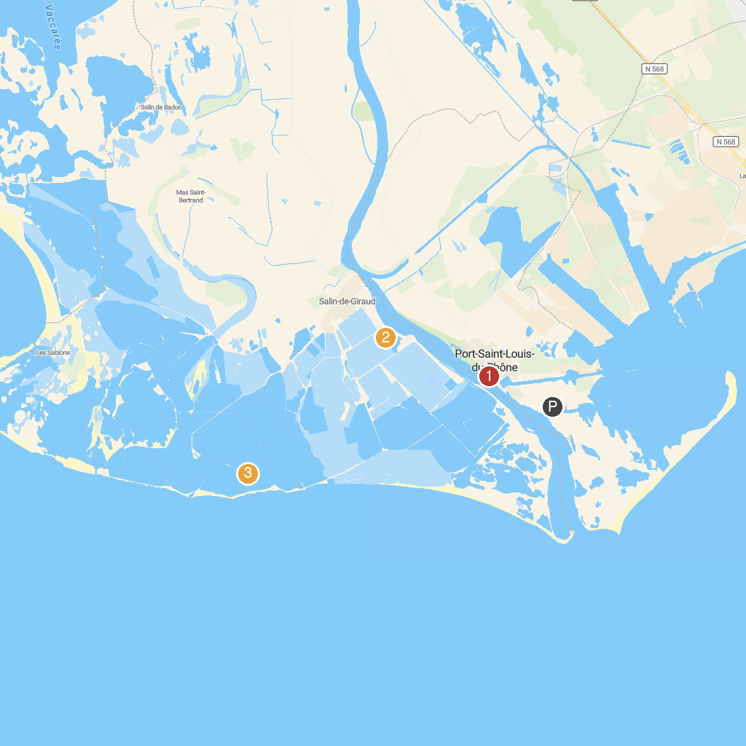
MAP KEY
1. Maison de la Mer et du Sport | 4. Salt Pan Observation mound
2. Château de l'Hauture | 5. Faraman Lighthouse
3. Parc De La Révolution
P. Cruise port / terminal
Map © MapTiler © OpenStreetMap contributors · cruiseports.org

