Port Said, Port Said Governorate, Egypt
Port Said sits at the Mediterranean entrance to the Suez Canal, where container ships pass close enough to feel like part of the skyline. Stay local for canal views, a free ferry to Port Fouad, and seafood, or commit to a long escorted day to Cairo.
⚓ Docked (tourist quay) · 🕒 Typical call: 8-12 hrs · 💵 Egyptian Pound (USD/EUR common with taxis and guides) · 🗣️ Arabic (English at tourist sites)
✍️ MY DAY IN PORT (FILL IN)
Ship / Date
In port | arrive ______ · all aboard ______
Booked excursion
Notes / meeting point
GETTING ASHORE
- Docking: Ships usually dock alongside at Port Said's tourist quay; tendering is not typical
- Walk to center: 5-15 minutes to the Corniche, waterfront streets, and Port Fouad ferry
- Best For: Suez Canal watching, Cairo day trips, local seafood, colonial-era streets
- Don't Miss: The free public ferry to Port Fouad across the Suez Canal
GETTING AROUND
- 🚕 Taxi: ~E£3–10 for city trips — Blue-and-white taxis wait outside the port gate. Always agree on the fare before departing — meters are rarely used.
- 📱 Rideshare: ✅ inDrive, DiDi
TOP THINGS TO DO
- Cairo, Giza Pyramids & Sphinx — The headline excursion from Port Said: an early bus or private van run to the Giza plateau, often paired with Cairo highlights or…
- Port Fouad by Free Ferry — Cross the Suez Canal on the public ferry to Port Fouad, a quieter sister city with broad streets, canal views, and a quick…
- Port Said Military Museum — A compact museum covering Port Said's role in modern Egyptian history, especially the Suez Crisis and later conflicts, with…
- Seafood Lunch in Port Said — Port Said is a strong local seafood town.
- Corniche, Canalfront & Beach — Keep the day simple with a stroll along Palestine Street and the Corniche, ship-watching at the canal entrance, and a look at…
BEST WALKS
- Suez Canal Waterfront Stroll: 1-2 km | Easy | Flat waterfront streets — Walk from the cruise terminal area toward Palestine Street for close-up views of canal traffic and…
- Free Ferry to Port Fouad: 1-2 hrs | Easy | Ferry plus short town walk — Use the public ferry across the Suez Canal, then walk a small loop in Port Fouad before returning…
- Port Said Military Museum: 2-3 km | Easy | City streets — A practical in-town target if you want a real stop rather than only a promenade walk.
WEATHER · DAYLIGHT · MONEY
Month | High °F | Low °F | Rainy days
May | 81 | 67 | 1
Jul | 89 | 75 | 0
Sep | 87 | 75 | 0
Daylight: May 5:55AM–7:39PM · Jul 5:57AM–7:56PM · Sep 6:35AM–6:56PM
cruiseports.org/port-said · Confirm terminal & all-aboard time with your ship

Port Said, Port Said Governorate, Egypt — Port Map
Red = walkable sights · Amber = excursions farther out · P = cruise terminal
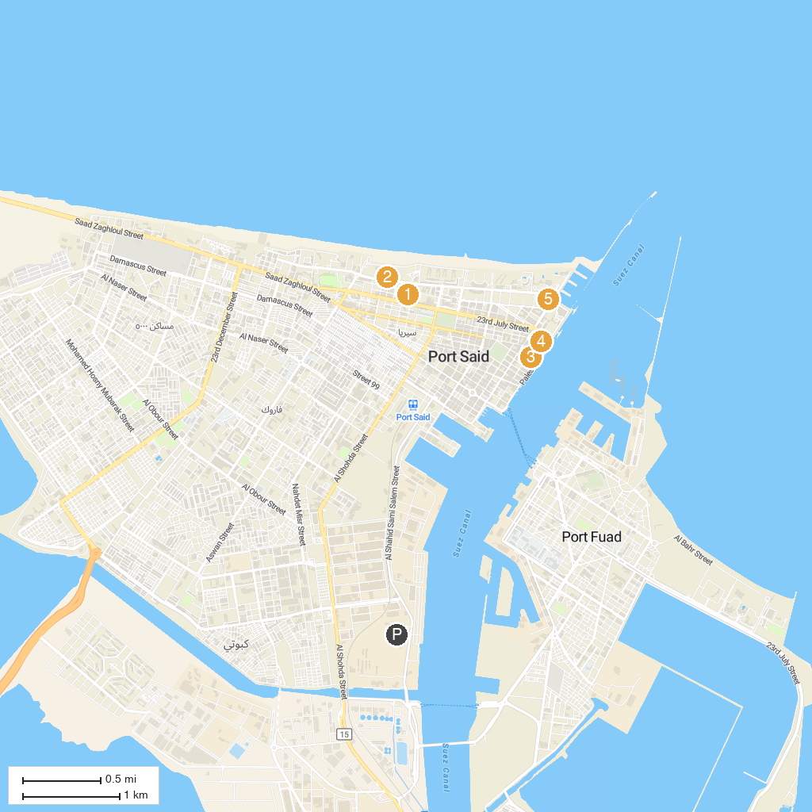
MAP KEY
1. Port Said Military Museum | 4. History Garden
2. El-Montazah Park - حديقه المنتزه | 5. Al Salam Mosque
3. The Lighthouse of Port Said
P. Cruise port / terminal
Map © MapTiler © OpenStreetMap contributors · cruiseports.org

