Port Moresby, National Capital District, Papua New Guinea
Where ancient tribal traditions meet a Pacific capital — Port Moresby greets every cruise ship with feathers, drums, and a Sing-Sing welcome that you won't forget.
⚓ Docked (pier) · 🕒 Typical call: 8-10 hrs · 💵 Papua New Guinea Kina (PGK) · 🗣️ English & Tok Pisin · ⚠️ Guided tours strongly recommended
✍️ MY DAY IN PORT (FILL IN)
Ship / Date
In port | arrive ______ · all aboard ______
Booked excursion
Notes / meeting point
GETTING ASHORE
- Docking: Pier — Motukea Island Terminal (most ships) or Main Wharf, Fairfax Harbour
- Walk to center: Not walkable — Motukea is 20 km from city; shuttles/tours required
- Best For: Wildlife (tree kangaroos, birds of paradise), WWII history, tribal culture
- Don't Miss: Sing-Sing welcome on the wharf; Port Moresby Nature Park; Bomana War Cemetery
GETTING AROUND
- 🚕 Taxi: PGK 80–150 (~$22–$42 USD) — Hailing taxis at the port or on the street is strongly discouraged due to high crime rates. If used, only board vehicles
- 📱 Rideshare: ❌ not available
TOP THINGS TO DO
- Port Moresby Nature Park — PNG's flagship zoo and botanical garden is the must-do stop — tree kangaroos, cassowaries, hornbills, and multiple species of…
- Bomana War Cemetery — The largest Commonwealth war cemetery in the Pacific, Bomana holds over 3,800 WWII burials — mostly Australian, alongside…
- National Museum & Art Gallery — Over 600,000 artefacts covering PNG's extraordinary cultural mosaic — tribal masks, ancestral canoes, bark paintings, Sepik…
- Varirata National Park — A highland escape 45-60 minutes from the port with hiking trails, sweeping views of Port Moresby and the Coral Sea, and excellent…
- Loloata Island Day Pass — A private island resort in Bootless Bay — take the short ferry ride out for snorkeling in clear coral waters, a buffet lunch, and…
BEST WALKS
- Harbourside Precinct Waterfront Stroll: ~30 min | Flat | Paved boardwalk | Safe on cruise days — The gated Harbourside Precinct is a modern, heavily secured waterfront development with cafés…
- Ela Beach Promenade: ~45 min | Flat | Paved path | Stay during daytime — Port Moresby's main public beach has a revitalised promenade with basketball courts and a beachside…
WEATHER · DAYLIGHT · MONEY
Month | High °F | Low °F | Rainy days
May | 85 | 75 | 14
Jul | 84 | 74 | 9
Sep | 85 | 74 | 12
Daylight: May 6:17AM–5:58PM · Jul 6:29AM–6:05PM · Sep 6:05AM–6:07PM
cruiseports.org/port-moresby · Confirm terminal & all-aboard time with your ship

Port Moresby, National Capital District, Papua New Guinea — Port Map
Red = walkable sights · Amber = excursions farther out · P = cruise terminal
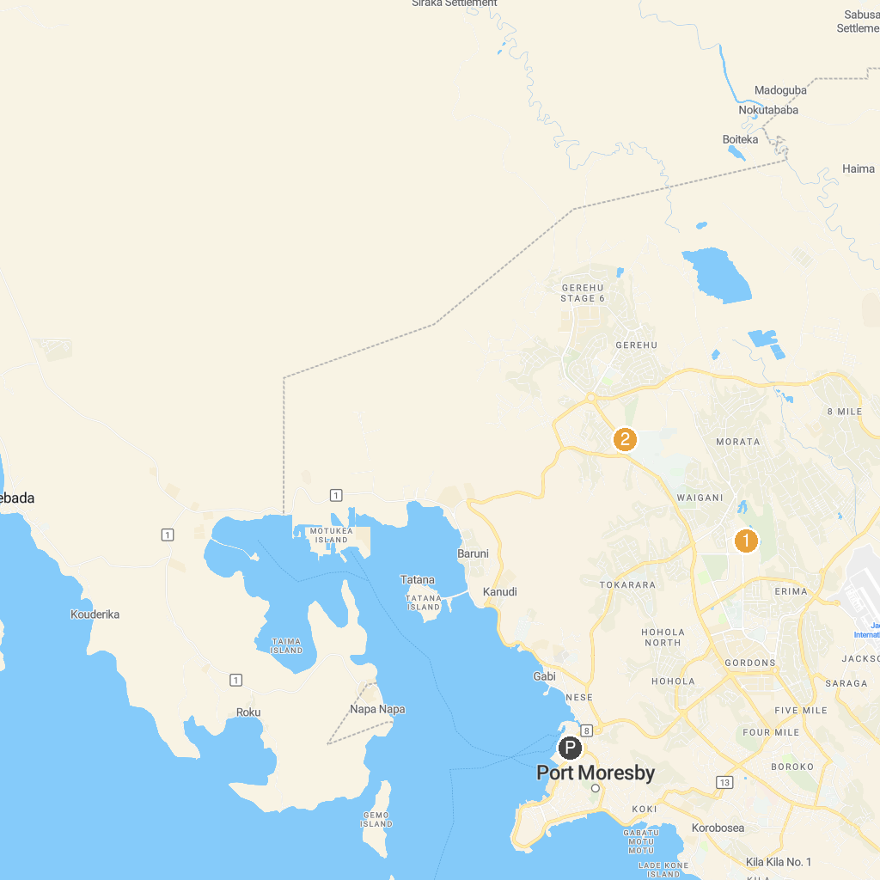
MAP KEY
1. Papua New Guinea National Museum & Art Gallery | 3. Bomana War Cemetery
2. Port Moresby Nature Park
P. Cruise port / terminal
Map © MapTiler © OpenStreetMap contributors · cruiseports.org

