Port Louis, Mauritius
Mauritius's compact capital sits between volcanic mountains and a turquoise lagoon — ships dock right at the Caudan Waterfront, steps from a UNESCO immigration depot, a vivid market, and gateways to the island's coloured earths and sacred lakes.
⚓ Docked (Caudan Waterfront) · 🕒 Typical call: 8–10 hrs · 💵 Mauritian Rupee (MUR) · 🗣️ English / French / Creole
✍️ MY DAY IN PORT (FILL IN)
Ship / Date
In port | arrive ______ · all aboard ______
Booked excursion
Notes / meeting point
GETTING ASHORE
- Docking: Caudan Waterfront, central Port Louis
- Walk to center: Steps away
- Best For: History · Island excursions
- Don't Miss: Chamarel Seven Coloured Earths
GETTING AROUND
- 🚕 Taxi: 650–800 MUR (~$14–18 USD) — The city center is about 5km from the cruise pier — a quick 10-minute ride. Negotiate or confirm the fare before getting
- 📱 Rideshare: ✅ Uber
TOP THINGS TO DO
- Chamarel Seven Coloured Earths & Waterfall — Mauritius's most photographed natural wonder — volcanic dunes of seven distinct hues (red, brown, violet, green, blue, purple…
- Black River Gorges National Park — Mauritius's largest national park: dense rainforest, endemic birds (pink pigeon, echo parakeet), waterfalls, and hiking trails…
- Aapravasi Ghat & Blue Penny Museum — Walk to the UNESCO-listed immigration depot where half a million indentured labourers arrived after slavery's abolition — then…
- Central Market & City Walk — Port Louis's bustling bazaar overflows with vanilla, saffron, Creole street food, and handcrafts.
- Grand Bassin Sacred Lake — A crater lake in the highlands, sacred to Mauritian Hindus as a source of water for the Maha Shivaratri festival.
BEST WALKS
- Caudan Waterfront to Central Market: ~2 km · 1.5 hrs · easy — From the cruise terminal, stroll the Caudan Waterfront promenade past the Blue Penny Museum and…
- Aapravasi Ghat & Champ de Mars: ~3 km · 2 hrs · easy — Head north from the waterfront to the Aapravasi Ghat immigration depot on the harbour edge…
WEATHER · DAYLIGHT · MONEY
Month | High °F | Low °F | Rainy days
May | 81 | 72 | 11
Jul | 77 | 68 | 10
Sep | 79 | 68 | 7
Daylight: May 6:31AM–5:40PM · Jul 6:45AM–5:46PM · Sep 6:06AM–6:04PM
cruiseports.org/port-louis · Confirm terminal & all-aboard time with your ship

Port Louis, Mauritius — Port Map
Red = walkable sights · Amber = excursions farther out · P = cruise terminal
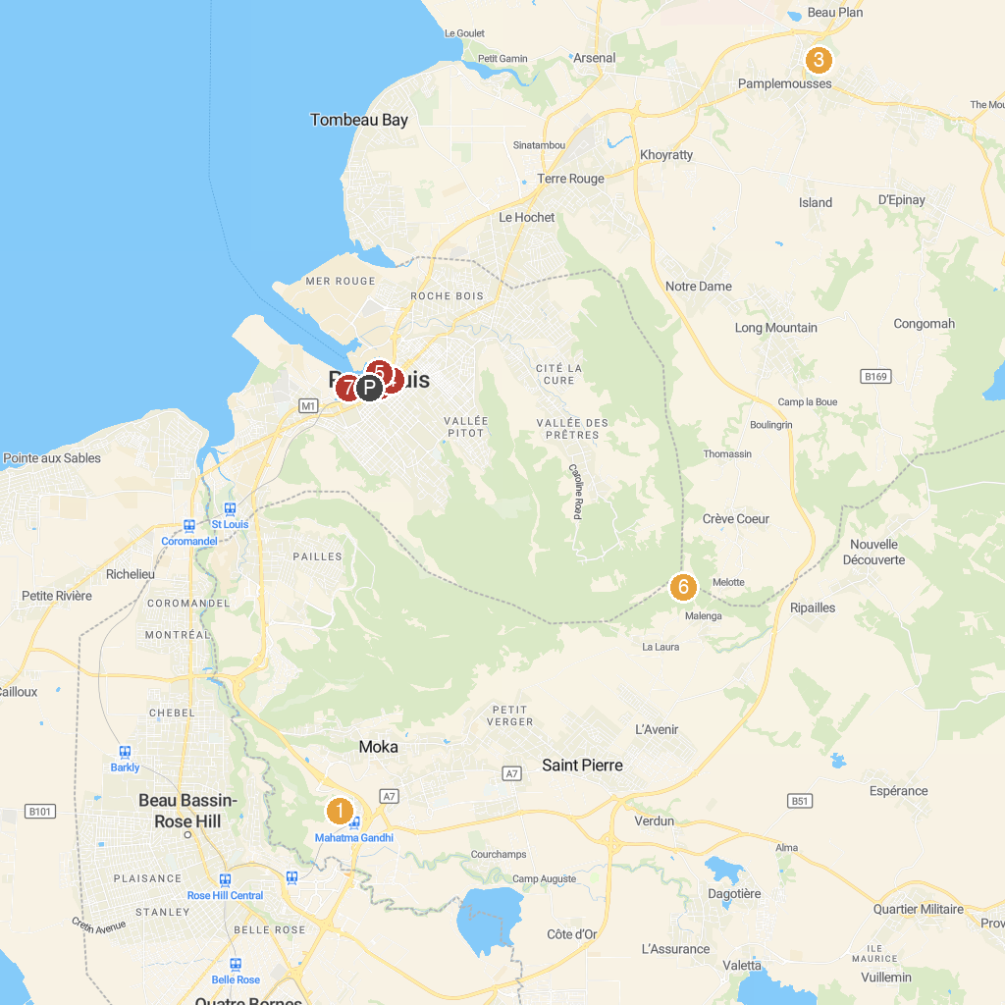
MAP KEY
1. Le Reduit | 5. Aapravasi Ghat World Heritage Site
2. Central Market Port Louis | 6. Pieter Both
3. Sir Seewoosagur Ramgoolam Botanical Garden | 7. Shiv Shakti Mandir
4. Jummah Masjid | 8. Blue Penny Museum
P. Cruise port / terminal
Map © MapTiler © OpenStreetMap contributors · cruiseports.org

