Port Lincoln, South Australia, Australia
Self-proclaimed Seafood Capital of Australia, Port Lincoln sits on vast Boston Bay with world-class tuna, the only great white shark cage diving in Australia, and playful sea lions just offshore.
⚓ Pier (Brennan Wharf) · 🕒 Typical call: 8–10 hrs · 💵 AUD · 🗣️ English · 🦈 Wildlife
✍️ MY DAY IN PORT (FILL IN)
Ship / Date
In port | arrive ______ · all aboard ______
Booked excursion
Notes / meeting point
GETTING ASHORE
- Docking: Pier — Brennan Wharf (working commercial port; shuttle to town center)
- Walk to center: ~10 min by shuttle; pedestrians not permitted through port area
- Best For: Seafood, wildlife encounters, cage diving with great white sharks
- Don't Miss: Coffin Bay oysters, Makybe Diva statue, sea lion swim at Hopkins Island
GETTING AROUND
- 🚕 Taxi: A$10–20 — Local taxis serve the port area; a short ride into town costs around A$10–20. The town center is also just a 10-minute w
- 🚌 Hop-on hop-off: ✅ City of Port Lincoln (Rezdy)
TOP THINGS TO DO
- Great White Shark Cage Diving — The only great white shark cage diving in Australia departs from Port Lincoln.
- Swim with Australian Sea Lions — Boat charter to Hopkins Island or Dangerous Reef to snorkel with wild Australian sea lions — often called the 'puppies of the…
- Mikkira Station — Koalas in the Wild — A historic homestead ~30 minutes from town where wild koalas live in low-hanging manna gum trees — you can stand inches away from…
- Coffin Bay Oyster Experience — Drive 30 minutes to Coffin Bay to harvest and eat world-famous oysters directly from the leases.
- Lincoln National Park & Wild Beaches — Rugged coastal scenery, dramatic clifftops, Fishery Bay and Sleaford Bay.
BEST WALKS
- Tasman Terrace Foreshore Loop: 1.5 km · 30–40 min · Easy — From the Visitor Information Centre walk south along Tasman Terrace to the Makybe Diva statue on…
- Winters Hill Lookout: 5 min by taxi · Steep walk not recommended · Panoramic views — Take a taxi or ride-share to the top of Winters Hill for a 360° panorama over Boston Bay, Port…
WEATHER · DAYLIGHT · MONEY
Month | High °F | Low °F | Rainy days
May | 64 | 54 | 8
Jul | 59 | 49 | 11
Sep | 63 | 51 | 8
Daylight: May 7:13AM–5:31PM · Jul 7:31AM–5:33PM · Sep 6:26AM–6:17PM
cruiseports.org/port-lincoln · Confirm terminal & all-aboard time with your ship

Port Lincoln, South Australia, Australia — Port Map
Red = walkable sights · Amber = excursions farther out · P = cruise terminal
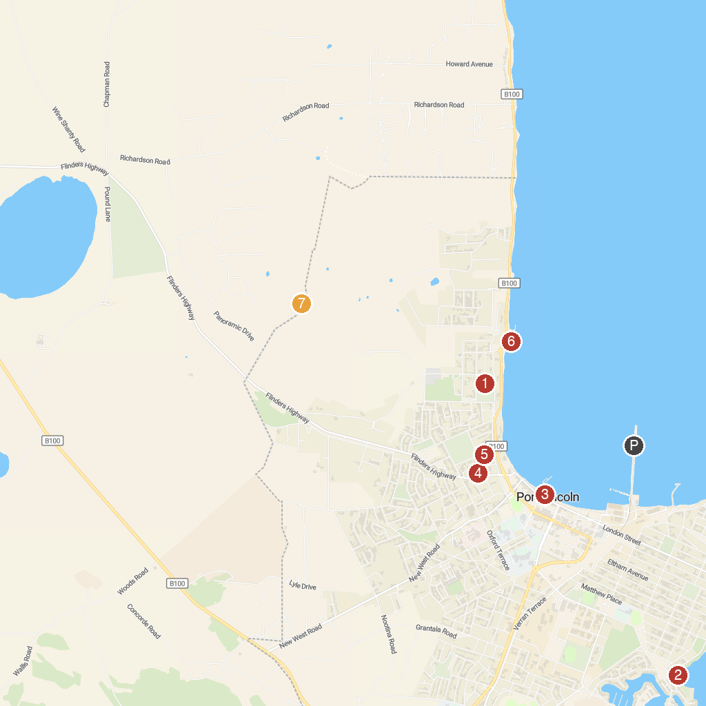
MAP KEY
1. Puckridge Park | 5. Flinders Park
2. Glen-Forest Tourist Park & Vineyard | 6. The Old Mill Lookout
3. Mundy's Mooring | 7. Axel Stenross Maritime Museum
4. Makybe Diva Statue | 8. Winter Hill Lookout
P. Cruise port / terminal
Map © MapTiler © OpenStreetMap contributors · cruiseports.org

