Port Klang (Kuala Lumpur), Malaysia
Malaysia's busiest port is an industrial gateway, not a destination — but an hour away lies Kuala Lumpur: twin towers that pierce the clouds, a Hindu shrine inside a limestone mountain, and a city that mixes colonial squares with hawker-stall heat.
⚓ Docked (Boustead Cruise Centre) · 🕒 Typical call: 8–10 hrs · 💵 Malaysian Ringgit (MYR) · 🗣️ Malay / English
✍️ MY DAY IN PORT (FILL IN)
Ship / Date
In port | arrive ______ · all aboard ______
Booked excursion
Notes / meeting point
GETTING ASHORE
- Docking: Boustead Cruise Centre, Port Klang
- Distance to KL: ~60 km · 1–1.5 hrs each way
- Best For: KL skyline · Batu Caves
- Don't Miss: Petronas Twin Towers
GETTING AROUND
- 🚕 Taxi: RM 70–90 (~$15–20 USD) one way — Official taxis available outside the terminal with fixed fares to Kuala Lumpur city center. Journey takes 60–90 minutes
- 📱 Rideshare: ✅ Grab, Bolt
TOP THINGS TO DO
- Petronas Twin Towers & KLCC — The defining image of modern Malaysia — twin 88-floor steel-and-glass spires connected by a sky bridge on the 41st floor.
- Batu Caves — A series of vast limestone caves sheltering one of the most important Hindu shrines outside India.
- Merdeka Square & Colonial KL — The grand open square where Malaysia's independence flag was first raised, flanked by the colonial-era Sultan Abdul Samad…
- Chinatown (Petaling Street) & Central Market — The covered Petaling Street market is KL's famous Chinatown — haggle for souvenirs, eat char kway teow at a hawker stall, and…
- KL Tower (Menara KL) — The 421-metre telecommunications tower on Bukit Nanas hill offers a 360° observation deck above the KL skyline — a different…
BEST WALKS
- Golden Triangle: KLCC to Bukit Bintang: ~2.5 km · 1–2 hrs · easy — Walk KL's glitzy core — from the Petronas Twin Towers through KLCC Park, along Jalan Ampang, and…
- Historic Heart: Merdeka Square to Chinatown: ~1.5 km · 1 hr · easy — Stroll from the colonial grandeur of Merdeka Square past Masjid Jamek, through the Kasturi Walk…
WEATHER · DAYLIGHT · MONEY
Month | High °F | Low °F | Rainy days
May | 86 | 77 | 27
Jul | 86 | 77 | 19
Sep | 86 | 76 | 23
Daylight: May 7:03AM–7:18PM · Jul 7:12AM–7:28PM · Sep 7:05AM–7:13PM
cruiseports.org/port-klang · Confirm terminal & all-aboard time with your ship

Port Klang (Kuala Lumpur), Malaysia — Port Map
Red = walkable sights · Amber = excursions farther out · P = cruise terminal
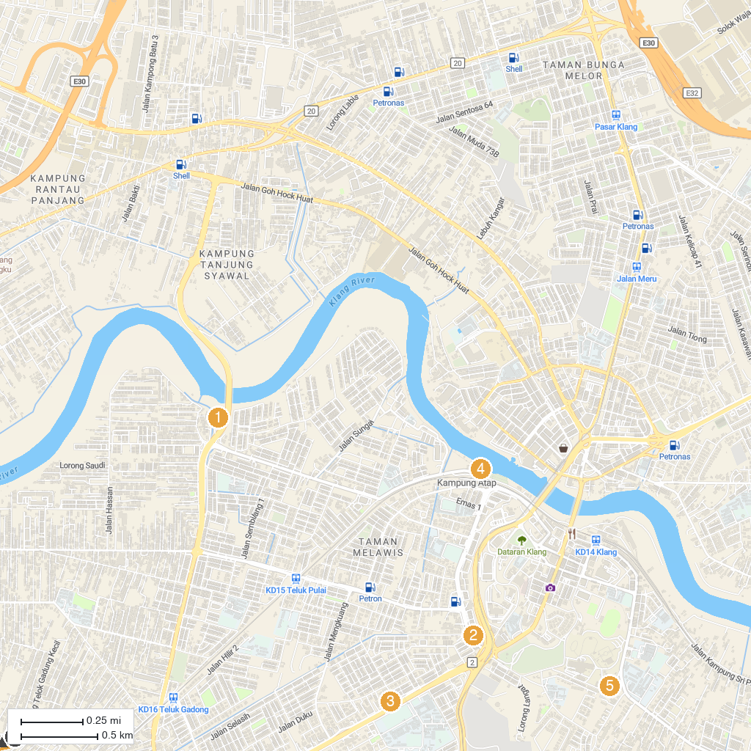
MAP KEY
1. Tian Hock Kung | 5. Sri Maha Mariamman Devasthanam • I-City
2. PERSATUAN PENYOKONG RUMAH BERHALA KWAN IMM KLANG | 6. Laman Seni 7
3. Sri Sundararaja Perumal Temple, Klang - Malaysia | 7. Sultan Suleiman Royal Mosque
4. Taman Awam Pangkalan Batu | 8. Jetty Bagan Hailam
P. Cruise port / terminal
Map © MapTiler © OpenStreetMap contributors · cruiseports.org

