Port Kembla, New South Wales, Australia
Where industrial heritage meets dramatic coastline. Port Kembla puts you just minutes from pristine beaches, towering Buddhist pagodas, and one of Australia's most photographed bridges — all backdropped by the sheer Illawarra Escarpment.
⚓ Pier (alongside berth) · 🕒 Typical call: 8-10 hrs · 💵 Australian Dollar (AUD) · 🗣️ English · 🦘 Wildlife nearby
✍️ MY DAY IN PORT (FILL IN)
Ship / Date
In port | arrive ______ · all aboard ______
Booked excursion
Notes / meeting point
GETTING ASHORE
- Docking: Alongside pier at Australian Amalgamated Terminals (AAT) — no tender required
- Walk to centre: Port is industrial — free shuttle bus to Port Kembla town (10 min) or Wollongong CBD (20 min)
- Best For: Beaches, the Nan Tien Buddhist Temple, Sea Cliff Bridge views, Australian wildlife
- Don't Miss: Nan Tien Temple — the largest Buddhist temple in the Southern Hemisphere, free entry
GETTING AROUND
- 🚕 Taxi: AUD $28–35 — Taxis (13cabs and local operators) are available at the terminal. The ride to Wollongong city centre takes about 8 minut
- 📱 Rideshare: ✅ Uber
TOP THINGS TO DO
- Nan Tien Temple, Berkeley — The largest Buddhist temple in the Southern Hemisphere sits just 10 minutes from the pier.
- Sea Cliff Bridge & Grand Pacific Drive — The 665-metre Sea Cliff Bridge curves out over the Pacific Ocean on the Sea Cliff bluffs north of Wollongong — one of Australia's…
- Symbio Wildlife Park — About 30 minutes north near Helensburgh, Symbio lets you hand-feed kangaroos, pat koalas, and see Tasmanian devils and wombats up…
- Hill 60 Lookout & WWII Gun Emplacements — Minutes from the pier, Hill 60 offers 360-degree views of the coastline and Five Islands Nature Reserve.
- Illawarra Escarpment & Treetop Adventures — The sheer rainforest escarpment directly behind Wollongong offers several adventure options.
BEST WALKS
- Wollongong Harbour & City Beach Walk: ⏱ 1.5–2 hrs · Easy · Flat coastal path — From the Crown Street Mall shuttle drop, walk east to Wollongong City Beach, then north along the…
- Wollongong Botanic Garden Stroll: ⏱ 1–1.5 hrs · Easy · Free entry — A 1.5 km walk from the CBD shuttle drop brings you to the Wollongong Botanic Garden, tucked against…
WEATHER · DAYLIGHT · MONEY
Month | High °F | Low °F | Rainy days
May | 67 | 52 | 6
Jul | 62 | 47 | 6
Sep | 67 | 51 | 9
Daylight: May 6:42AM–5:02PM · Jul 7:01AM–5:03PM · Sep 5:56AM–5:47PM
cruiseports.org/port-kembla · Confirm terminal & all-aboard time with your ship

Port Kembla, New South Wales, Australia — Port Map
Red = walkable sights · Amber = excursions farther out · P = cruise terminal
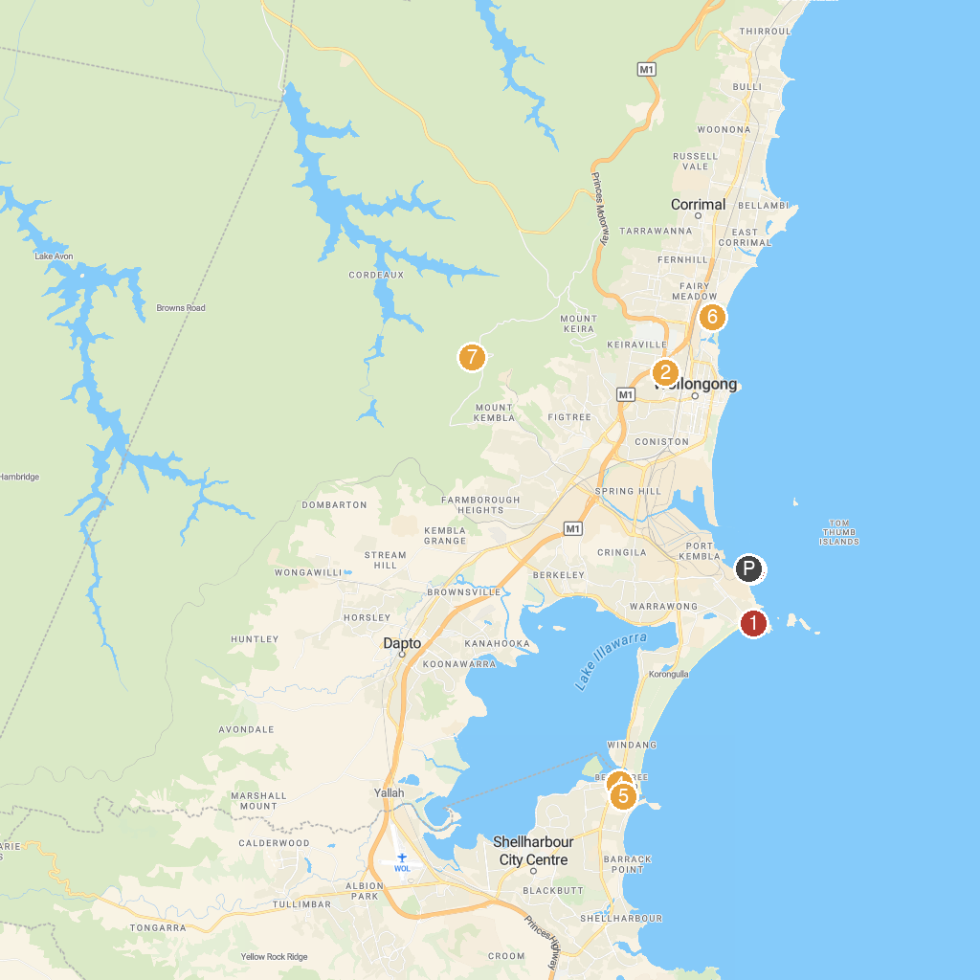
MAP KEY
1. Port Kembla Lookout Hill 60 | 5. Reddall Reserve
2. Wiseman Park Reserve | 6. UOW Science Space
3. Port Kembla Heritage Park | 7. Wollongong Motorcycle Club
4. Stand Up Paddle Boarding Shellharbour | 8. Cawley Park
P. Cruise port / terminal
Map © MapTiler © OpenStreetMap contributors · cruiseports.org

