Port Hedland, Western Australia, Australia
The world's largest bulk-export port by tonnage, Port Hedland is a raw, industrial Pilbara town where colossal iron ore carriers dwarf everything in sight — and where flatback turtles nest on quiet beaches just minutes from the waterfront.
⚓ Docked (pier) · 🕒 Typical call: 6–8 hrs · 💵 Australian Dollar (AUD) · 🗣️ English · ☀️ Hot & arid climate
✍️ MY DAY IN PORT (FILL IN)
Ship / Date
In port | arrive ______ · all aboard ______
Booked excursion
Notes / meeting point
GETTING ASHORE
- Docking: Pier — ships berth at the commercial port wharves
- Walk to Town: ~15–20 min walk or short taxi to West End / Visitor Centre
- Best For: Industrial port photography, Aboriginal art, turtle beaches
- Don't Miss: Staircase to the Moon (seasonal), Cemetery Beach turtles, Courthouse Gallery
GETTING AROUND
- 🚕 Taxi: AUD 15–25 — 13cabs operates in Port Hedland with government-regulated fares. Flagfall is AUD 5.40 (Mon–Fri daytime); higher rates ap
- 📱 Rideshare: ✅ Rideroo, H Ride
TOP THINGS TO DO
- Harbour Port Tour — A boat tour around one of the world's busiest bulk-export ports, putting you up close to 300-metre iron ore carriers, tugs, and…
- West End Heritage Trail — Self-guided walk through Port Hedland's historic West End, taking in the SS Koombana Lookout (memorial to the 1912 cyclone…
- Courthouse Gallery & Spinifex Hill Studios — Port Hedland's cultural heart showcases Aboriginal and local art.
- Cemetery Beach Turtle Walk — Cemetery Beach is one of Australia's most accessible flatback turtle nesting sites.
- Staircase to the Moon — On three nights each month around the full moon, the rising moon's reflection on exposed tidal mudflats creates the illusion of a…
BEST WALKS
- West End Heritage Walk: 2.5 km · 45–60 min · Easy — Start at the Port Hedland Visitor Centre, stroll to Marapikurrinya Park for panoramic port views…
- Cemetery Beach Stroll: 1 km beach loop · 30 min · Easy — A short drive or taxi from town (approx.
WEATHER · DAYLIGHT · MONEY
Month | High °F | Low °F | Rainy days
May | 87 | 69 | 2
Jul | 81 | 61 | 0
Sep | 90 | 68 | 0
Daylight: May 6:27AM–5:36PM · Jul 6:41AM–5:41PM · Sep 6:02AM–5:59PM
cruiseports.org/port-hedland · Confirm terminal & all-aboard time with your ship

Port Hedland, Western Australia, Australia — Port Map
Red = walkable sights · Amber = excursions farther out · P = cruise terminal
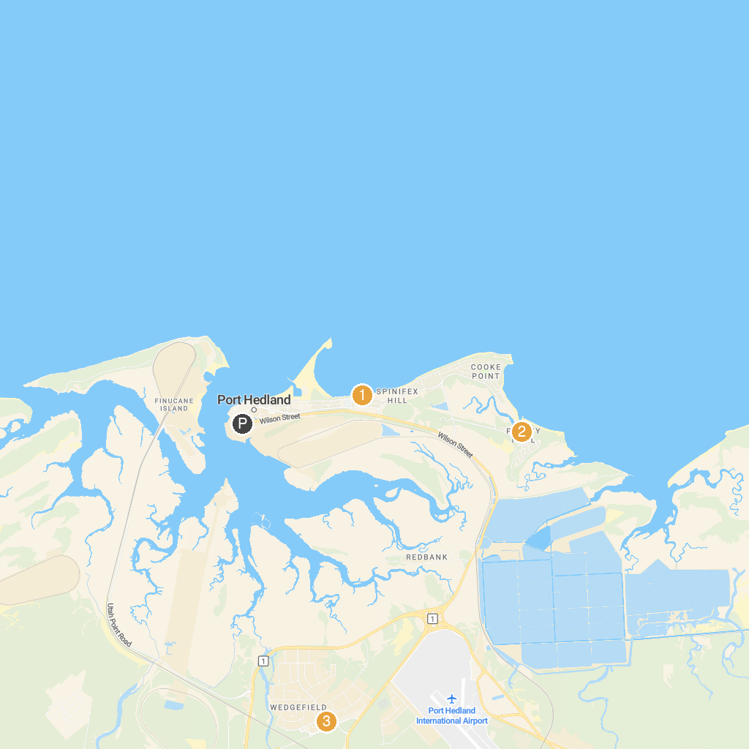
MAP KEY
1. Cemetery Beach Park | 3. The Big Wheelbarrow
2. Pretty Pool Park
P. Cruise port / terminal
Map © MapTiler © OpenStreetMap contributors · cruiseports.org

