Gqeberha (Port Elizabeth), Eastern Cape, South Africa
South Africa's 'Friendly City' sits where the Indian Ocean meets wide sandy beaches and the wild Eastern Cape — the closest cruise port to the world's densest elephant population.
⚓ Docked (Port Elizabeth Harbour) · 🕒 Typical call: 8–10 hrs · 💵 South African Rand (ZAR) · 🗣️ English · Xhosa · Afrikaans
✍️ MY DAY IN PORT (FILL IN)
Ship / Date
In port | arrive ______ · all aboard ______
Booked excursion
Notes / meeting point
GETTING ASHORE
- Docking: Commercial berth, working harbour
- Walk to center: 15–20 min or short taxi
- Best For: Wildlife · Beaches · History
- Don't Miss: Addo Elephant National Park
GETTING AROUND
- 🚕 Taxi: $4–7 USD — Taxi ranks are available near the port security gate. Fares may require negotiation; confirm price before boarding.
- 📱 Rideshare: ✅ Uber, Bolt
TOP THINGS TO DO
- Addo Elephant National Park — Home to over 600 African elephants plus buffalo, lion, rhino, and hippo, Addo is 72 km from port and absolutely worth the drive.
- Kragga Kamma Game Park — A compact private reserve just 20 minutes from port with rhino, giraffe, zebra, cheetah, and more.
- Bayworld Museum Complex — A beachfront complex in Humewood combining the Port Elizabeth Museum (natural and cultural history) and the historic Snake Park…
- Beachfront Boardwalk & Hobie Beach — PE's kilometre-long beachfront boardwalk runs from Humewood to Hobie Beach — one of the best swimming beaches on the Indian Ocean…
- Donkin Reserve & Victorian Heritage Walk — The hilltop Donkin Reserve overlooks the city and harbour with a distinctive stone pyramid built in 1820.
BEST WALKS
- Donkin Reserve to Market Square: 1.5 km · 30 min · Easy — Start at the Donkin Reserve on the hill for panoramic harbour views, then walk down through the…
- Kings Beach to Hobie Beach Boardwalk: 2 km · 40 min · Flat — A classic beachfront stroll along the Indian Ocean.
WEATHER · DAYLIGHT · MONEY
Month | High °F | Low °F | Rainy days
May | 70 | 58 | 6
Jul | 66 | 53 | 5
Sep | 67 | 56 | 7
Daylight: May 7:03AM–5:24PM · Jul 7:20AM–5:26PM · Sep 6:16AM–6:09PM
cruiseports.org/port-elizabeth · Confirm terminal & all-aboard time with your ship

Gqeberha (Port Elizabeth), Eastern Cape, South Africa — Port Map
Red = walkable sights · Amber = excursions farther out · P = cruise terminal
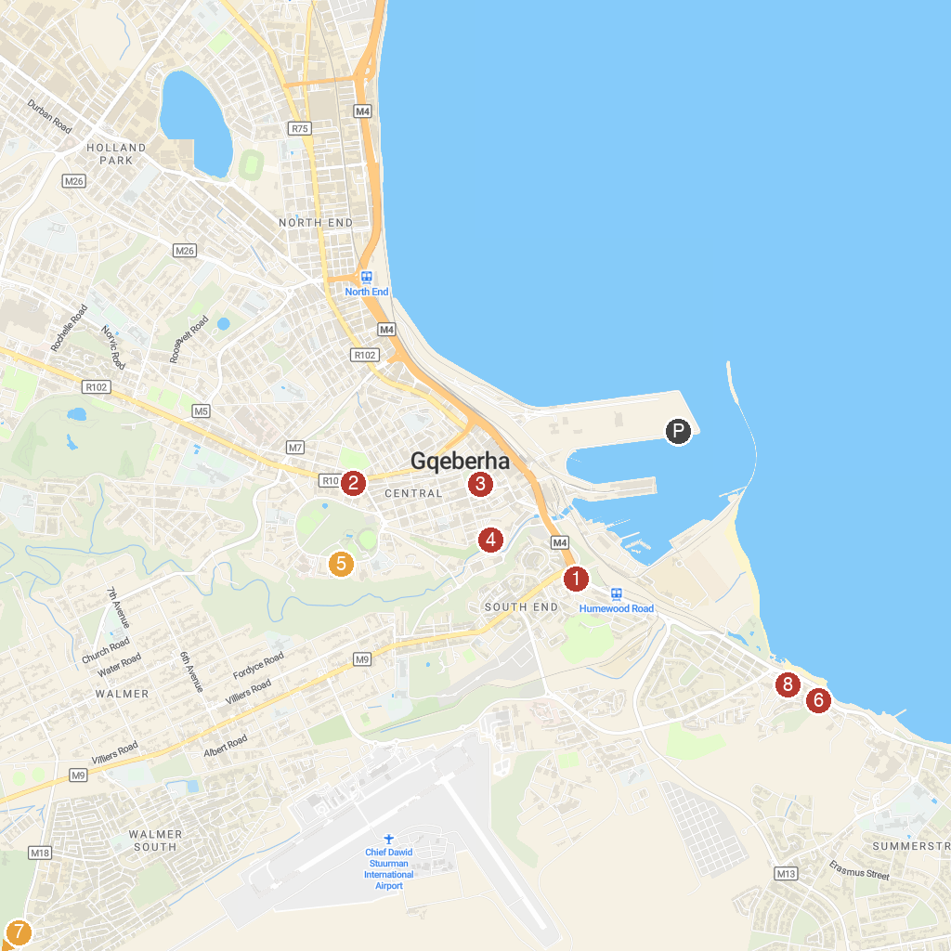
MAP KEY
1. South End Museum | 5. GFI Art Gallery
2. Horse Memorial | 6. Happy Valley
3. The Donkin Lighthouse (Est. 1861) | 7. Start of Sacramento Trail
4. Fort Frederick, Eastern Cape | 8. Bayworld
P. Cruise port / terminal
Map © MapTiler © OpenStreetMap contributors · cruiseports.org

