Port Douglas, Queensland, Australia
The only place on Earth where two UNESCO World Heritage sites converge — the Great Barrier Reef and the world's oldest tropical rainforest — just steps from a charming barefoot-luxury village.
⚓ Tender port · 🕒 Typical call: 8–10 hrs · 💵 Australian Dollar (AUD) · 🗣️ English · 🌊 Reef & Rainforest gateway
✍️ MY DAY IN PORT (FILL IN)
Ship / Date
In port | arrive ______ · all aboard ______
Booked excursion
Notes / meeting point
GETTING ASHORE
- Docking: Tender — ships anchor offshore; 15–20 min ride to Reef Marina jetty
- Walk to centre: 5 min from tender pier to Macrossan Street shops & cafes
- Best For: Great Barrier Reef snorkelling, Daintree Rainforest day trips, beach
- Don't Miss: Flagstaff Hill Lookout view over Four Mile Beach
GETTING AROUND
- 🚕 Taxi: AUD $10–20 — Taxis are available at the marina. Starting fare (flagfall) is around AUD $3.80–6.20 plus about AUD $2.90/km. A typical
- 📱 Rideshare: ✅ Uber
TOP THINGS TO DO
- Great Barrier Reef Snorkel & Dive — Port Douglas sits closer to the outer reef than Cairns, so boats reach prime coral in about 90 minutes.
- Mossman Gorge & Daintree Rainforest — Drive 20 minutes north to Mossman Gorge — ancient rainforest, suspension bridges over the boulder-strewn river, and Kuku Yalanji…
- Wildlife Habitat Port Douglas — Walk through recreated wetland, rainforest, savannah, and woodland habitats.
- Four Mile Beach & Stinger Enclosure — Four miles of palm-backed golden sand, firm enough to walk or jog.
- Macrossan Street & Flagstaff Hill — Stroll palm-lined Macrossan Street for boutiques, galleries, and coffee.
BEST WALKS
- Macrossan Street & Flagstaff Hill Loop: 3.5 km · 1 hr · Easy — Walk from the marina jetty up Wharf Street to Macrossan Street, browse the shops, then continue to…
- Reef Marina to Four Mile Beach: 3 km one-way · 40 min · Easy — Head down Macrossan Street and continue straight to the northern end of Four Mile Beach and the…
WEATHER · DAYLIGHT · MONEY
Month | High °F | Low °F | Rainy days
May | 78 | 70 | 12
Jul | 74 | 66 | 9
Sep | 78 | 68 | 8
Daylight: May 6:34AM–5:55PM · Jul 6:47AM–6:01PM · Sep 6:14AM–6:13PM
cruiseports.org/port-douglas · Confirm terminal & all-aboard time with your ship

Port Douglas, Queensland, Australia — Port Map
Red = walkable sights · Amber = excursions farther out · P = cruise terminal
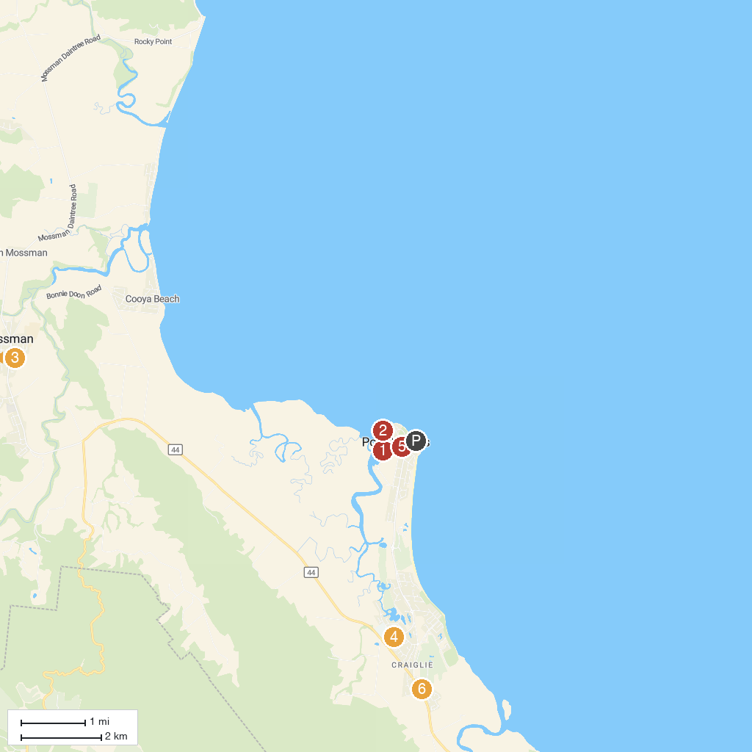
MAP KEY
1. Quicksilver Cruises | 4. Wildlife Habitat
2. Port Douglas Sugar Wharf | 5. Wavelength Reef Cruises
3. Janbal Gallery | 6. Tony's Tropical Tours
P. Cruise port / terminal
Map © MapTiler © OpenStreetMap contributors · cruiseports.org

