Port Denarau, Viti Levu, Fiji
Fiji's premier cruise gateway opens the door to pristine island beaches, volcanic mud pools, and one of the world's most genuinely warm welcomes — all starting from a modern marina hub.
⚓ Tender (most large ships) · 🕒 Typical call: 8–10 hrs · 💵 Fijian Dollar (FJD) · 🗣️ English & Fijian
✍️ MY DAY IN PORT (FILL IN)
Ship / Date
In port | arrive ______ · all aboard ______
Booked excursion
Notes / meeting point
GETTING ASHORE
- Docking: Tender for large ships; small vessels may dock at marina wharf
- Walk to town: Marina shops/dining: 2–5 min walk; Nadi Town: not walkable (10 km, taxi/bus needed)
- Best For: Island day trips, snorkeling, cultural experiences, beach clubs
- Don't Miss: Malamala Beach Club island day trip or South Sea Island snorkeling
GETTING AROUND
- 🚕 Taxi: FJ$4–FJ$7 (approx. US$2–3) — Metered taxis are plentiful at the port and reach Nadi city center in about 7–10 minutes. Confirm the meter is running o
- 📱 Rideshare: ❌ not available
TOP THINGS TO DO
- Malamala Beach Club Island Day — The world's first island beach club sits just 25 min by fast boat from the marina.
- South Sea Island & Snorkeling — A tiny coral-sand cay 30 min from Port Denarau with brilliant snorkeling, kayaking, and a semi-submersible.
- Sabeto Mud Pools & Hot Springs — Slather on warm volcanic mud, bake in the sun, then rinse off and soak in natural hot springs at the foot of the Sabeto Mountains…
- Sri Siva Subramaniya Temple & Nadi Town — The largest Hindu temple in the Southern Hemisphere dazzles with Dravidian architecture and vivid murals.
- Garden of the Sleeping Giant — Over 2,000 orchid varieties fill this lush garden nestled against the Sabeto Mountains — originally started by actor Raymond Burr.
BEST WALKS
- Port Denarau Marina Stroll: Easy · 30–60 min · Flat paved path — Walk the marina promenade from the passenger terminal past boutique shops, restaurants, and the…
- Nadi Town Market Walk: Easy · 45 min · Flat streets — Take a taxi or local bus into Nadi Town, then walk from the market to the Sri Siva Subramaniya…
cruiseports.org/port-denarau-nadi · Confirm terminal & all-aboard time with your ship

Port Denarau, Viti Levu, Fiji — Port Map
Red = walkable sights · Amber = excursions farther out · P = cruise terminal
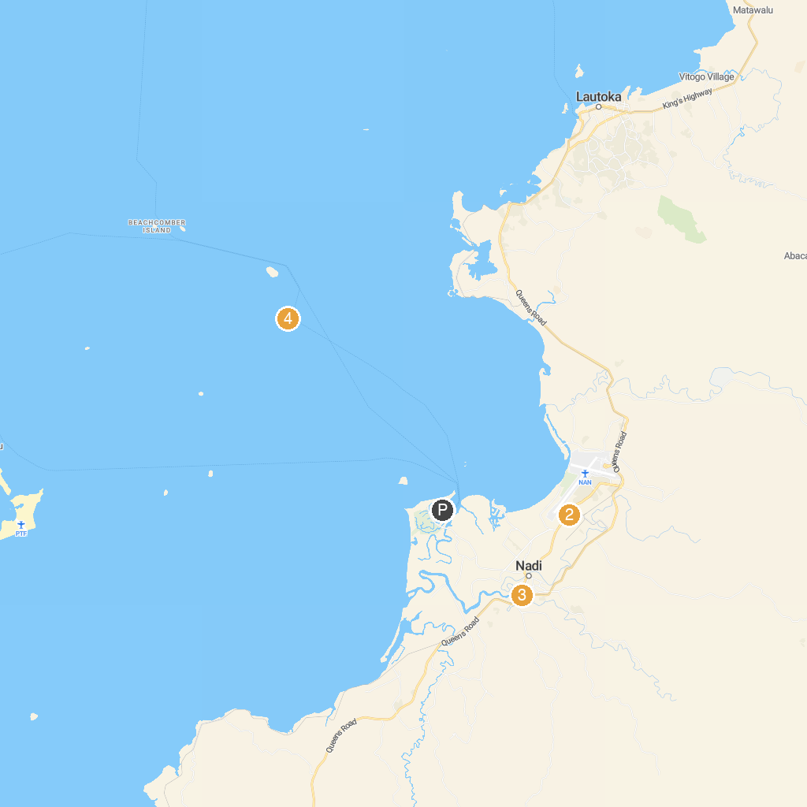
MAP KEY
1. Yasawa Adventures Fiji | 3. Sri Siva Subramaniya Swami Temple
2. Mount Saint Mary's Catholic Church | 4. South Sea Island
P. Cruise port / terminal
Map © MapTiler © OpenStreetMap contributors · cruiseports.org

