Port Canaveral, Florida, USA
America's second-busiest cruise port sits next to a rocket launch pad. Watch a SpaceX liftoff from the deck, tour NASA in the morning, and dig your toes into Cocoa Beach sand by afternoon — nowhere else combines a cruise departure with outer space quite like this.
⚓ Docked (no tendering) · 🏠 Home port (turnaround day) · 💵 USD · 🗣️ English · 🚀 Adjacent to Kennedy Space Center
✍️ MY DAY IN PORT (FILL IN)
Ship / Date
In port | arrive ______ · all aboard ______
Booked excursion
Notes / meeting point
GETTING ASHORE
- Docking: All ships dock at cruise terminals CT1–CT10; no tendering ever required
- Walk to center: No walkable center from piers; The Cove is 1.5–3 mi; Cocoa Beach ~5 mi by rideshare
- Best For: Kennedy Space Center, Cocoa Beach, bioluminescent kayaking, Orlando parks
- Don't Miss: Kennedy Space Center Visitor Complex — Space Shuttle Atlantis is a genuine jaw-drop
GETTING AROUND
- 🚕 Taxi: $20–$130 — Taxis are readily available at the terminal. Expect around $20 to Cocoa Beach (~20 min) or $130+ to downtown Orlando (~1
- 📱 Rideshare: ✅ Uber, Lyft
TOP THINGS TO DO
- Kennedy Space Center Visitor Complex — Walk beneath a Saturn V rocket, board the Space Shuttle Atlantis exhibit (genuinely awe-inspiring), and ride the simulated…
- Bioluminescent Kayaking — Paddle after dark through the Indian River Lagoon or Banana River while millions of glowing dinoflagellates light up every stroke.
- Cocoa Beach — Florida's nearest beach to the port.
- Airboat Ride & Gator Safari — Flat-bottom airboats skim the Florida marshlands at speed while guides point out alligators, osprey, and roseate spoonbills.
- Orlando Theme Parks — Walt Disney World, Universal Orlando, and SeaWorld are all ~60 miles west.
BEST WALKS
- The Cove Waterfront Loop: ⏱ 30–45 min · 🚶 Easy · 🌊 Waterfront dining — The Cove is a compact waterfront district inside the port with restaurants (Grills Seafood, Rusty's…
- Exploration Tower & Jetty Park: ⏱ 45–60 min · 🚶 Easy · 🚀 Views + beach — Exploration Tower is a 7-story architectural landmark at the port entrance with panoramic views of…
WEATHER · DAYLIGHT · MONEY
Month | High °F | Low °F | Rainy days
May | 82 | 71 | 13
Jul | 87 | 77 | 24
Sep | 84 | 76 | 22
Daylight: May 6:32AM–8:05PM · Jul 6:35AM–8:21PM · Sep 7:07AM–7:26PM
cruiseports.org/port-canaveral · Confirm terminal & all-aboard time with your ship

Port Canaveral, Florida, USA — Port Map
Red = walkable sights · Amber = excursions farther out · P = cruise terminal
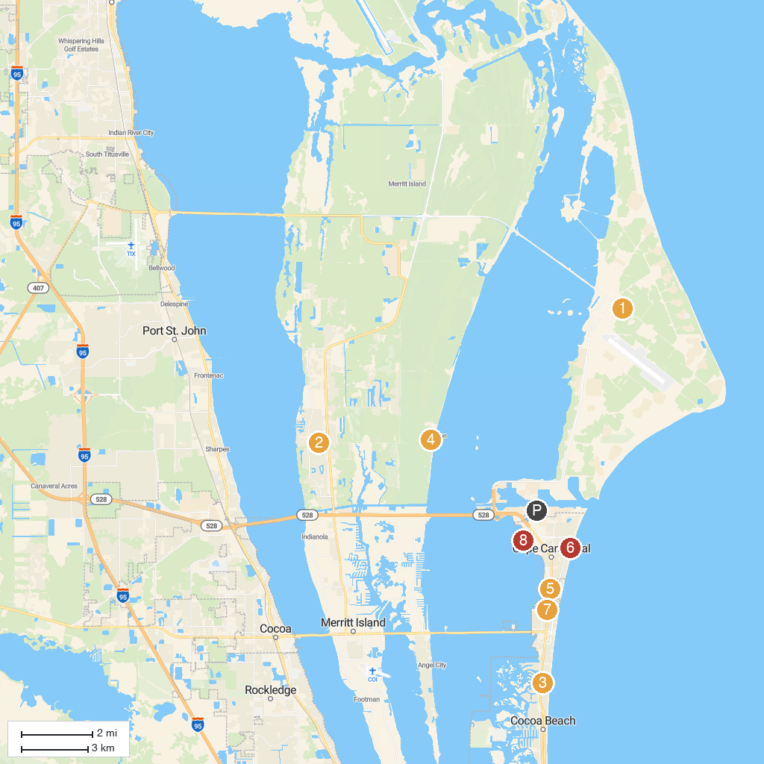
MAP KEY
1. Cape Canaveral Air Force Station | 5. Golf N Gator
2. Mitchell Ellington Park | 6. Cherie Down Park
3. Lori Wilson Park | 7. Church of Our Saviour
4. KARS Park | 8. Manatee Sanctuary Park
P. Cruise port / terminal
Map © MapTiler © OpenStreetMap contributors · cruiseports.org

