Port Blair, Andaman Islands, India
Capital of India's remote Andaman archipelago, Port Blair pairs the haunting Cellular Jail — where freedom fighters were exiled — with jungle-strangled British ruins, vivid coral reefs, and the fringes of humanity's last uncontacted tribes.
⚓ Docked (Haddo Wharf) · 🕒 Typical call: 8-10 hrs · 💵 Indian Rupee (INR) — carry cash · 🗣️ Hindi, Bengali, English · 🛂 Indian visa required
✍️ MY DAY IN PORT (FILL IN)
Ship / Date
In port | arrive ______ · all aboard ______
Booked excursion
Notes / meeting point
GETTING ASHORE
- Docking: Docked at Haddo Wharf (Jetty No. 4); shuttle to gate required
- Walk to centre: Not walkable from port — taxi or auto-rickshaw needed (~15 min to town)
- Best For: Colonial history, wildlife, snorkelling, Indian independence heritage
- Don't Miss: Cellular Jail light & sound show (evening) and Ross Island ruins
GETTING AROUND
- 🚕 Taxi: INR 150–300 (~$2–$4) — Non-metered taxis wait outside Haddo Wharf. Agree on fare before departure; city center (Aberdeen Bazaar) is about 3 km
- 📱 Rideshare: ❌ not available
- 🚌 Hop-on hop-off: ✅
TOP THINGS TO DO
- Cellular Jail (Kala Pani) — The most significant monument in the Andamans — a seven-wing star-shaped British colonial prison used to exile Indian freedom…
- Ross Island (Netaji Subhas Chandra Bose Dweep) Ruins — The former British administrative HQ — officially renamed Netaji Subhas Chandra Bose Dweep in 2018 — is now a ghost town where…
- Corbyn's Cove Beach — The closest beach to Port Blair — a crescent of sand fringed with coconut palms.
- Samudrika Marine Museum — Run by the Indian Navy, this excellent museum covers the islands' marine life, indigenous tribes, and coral ecosystems.
- Wandoor Beach & Marine National Park — A quieter beach near the Mahatma Gandhi Marine National Park — stunning views of uninhabited islands and some of the best…
BEST WALKS
- Aberdeen Bazaar to Cellular Jail: ~1.5 km | 20 min | Flat — From the heart of Port Blair's market, walk north-east along the waterfront promenade to reach the…
- Aberdeen Jetty to Ross Island Boat: Short walk | 5 min | Flat — From Aberdeen Bazaar, it's a short walk to Aberdeen Jetty (Water Sports Complex) where speedboats…
WEATHER · DAYLIGHT · MONEY
Month | High °F | Low °F | Rainy days
May | 86 | 80 | 26
Jul | 84 | 78 | 28
Sep | 83 | 77 | 28
Daylight: May 4:55AM–5:35PM · Jul 5:02AM–5:47PM · Sep 5:08AM–5:19PM
cruiseports.org/port-blair · Confirm terminal & all-aboard time with your ship

Port Blair, Andaman Islands, India — Port Map
Red = walkable sights · Amber = excursions farther out · P = cruise terminal
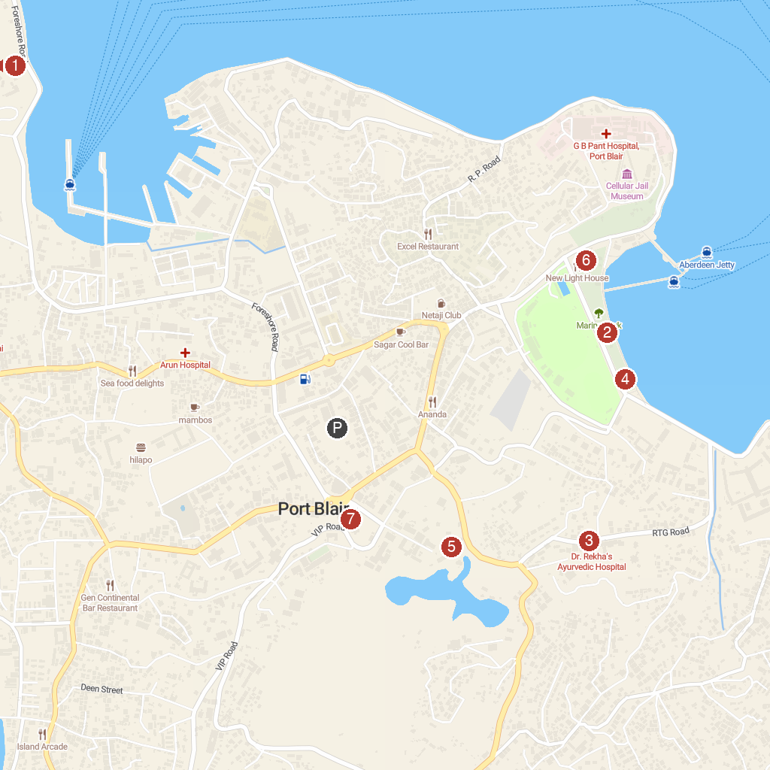
MAP KEY
1. Mini Zoo | 5. Gandhi Park
2. Marina Park | 6. Fisheries Museum Cum Aquarium
3. SUBMERSIBLE SCOOTERS | 7. Zonal Anthropological Museum
4. Parama Vira Chakra Memorial
P. Cruise port / terminal
Map © MapTiler © OpenStreetMap contributors · cruiseports.org

