Port Arthur, Tasmania, Australia
Once Britain's harshest penal colony, Port Arthur is now Tasmania's most visited historic site — a hauntingly beautiful open-air museum of sandstone ruins set against wild coastal headlands.
⚓ Tender port (anchors in Carnarvon Bay) · 🕒 Typical call: 8-10 hrs · 💵 Australian Dollar (AUD) · 🗣️ English · 🌿 UNESCO World Heritage Site
✍️ MY DAY IN PORT (FILL IN)
Ship / Date
In port | arrive ______ · all aboard ______
Booked excursion
Notes / meeting point
GETTING ASHORE
- Docking: Tender — ships anchor in Carnarvon Bay; tender jetty is inside the Historic Site
- Walk to centre: 2-minute walk from tender jetty to the Visitor Centre entrance
- Best For: History, convict heritage, coastal wilderness, wildlife
- Don't Miss: The Separate Prison, harbour cruise, and a Tasmanian scallop pie
GETTING AROUND
- 🚕 Taxi: Varies — Pre-booked taxis and hire cars can reach Port Arthur from Hobart (approx. 100 km / 1.5 hrs). No rideshare apps operate a
TOP THINGS TO DO
- Port Arthur Historic Site — The centrepiece of any call here.
- Isle of the Dead Cemetery Tour — A short ferry ride to the small island where over 1,100 convicts, soldiers, and officers were buried in unmarked graves.
- Tasman Island Wilderness Cruise — Pennicott Wilderness Journeys runs small eco-boats under some of the highest sea cliffs in the Southern Hemisphere, past…
- Tasmanian Devil Unzoo — About 10 minutes' drive from the Historic Site, the Unzoo at Taranna offers hand-feeding wallabies, Tasmanian devil encounters…
- Point Puer Boys' Prison — The first purpose-built reformatory for juvenile males in the British Empire, on a spit of land opposite the main site.
BEST WALKS
- Historic Site Self-Guided Walk: 2-4 hrs · Flat/gentle · Gravel paths — Pick up a map at the Visitor Centre and wander between the Penitentiary, Separate Prison, Gothic…
- Stewarts Bay Beach Walk: 1.5 hrs return · Easy · Coastal track — A well-marked trail from the Historic Site leads through coastal bush to Stewarts Bay, a sheltered…
WEATHER · DAYLIGHT · MONEY
Month | High °F | Low °F | Rainy days
May | 57 | 49 | 12
Jul | 54 | 45 | 11
Sep | 57 | 47 | 12
Daylight: May 7:14AM–4:56PM · Jul 7:36AM–4:53PM · Sep 6:12AM–5:57PM
cruiseports.org/port-arthur · Confirm terminal & all-aboard time with your ship

Port Arthur, Tasmania, Australia — Port Map
Red = walkable sights · Amber = excursions farther out · P = cruise terminal
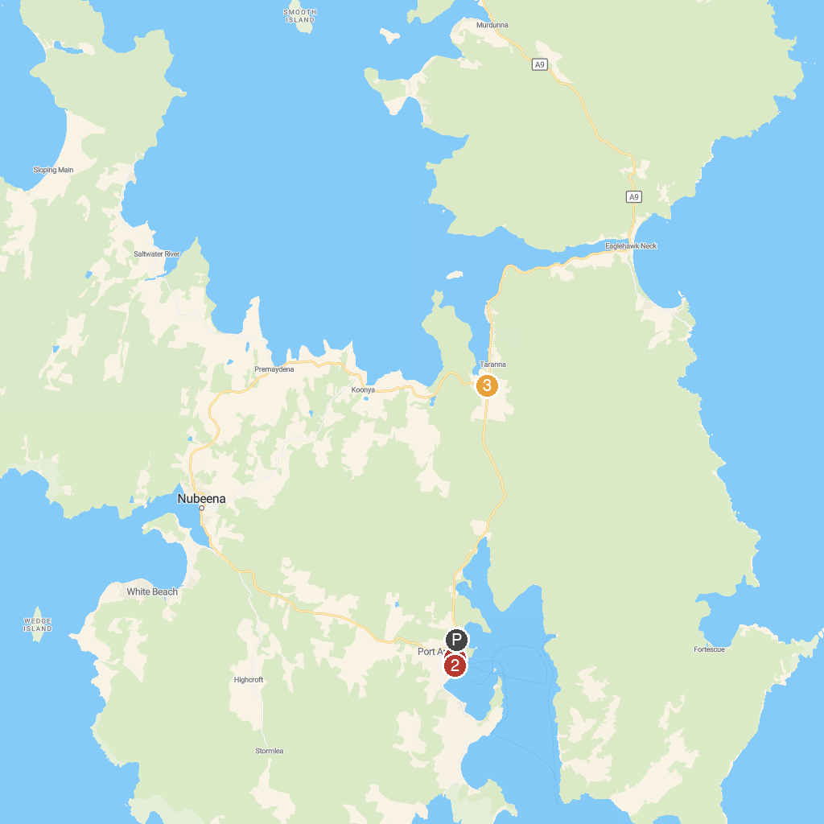
MAP KEY
1. Port Arthur Ghost Tours | 3. Tasmanian Devil Unzoo
2. The Penitentiary | 4. Tasman Island Cruises
P. Cruise port / terminal
Map © MapTiler © OpenStreetMap contributors · cruiseports.org

