Port Antonio, Portland, Jamaica
Jamaica's best-kept secret, Port Antonio trades mega-resort crowds for lush rainforest, bamboo-rafted rivers, Hollywood-haunted lagoons, and the original jerk pits at Boston Beach.
⚓ Docked — Ken Wright Pier (small ships only) · 🕒 Typical call: 7–9 hrs · 💵 USD widely accepted (JMD also in use) · 🗣️ English · 🌧️ Portland is Jamaica's rainiest parish — pack a poncho
✍️ MY DAY IN PORT (FILL IN)
Ship / Date
In port | arrive ______ · all aboard ______
Booked excursion
Notes / meeting point
GETTING ASHORE
- Docking: Ken Wright Pier, Errol Flynn Marina — small/luxury ships only; no mega-ships
- Walk to center: 10 min from pier into downtown Port Antonio
- Best For: Rio Grande rafting, Blue Lagoon, Reach Falls, authentic jerk
- Don't Miss: Boston Jerk Centre — birthplace of Jamaican jerk cooking, ~25 min from pier
GETTING AROUND
- 🚕 Taxi: $10–30 USD — Licensed JUTA taxis wait just outside the pier gate. Fares are unmetered — agree on the price before you get in. Fares a
- 📱 Rideshare: ❌ not available
TOP THINGS TO DO
- Rio Grande Bamboo Rafting — The quintessential Port Antonio experience.
- Blue Lagoon — Cold freshwater springs mix with warm Caribbean water creating mesmerizing color shifts — deep cobalt to turquoise.
- Reach Falls — Jamaica's most beautiful waterfall, deep in the Montane Forest.
- Frenchman's Cove Beach — Often listed among the world's most beautiful beaches: a crystal-clear freshwater river winds through jungle and empties onto a…
- Boston Jerk Centre & Beach — Pilgrimage to the birthplace of Jamaican jerk.
BEST WALKS
- Marina to Titchfield Peninsula: 1.5 km · 30–40 min · Easy — From the Errol Flynn Marina, follow the harbourfront into town, cross onto the Titchfield Peninsula…
WEATHER · DAYLIGHT · MONEY
Month | High °F | Low °F | Rainy days
May | 84 | 76 | 22
Jul | 86 | 78 | 21
Sep | 87 | 78 | 21
Daylight: May 5:32AM–6:31PM · Jul 5:38AM–6:44PM · Sep 5:53AM–6:07PM
cruiseports.org/port-antonio · Confirm terminal & all-aboard time with your ship

Port Antonio, Portland, Jamaica — Port Map
Red = walkable sights · Amber = excursions farther out · P = cruise terminal
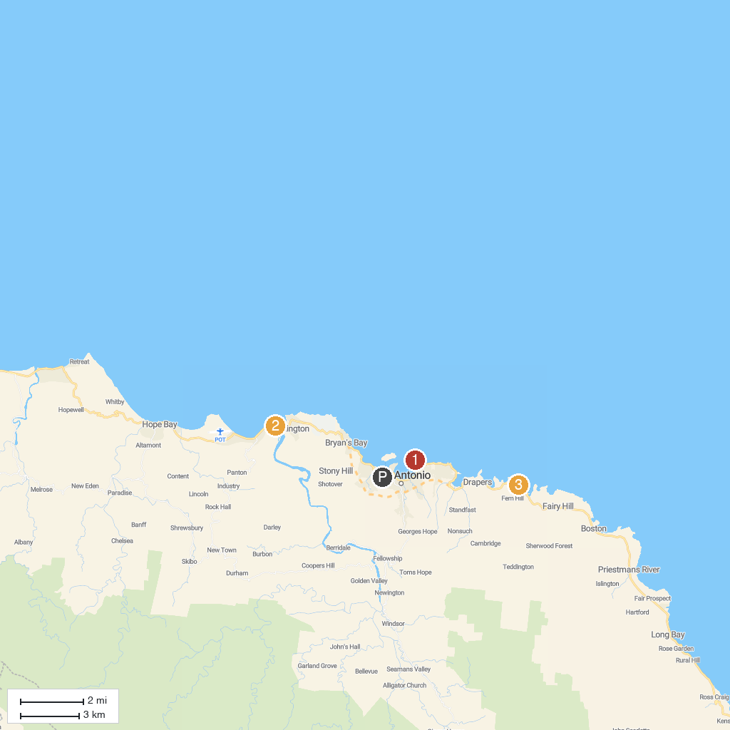
MAP KEY
1. Folly Ruins | 3. Pellew Island
2. Rafter's Rest (Rio Grande Rafting)
P. Cruise port / terminal
Map © MapTiler © OpenStreetMap contributors · cruiseports.org

