Port Angeles, Washington, USA
Gateway to Olympic National Park, Port Angeles sits on the Strait of Juan de Fuca with the snow-capped Olympics at its back — a rare Alaska-route port that rewards both walkers and wilderness seekers.
⚓ Docked (deepwater pier) · 🕒 Typical call: 7-10 hrs · 💵 USD · 🗣️ English · 🏔️ Olympic National Park access
✍️ MY DAY IN PORT (FILL IN)
Ship / Date
In port | arrive ______ · all aboard ______
Booked excursion
Notes / meeting point
GETTING ASHORE
- Docking: Deepwater berth at Port of Port Angeles — ships dock directly, no tender
- Walk to center: 5–10 min walk to downtown along the waterfront
- Best For: Olympic National Park, Hurricane Ridge, whale watching, Twilight fans
- Don't Miss: Hurricane Ridge views or a whale-watch on the Strait of Juan de Fuca
GETTING AROUND
- 🚕 Taxi: $5–$15 — Several local taxi companies operate in Port Angeles including Northwest Cabs and Sun Taxi. Fares to most downtown or wa
- 📱 Rideshare: ✅ Uber, Lyft
TOP THINGS TO DO
- Hurricane Ridge — Shuttle or drive 17 miles up to 5,242 ft for panoramic views of the Olympic Mountains, glacier-carved valleys, and on clear days…
- Whale Watching on the Strait — Puget Sound Express and other operators run mid-day tours from the Port Angeles Wharf into the Strait of Juan de Fuca and toward…
- Hoh Rain Forest — One of the largest temperate rainforests in North America, draped in moss-covered maples and Sitka spruce.
- Lake Crescent Hike & Paddle — Glacially carved and impossibly blue, Lake Crescent is 20 miles west of port.
- Ferry to Victoria, BC — The Black Ball Ferry (MV Coho) runs a 90-minute crossing to Victoria, British Columbia — one of Canada's most charming cities.
BEST WALKS
- City Pier to Downtown Front Street: 0.5 mi · Flat · 15 min — Stroll the waterfront from the City Pier past the Feiro Marine Life Center, along the promenade…
- Waterfront Trail toward Ediz Hook: 1-2 mi one-way · Flat · 30-60 min — Head west along the waterfront toward Ediz Hook, a natural sandy spit extending into the harbor.
WEATHER · DAYLIGHT · MONEY
Month | High °F | Low °F | Rainy days
May | 61 | 49 | 10
Jul | 69 | 58 | 5
Sep | 65 | 54 | 11
Daylight: May 5:34AM–8:46PM · Jul 5:30AM–9:08PM · Sep 6:51AM–7:24PM
cruiseports.org/port-angeles-wa · Confirm terminal & all-aboard time with your ship

Port Angeles, Washington, USA — Port Map
Red = walkable sights · Amber = excursions farther out · P = cruise terminal
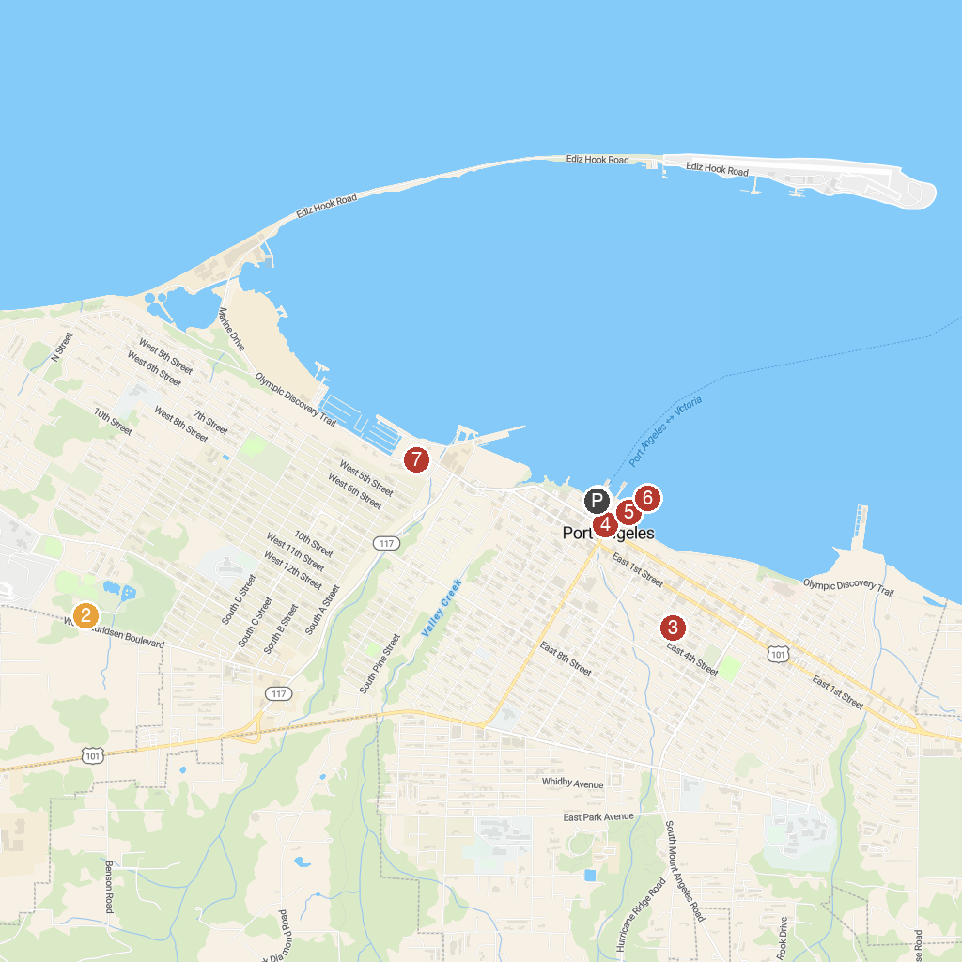
MAP KEY
1. Black Ball Ferry Line | 5. Feiro Marine Life Center
2. Lincoln Park | 6. Port Angeles City Pier & Hollywood Beach
3. Jessie Webster Park | 7. Olympic Hiking Co.
4. Port Angeles Farmers Market
P. Cruise port / terminal
Map © MapTiler © OpenStreetMap contributors · cruiseports.org

