Porbandar, Gujarat, India
The birthplace of Mahatma Gandhi sits on the Arabian Sea coast of Gujarat — a compact, walkable city of cream Porbandar stone where temples, a Gandhi memorial, and a working fishing harbor fill a short port day.
⚓ Pier (most vessels; large ships may tender) · 🕒 Typical call: 6-8 hrs · 💵 Indian Rupee (INR) · 🗣️ Gujarati / Hindi (some English) · 🚫 Dry state — no alcohol ashore
✍️ MY DAY IN PORT (FILL IN)
Ship / Date
In port | arrive ______ · all aboard ______
Booked excursion
Notes / meeting point
GETTING ASHORE
- Docking: Berth at Porbandar Port jetty (up to ~200 m / 50,000 DWT); larger ships anchor & tender
- Walk to Kirti Mandir: ~2 km from port gate (~25-min walk or 5-min auto-rickshaw)
- Best For: History pilgrims, temple-hopping, birdwatching (winter), cultural immersion
- Don't Miss: Gandhi's ancestral home at Kirti Mandir and the ornate Sudama Temple
GETTING AROUND
- 🚕 Taxi: ₹100–200 — Taxis are available at the port gate and charge roughly ₹10–11 per km. Useful for reaching attractions like Kirti Mandir
TOP THINGS TO DO
- Kirti Mandir — Gandhi's Birthplace — The 79-foot memorial complex surrounds Gandhi's ancestral three-story home, where he was born on 2 October 1869.
- Sudama Temple — One of India's very few temples dedicated to a mortal — Sudama, Lord Krishna's childhood friend.
- Porbandar Bird Sanctuary — A freshwater wetland right inside the city hosting 200+ bird species, with spectacular pink flamingo flocks arriving…
- Chowpatty Beach & Marine Drive — Porbandar's seafront promenade runs along the Arabian Sea past Huzoor Palace (exterior only) to a local beach where vendors sell…
- Old Porbandar Stone Town Walk — The entire old city is built of soft miliolite limestone ('Porbandar stone') weathered to a warm cream by sea salt.
BEST WALKS
- Port to Gandhi Birthplace & Sudama Temple: 3.5 km round trip · ~1.5 hrs · easy — Walk or take a rickshaw from the port gate to Kirti Mandir, explore the Gandhi complex, then…
- Marine Drive to Chowpatty Beach: 2 km one-way · 30 min · easy — From the port area head south along the seafront Marine Drive past Huzoor Palace to Chowpatty Beach.
WEATHER · DAYLIGHT · MONEY
Month | High °F | Low °F | Rainy days
May | 90 | 80 | 2
Jul | 85 | 80 | 28
Sep | 85 | 78 | 11
Daylight: May 6:13AM–7:22PM · Jul 6:17AM–7:37PM · Sep 6:38AM–6:54PM
cruiseports.org/porbandar · Confirm terminal & all-aboard time with your ship

Porbandar, Gujarat, India — Port Map
Red = walkable sights · Amber = excursions farther out · P = cruise terminal
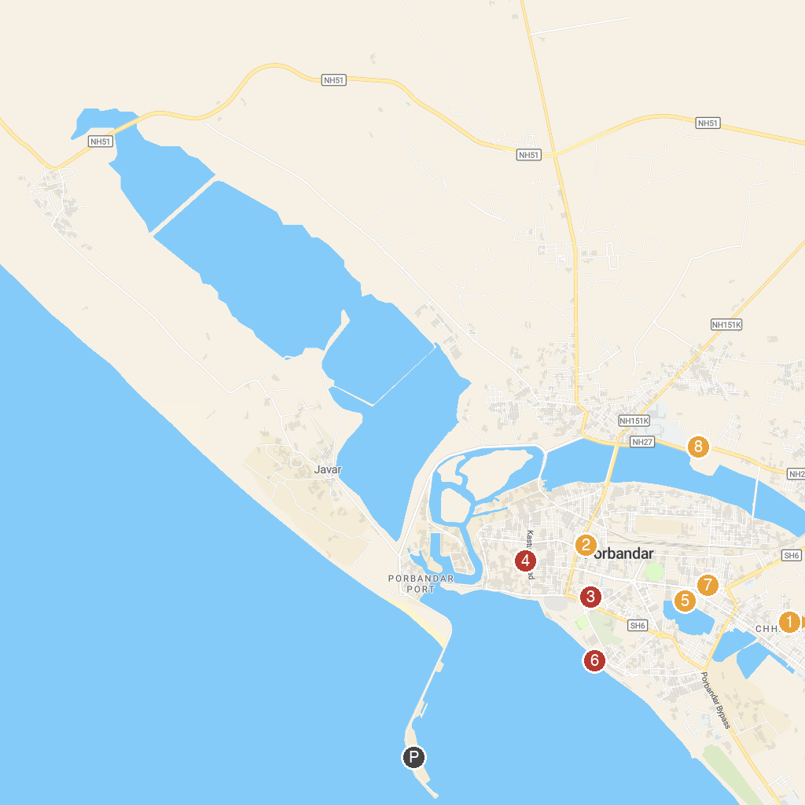
MAP KEY
1. Shree Hari Temple | 5. Porbandar Bird Sanctuary
2. Ramdhun Mandir by Prem Bhikshu Ji Maharaj | 6. Porbandar Beach
3. Bhutnath Mahadev Mandir | 7. Shri Satyanarayan Temple
4. Kirti Mandir (Mahatma Gandhi's Birth Place) | 8. Shree Gayatri Mataji Temple
P. Cruise port / terminal
Map © MapTiler © OpenStreetMap contributors · cruiseports.org

