Poole, Dorset, England
Home to the world's second-largest natural harbour, Poole packs sandy beaches, red-squirrel islands, and dramatic Jurassic Coast cliffs into one shore day.
⚓ Docked — South Quay (most ships) · 🕒 Typical call: 8-10 hrs · 💷 British Pound Sterling (£) · 🗣️ English
✍️ MY DAY IN PORT (FILL IN)
Ship / Date
In port | arrive ______ · all aboard ______
Booked excursion
Notes / meeting point
GETTING ASHORE
- Docking: South Quay deep-water berth (up to 220 m); shuttle to Poole Quay
- Walk to centre: 5-min shuttle bus from South Quay to Poole Quay
- Best For: Brownsea Island red squirrels, Jurassic Coast, Sandbanks beach
- Don't Miss: Ferry to Brownsea Island — birthplace of the Scout movement
GETTING AROUND
- 🚕 Taxi: £6–£8 — Metered taxis are available at the port. The ride to Poole town centre or railway station is very short (about 2 minutes
- 📱 Rideshare: ✅ Uber
- 🚌 Hop-on hop-off: ✅ City Sightseeing Bournemouth
TOP THINGS TO DO
- Brownsea Island Ferry — A 20-minute ferry from Poole Quay reaches this car-free National Trust island, famous for its rare red squirrels, peacocks, and…
- Corfe Castle & Swanage Steam Railway — Ride a vintage steam train from Swanage to the dramatic ruins of Corfe Castle, a 1,000-year-old royal fortress blown up in the…
- Durdle Door & Lulworth Cove — The Jurassic Coast's most photographed landmark — a natural limestone arch plunging into turquoise water, paired with the…
- Sandbanks Beach — One of the UK's top-rated beaches — Blue Flag golden sand, shallow safe water, and the so-called 'Millionaire's Row' of…
- Poole Old Town & Cockle Trail — Follow brass plaques set into the pavement on a 1.5-hour self-guided walk through Poole's seafaring past — smugglers…
BEST WALKS
- Poole Quay to Old Town Loop: 1.5 km · Easy · ~45 min — From the shuttle drop-off at Poole Quay, walk west along the waterfront past the Town Cellars to…
- Poole Quay to Poole Park: 1 km · Easy · ~20 min each way — Head north along the High Street from the Quay to reach Poole Park, a Victorian gem with a large…
WEATHER · DAYLIGHT · MONEY
Month | High °F | Low °F | Rainy days
May | 61 | 49 | 12
Jul | 70 | 58 | 8
Sep | 66 | 55 | 9
Daylight: May 5:19AM–8:50PM · Jul 5:12AM–9:14PM · Sep 6:43AM–7:21PM
cruiseports.org/poole · Confirm terminal & all-aboard time with your ship

Poole, Dorset, England — Port Map
Red = walkable sights · Amber = excursions farther out · P = cruise terminal
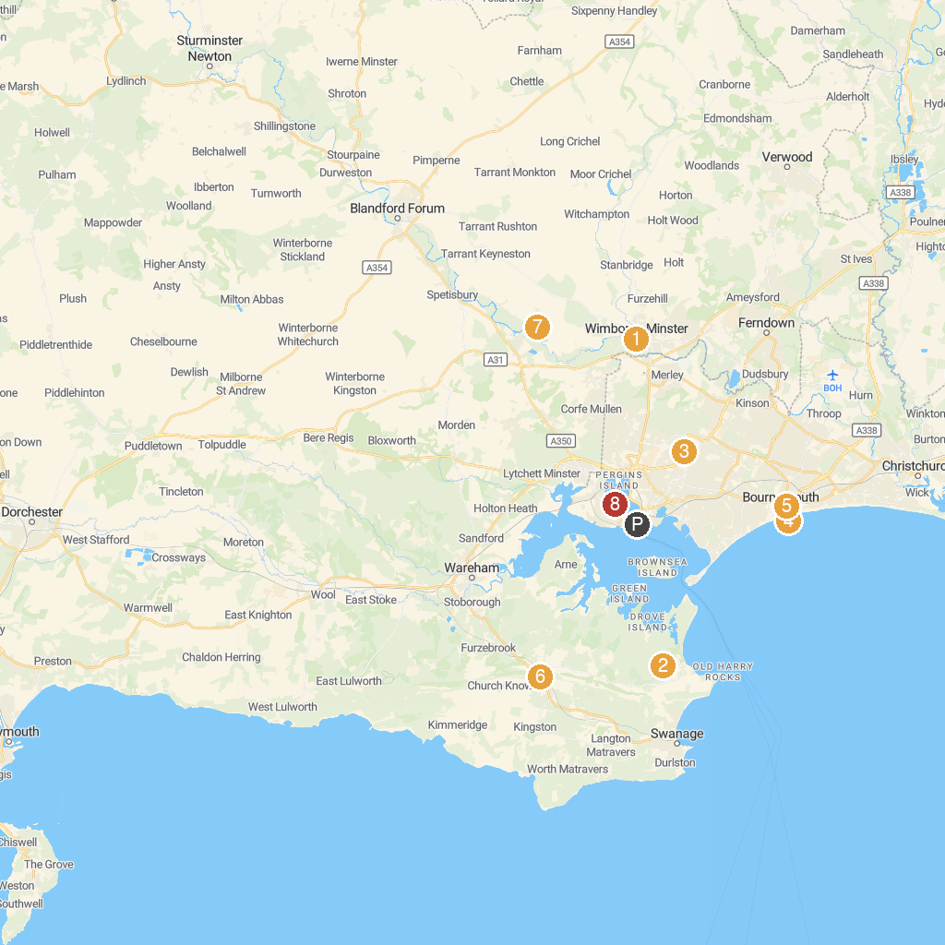
MAP KEY
1. Wimborne Minster Parish Office | 5. St Peter's Church
2. Agglestone Rock | 6. Corfe Castle
3. Splashdown Waterpark | 7. National Trust - White Mill
4. Bournemouth Pier | 8. Poole Boat Hire
P. Cruise port / terminal
Map © MapTiler © OpenStreetMap contributors · cruiseports.org

