Ponta Delgada, São Miguel, Azores, Portugal
The volcanic heart of the Azores — where twin crater lakes shimmer in ancient calderas, geothermal earth cooks your lunch at Furnas, and whale spouts dot the Atlantic horizon.
⚓ Pier (Portas do Mar terminal) · 🕒 Typical call: 8–10 hrs · 💶 Euro (€) · 🗣️ Portuguese
✍️ MY DAY IN PORT (FILL IN)
Ship / Date
In port | arrive ______ · all aboard ______
Booked excursion
Notes / meeting point
GETTING ASHORE
- Docking: Pier — Terminal Marítimo (Portas do Mar), 200 m from historic center
- Walk to center: 5–10 min flat walk along the mosaic seafront promenade
- Best For: Volcanic landscapes, whale watching, geothermal hot springs, local food
- Don't Miss: Sete Cidades caldera viewpoint or a soak at Furnas thermal pools
GETTING AROUND
- 🚕 Taxi: €6–€10 — Taxis are metered (starting at €3.60 + €0.74/km daytime). Cash only in most cases. Short hops around town cost €6–€10; r
- 📱 Rideshare: ✅ Bolt
- 🚌 Hop-on hop-off: ✅ São Miguel Hop-On Hop-Off Sightseeing Bus (Azores On Route)
TOP THINGS TO DO
- Sete Cidades Caldera — Stand at the Vista do Rei viewpoint over the twin-colored caldera lakes — one blue, one green — inside an ancient collapsed…
- Furnas Valley & Geothermal Pools — Watch mud pots bubble and steam vents hiss in the fumarole fields, then soak in iron-rich thermal pools at Poça da Dona Beija or…
- Whale & Dolphin Watching — The Azores is one of the world's top cetacean destinations — sperm whales are year-round residents, blue whales visit in spring.
- Azorean Pineapple Greenhouse Tour — Visit Arruda's pineapple plantation in Fajã de Baixo — the only place in Europe where pineapples are grown in glass greenhouses…
- Lagoa do Fogo (Fire Lake) — A wild, undeveloped crater lake high in the island's mountains.
BEST WALKS
- Seafront to City Gates & Market: 1.5 km · 25 min · Flat — A classic introduction: walk the mosaic seafront promenade from the terminal to the iconic…
- Fort São Brás & Jardim António Borges: 2.5 km loop · 45 min · Flat — From the city gates, walk east to the 16th-century Forte de São Brás for harbor views and the…
WEATHER · DAYLIGHT · MONEY
Month | High °F | Low °F | Rainy days
May | 66 | 59 | 16
Jul | 74 | 67 | 13
Sep | 74 | 68 | 16
Daylight: May 6:33AM–8:45PM · Jul 6:33AM–9:03PM · Sep 7:24AM–7:50PM
cruiseports.org/ponta-delgada · Confirm terminal & all-aboard time with your ship

Ponta Delgada, São Miguel, Azores, Portugal — Port Map
Red = walkable sights · Amber = excursions farther out · P = cruise terminal
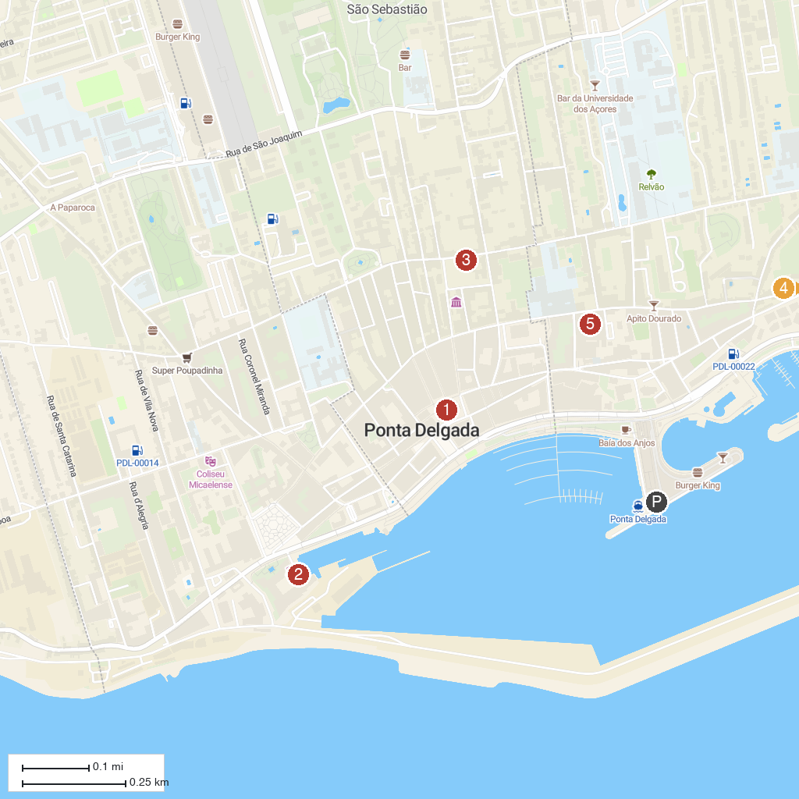
MAP KEY
1. Igreja Matriz de São Sebastião | 4. Observatório Vulcanológico e Geotérmico dos Açores
2. Museu Militar dos Açores | 5. Astronomical Observatory of Santana, Azores - OASA
3. Museu Carlos Machado | 6. Mercado da Graça
P. Cruise port / terminal
Map © MapTiler © OpenStreetMap contributors · cruiseports.org

