Ponce, Puerto Rico, USA
Puerto Rico's second city earns its nickname La Perla del Sur — from the candy-striped Parque de Bombas on the main plaza to a hilltop rum baron's castle with panoramic Caribbean views, Ponce delivers big-city culture with a genuine Puerto Rican soul.
⚓ Pier (docked) · 🕒 Typical call: 7-9 hrs · 💵 US Dollar (USD) · 🗣️ Spanish / English · 🌡️ Hot & dry — bring water
✍️ MY DAY IN PORT (FILL IN)
Ship / Date
In port | arrive ______ · all aboard ______
Booked excursion
Notes / meeting point
GETTING ASHORE
- Docking: Pier — Port of the Americas (Puerto de las Américas), no tendering
- Walk to center: ~3.5 miles to Plaza Las Delicias — shuttle or taxi required
- Best For: History, architecture, rum heritage, art museum
- Don't Miss: Parque de Bombas, Castillo Serrallés, King's Cream ice cream
GETTING AROUND
- 🚕 Taxi: $10–$20 — Taxis are available at the cruise terminal. The historic center (Ponce Pueblo) is roughly 3–5 miles away; confirm the fa
- 📱 Rideshare: ✅ Uber, Lyft
TOP THINGS TO DO
- Plaza Las Delicias & Parque de Bombas — The heart of Ponce: a grand colonial square anchored by the Lions Fountain and the unmistakable red-and-black 1882 fire station…
- Castillo Serrallés & Vigía Cross — The 1930s Spanish Revival mansion of Ponce's Don Q Rum dynasty perches on El Vigía Hill.
- Museo de Arte de Ponce — One of the finest art museums in the Americas, housing 4,500+ works including the famous Flaming June by Leighton.
- Hacienda Buena Vista Coffee Plantation — A beautifully restored 19th-century coffee and corn mill ~14 km into the mountains, run by the Conservation Trust of Puerto Rico.
- Caja de Muertos (Coffin Island) — Pristine nature reserve 8 miles offshore with white sand beaches, coral reefs, and an historic lighthouse.
BEST WALKS
- Plaza Las Delicias Heritage Walk: 1.5 miles · Easy · 1-2 hrs — Start at Parque de Bombas, circle the plaza to the Cathedral of Our Lady of Guadalupe and the Lions…
WEATHER · DAYLIGHT · MONEY
Month | High °F | Low °F | Rainy days
May | 88 | 73 | 17
Jul | 91 | 76 | 18
Sep | 88 | 76 | 19
Daylight: May 6:48AM–8:03PM · Jul 6:53AM–8:17PM · Sep 7:16AM–7:32PM
cruiseports.org/ponce · Confirm terminal & all-aboard time with your ship

Ponce, Puerto Rico, USA — Port Map
Red = walkable sights · Amber = excursions farther out · P = cruise terminal
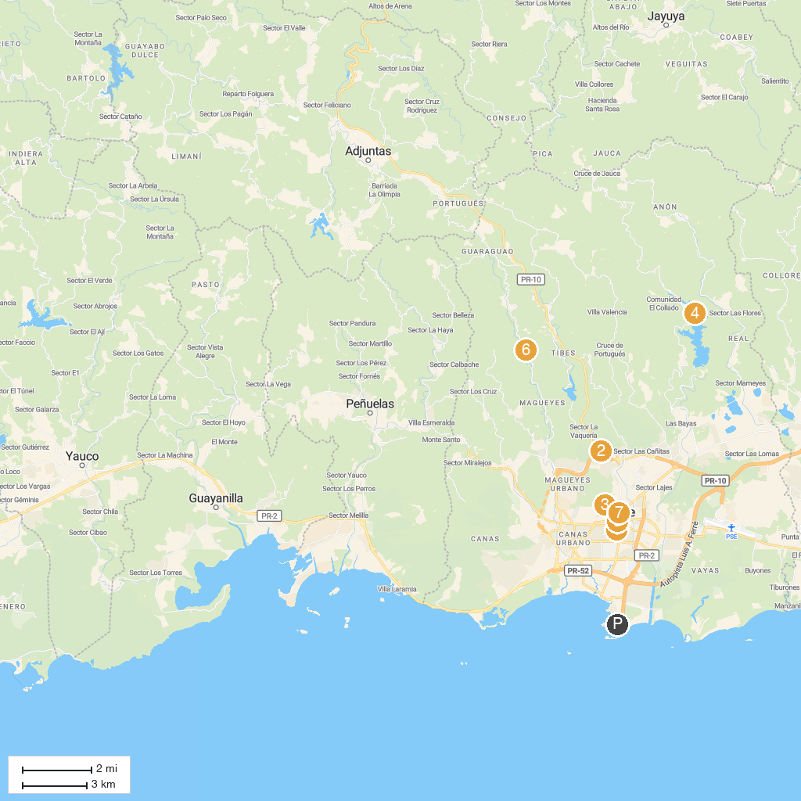
MAP KEY
1. Parque Urbano Dora Colón Clavell | 5. Parque de Bombas
2. Centro Ceremonial Indígena de Tibes | 6. Hacienda Buena Vista - Para la Naturaleza
3. Museo Castillo Serrallés | 7. Mercado Juan Ponce de León
4. Cerrillos Dam
P. Cruise port / terminal
Map © MapTiler © OpenStreetMap contributors · cruiseports.org

