Polesella, Veneto, Italy
A sleepy Po River town where Venetian history meets slow Italian life. Polesella sees almost no mass tourism — just a levee walk, a grand villa facade, and some of northern Italy's finest pasta.
⚓ Docked (river embankment) · 🕒 Typical call: 4–6 hrs · 💶 Euro (€) · 🗣️ Italian
✍️ MY DAY IN PORT (FILL IN)
Ship / Date
In port | arrive ______ · all aboard ______
Booked excursion
Notes / meeting point
GETTING ASHORE
- Docking: River dock — ships tie up directly at the Po embankment; no tender needed
- Walk to center: ~5–10 min (400 m) from the dock to Piazza Matteotti
- Best For: Authentic Italian village life, cycling the Destra Po route, day trips to Ferrara
- Don't Miss: Villa Morosini facade, espresso in a local bar, cappellacci di zucca pasta
GETTING AROUND
- 🚕 Taxi: €19–€24 — Taxis (including RadioTaxi Rovigo) can transfer you to Rovigo in about 15 minutes. Ferrara is roughly 22 km away; confir
TOP THINGS TO DO
- Ferrara Day Trip — Just 25 minutes away, Ferrara is a UNESCO World Heritage Renaissance city with the moated Estense Castle, elegant medieval…
- Villa Morosini & Town Walk — The Morosini family — connected to Francesco Morosini, Doge of Venice — built this grand 17th-century villa near the river.
- Destra Po Cycling Route — The levee path connects directly to one of Italy's longest bike routes, tracing the Po River through poplar groves and farmland.
- Po Delta Natural Park — Where the Po meets the Adriatic, this UNESCO biosphere reserve is a prime birdwatching destination with herons, egrets, and…
- Local Trattoria Lunch — Polesella sits at the Veneto–Emilia-Romagna border, so the food is exceptional.
BEST WALKS
- Levee & Villa Stroll: 1–1.5 hrs · Flat · Free — From the dock, walk up to the levee top and follow the embankment path west toward the Villa…
WEATHER · DAYLIGHT · MONEY
Month | High °F | Low °F | Rainy days
May | 73 | 56 | 13
Jul | 88 | 69 | 10
Sep | 78 | 61 | 9
Daylight: May 5:44AM–8:35PM · Jul 5:41AM–8:56PM · Sep 6:52AM–7:23PM
cruiseports.org/polesella · Confirm terminal & all-aboard time with your ship

Polesella, Veneto, Italy — Port Map
Red = walkable sights · Amber = excursions farther out · P = cruise terminal
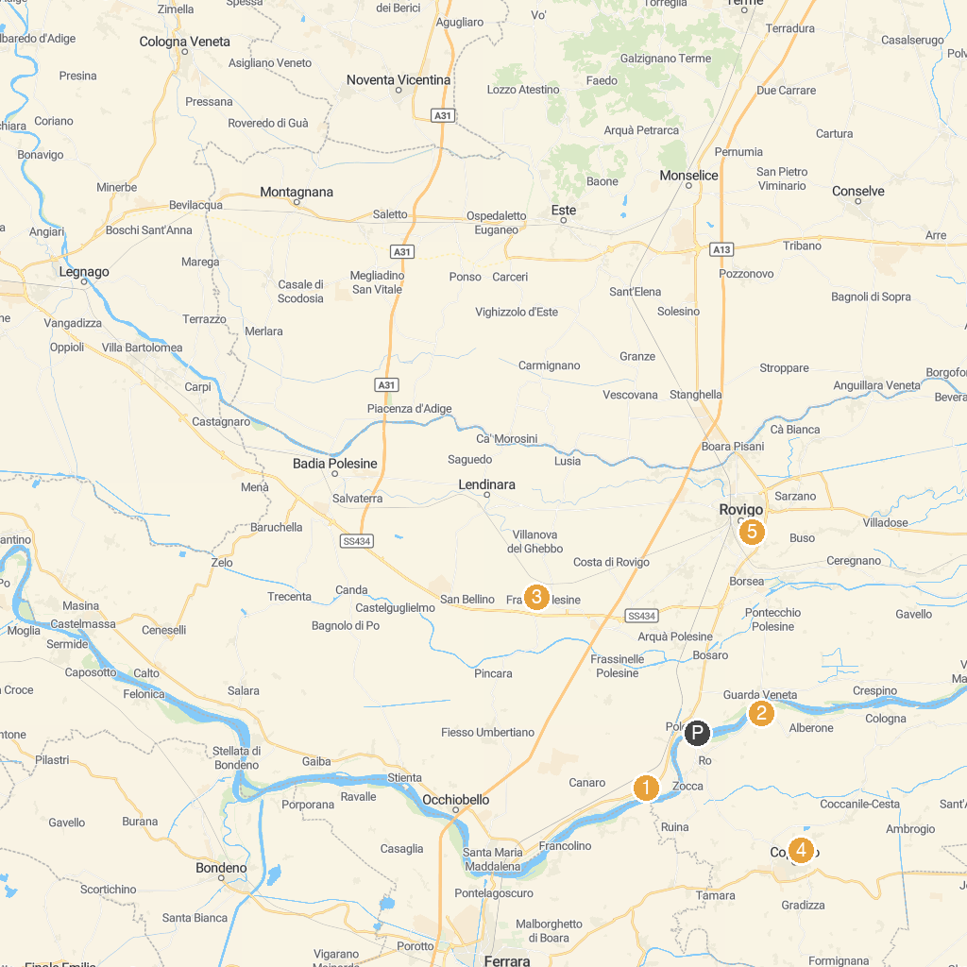
MAP KEY
1. MUVIG: MUseo VIrtuale del Garofalo | 4. Roncale Palace
2. Festa della Salama da Taglio | 5. Museo di Storia La Tratta
3. Museo Archeologico Nazionale di Fratta Polesine | 6. Museum of the Great Rivers
P. Cruise port / terminal
Map © MapTiler © OpenStreetMap contributors · cruiseports.org

