Pohang, North Gyeongsang, South Korea
South Korea's 'City of Steel and Light' has reinvented itself as a coastal destination — walk a futuristic steel art installation over the ocean, hunt for the bronze hand at the easternmost tip of the peninsula, and feast on the coldest, spiciest raw-fish soup you've ever had.
⚓ Pier (Yeongilman Port) · 🚌 Shuttle to city required · 🕒 Typical call: 8–10 hrs · 💵 South Korean Won (KRW) · 🗣️ Korean
✍️ MY DAY IN PORT (FILL IN)
Ship / Date
In port | arrive ______ · all aboard ______
Booked excursion
Notes / meeting point
GETTING ASHORE
- Docking: Pier at Yeongilman Port — new International Passenger Terminal (2024); no walking out; shuttle or taxi required
- Walk to center: Not walkable — port is 15 km from Yeongildae Beach; 20–25 min by shuttle or taxi
- Best For: Unique art installations, K-drama fans, seafood lovers, coastal walks
- Don't Miss: Space Walk at Hwanho Park — a free, walk-on steel art installation with 360° ocean views
GETTING AROUND
- 🚕 Taxi: ₩3,300 base + ₩600/km (~₩11,000 to city center) — Metered taxis are readily available at the terminal. The ride to Pohang Station or city center (approx. 13 km) costs aro
- 📱 Rideshare: ✅ Kakao T, Uber
- 🚌 Hop-on hop-off: ✅
TOP THINGS TO DO
- Space Walk at Hwanho Park — A massive walk-on steel art installation resembling a futuristic roller coaster — you literally walk its curving ramps high above…
- Homigot Sunrise Square — Hands of Harmony — South Korea's most emblematic sunrise spot: a giant bronze hand rises from the ocean at the peninsula's easternmost tip — the…
- Guryongpo Japanese Colonial Street — A preserved street of early-20th-century Japanese houses, now famous worldwide as the filming location for Netflix K-drama 'When…
- Igari Anchor Observatory — A skywalk shaped like a ship's anchor extends 102 meters out over the ocean (10 m high), surrounded by red pine trees.
- Jukdo Market Sashimi Alley — One of the largest traditional markets in eastern Korea.
BEST WALKS
- Yeongildae Beach Boardwalk: 1.5 km · Easy · 30–40 min — After the shuttle drops you at Yeongildae Beach, stroll the full length of the beachfront boardwalk…
- Guryongpo Colonial Street to Harbor: 1 km · Easy · 20–30 min — Walk the preserved Japanese colonial street from its inland entrance down to the Guryongpo fishing…
WEATHER · DAYLIGHT · MONEY
Month | High °F | Low °F | Rainy days
May | 75 | 57 | 7
Jul | 84 | 73 | 15
Sep | 76 | 66 | 13
Daylight: May 5:17AM–7:21PM · Jul 5:17AM–7:39PM · Sep 6:05AM–6:29PM
cruiseports.org/pohang · Confirm terminal & all-aboard time with your ship

Pohang, North Gyeongsang, South Korea — Port Map
Red = walkable sights · Amber = excursions farther out · P = cruise terminal
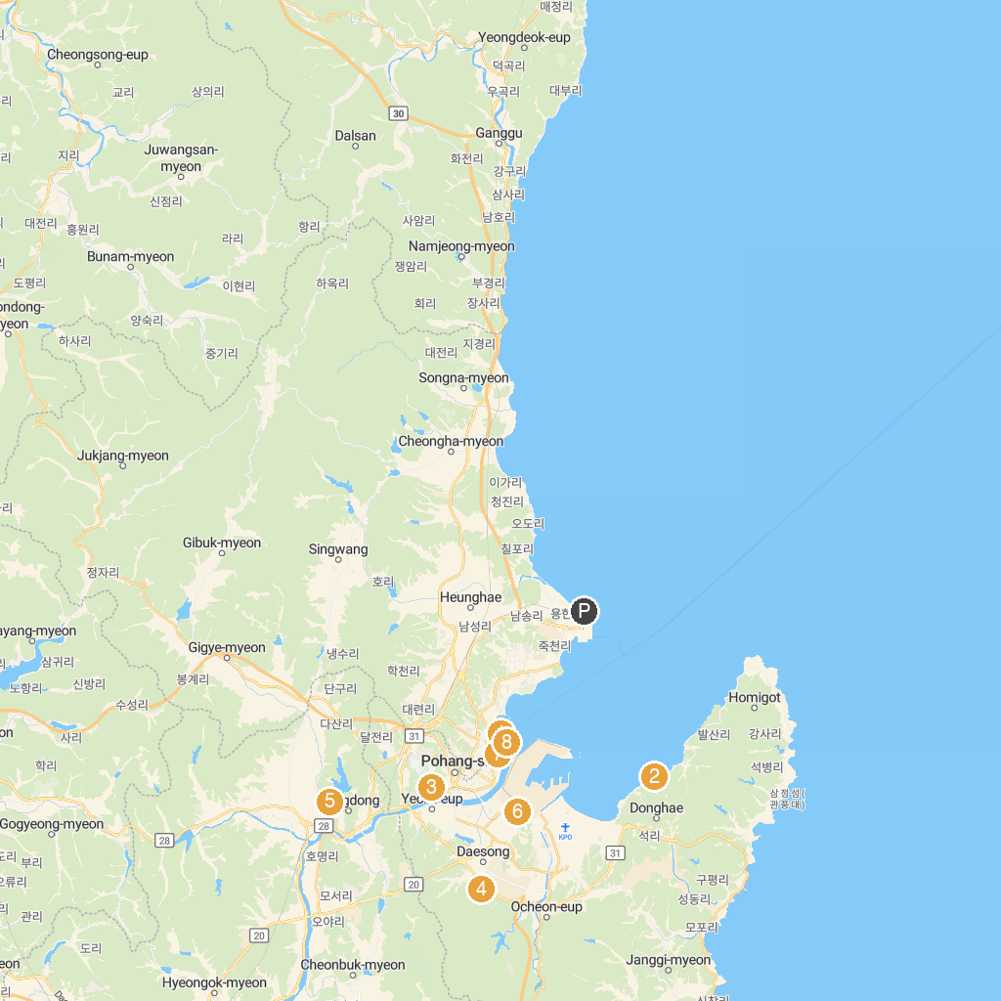
MAP KEY
1. 송도송림테마거리 | 5. Yangdong Folk Village
2. 하선대 | 6. The Posco Museum
3. 로보라이프뮤지엄 | 7. 포항운하
4. 영일만온천 | 8. 송도해변가
P. Cruise port / terminal
Map © MapTiler © OpenStreetMap contributors · cruiseports.org

