Plymouth, Massachusetts, USA
The Pilgrims landed here in 1620, and Plymouth hasn't stopped telling that story since. Step off the ship and walk straight into four centuries of American history — Plymouth Rock, a full-scale Mayflower replica, and some seriously good clam chowder are all within minutes of the pier.
⚓ Pier (American Cruise Lines small ships) · 🕒 Typical call: 6-8 hrs · 💵 USD · 🗣️ English · 🦞 Famous for seafood & cranberries
✍️ MY DAY IN PORT (FILL IN)
Ship / Date
In port | arrive ______ · all aboard ______
Booked excursion
Notes / meeting point
GETTING ASHORE
- Docking: Pier at Plymouth Town Wharf / State Pier; American Cruise Lines ships dock directly
- Walk to center: Immediate — Plymouth Rock is 2 min from the pier
- Best For: American Colonial history, seafood, walkable waterfront
- Don't Miss: Mayflower II replica and Plimoth Patuxet living history museum
GETTING AROUND
- 🚕 Taxi: $15–$25 — Local taxis are available at the wharf. Short trips within downtown are inexpensive; rates are metered and similar to Ub
- 📱 Rideshare: ✅ Uber, Lyft
- 🚌 Hop-on hop-off: ✅ America's Hometown Shuttle
TOP THINGS TO DO
- Mayflower II & Plymouth Rock — A full-scale reproduction of the original Pilgrim ship is docked steps from your pier.
- Plimoth Patuxet Living History Museum — Three miles south of the harbor, this world-class museum brings 1620s Plymouth to life with a recreated English Village with…
- Pilgrim Hall Museum — Opened in 1824, the oldest continuously operating public museum in the US houses actual Pilgrim artifacts — William Bradford's…
- Plymouth Long Beach Walk — A 3-mile barrier beach about 2.5 miles from the pier, Plymouth Long Beach is perfect for a breezy Atlantic stroll and birdwatching.
- Waterfront Seafood Crawl — The harbor waterfront is lined with seafood restaurants.
BEST WALKS
- Pilgrim History Loop: 1.5 miles · 45-60 min · Flat · Free — From the pier, walk south to Plymouth Rock and Mayflower II, then cross Water Street up Cole's Hill…
- National Monument to the Forefathers: 1 mile each way · 30-40 min · Gentle uphill · Free — Walk inland from the waterfront to see the massive 81-foot solid-granite monument honoring the…
WEATHER · DAYLIGHT · MONEY
Month | High °F | Low °F | Rainy days
May | 70 | 51 | 11
Jul | 84 | 66 | 9
Sep | 74 | 57 | 9
Daylight: May 5:25AM–7:55PM · Jul 5:20AM–8:15PM · Sep 6:20AM–7:00PM
cruiseports.org/plymouth-ma · Confirm terminal & all-aboard time with your ship

Plymouth, Massachusetts, USA — Port Map
Red = walkable sights · Amber = excursions farther out · P = cruise terminal
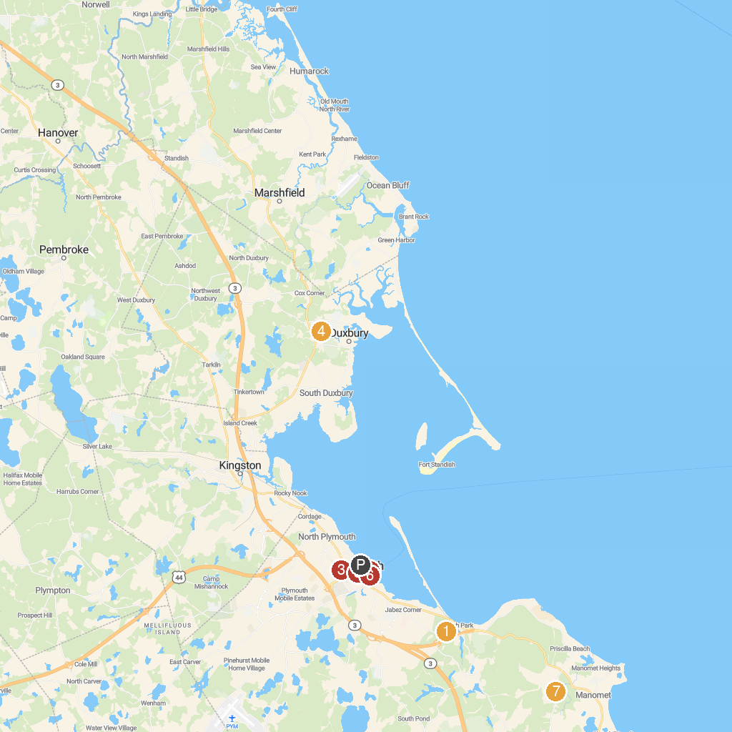
MAP KEY
1. Plimoth Patuxet Museums | 5. Pilgrim Hall Museum
2. Mayflower II | 6. Plymouth Rock
3. National Monument to the Forefathers | 7. Mass Audubon Tidmarsh Wildlife Sanctuary
4. Alden House Historic Site
P. Cruise port / terminal
Map © MapTiler © OpenStreetMap contributors · cruiseports.org

