Playas del Coco, Guanacaste, Costa Rica
A real Costa Rican beach town on the Gulf of Papagayo—dark volcanic sand, pura vida sodas, and some of the best diving in Central America just offshore.
⚓ Tender port (no pier for large ships) · 🕒 Typical call: 7-9 hrs · 💵 USD widely accepted / Costa Rican Colón · 🗣️ Spanish (English spoken in tourist areas) · 🌊 Diving, snorkeling & catamaran tours
✍️ MY DAY IN PORT (FILL IN)
Ship / Date
In port | arrive ______ · all aboard ______
Booked excursion
Notes / meeting point
GETTING ASHORE
- Docking: Tender — ships anchor in Bahía de El Coco; tenders land at the town pier or beach
- Walk to center: Immediate — town starts the moment you step ashore
- Best For: Scuba diving, catamaran day trips, zip-lining, authentic local food
- Don't Miss: Fresh ceviche at a beachfront soda and a boat trip to the Catalina Islands
GETTING AROUND
- 🚕 Taxi: Under $2 in town; $9–$17 to nearby beaches — Official red taxis wait near the beach park. Rides within town cost under $2; trips to nearby Playa Hermosa or Playa Oco
TOP THINGS TO DO
- Scuba Diving — Catalina Islands & Bat Islands — Nutrient-rich cold upwellings in the Gulf of Papagayo attract manta rays, white-tip reef sharks, sea turtles, and massive fish…
- Catamaran Snorkel & Sail Tour — Charter a catamaran around the Gulf of Papagayo for snorkeling at pristine coves, open bar, fresh fruit, and a sunset return.
- Diamante Eco Adventure Park — About 25 minutes from Coco, Diamante features Costa Rica's longest ocean-view zip-line (including a Superman line), an animal…
- Rincón de la Vieja Day Trip — Drive 90 minutes to this active volcano national park with bubbling mud pots, sulfur vents, and dramatic waterfalls.
- ATV & Canopy Combo — Local operators run ATV tours through dry-forest dirt trails above Coco, reaching hilltop viewpoints overlooking the bay.
BEST WALKS
- Boardwalk & Town Stroll: 30–45 min · Flat · No shade mid-day — From the tender landing, walk the Amor de Temporada boardwalk south along the bay — benches, palms…
- North Beach & Estuary Walk: 20–30 min · Flat · Wildlife likely — Head north along the beach toward the estuary at the end of the bay.
WEATHER · DAYLIGHT · MONEY
Month | High °F | Low °F | Rainy days
May | 88 | 77 | 21
Jul | 87 | 76 | 19
Sep | 84 | 75 | 28
Daylight: May 5:21AM–5:57PM · Jul 5:28AM–6:09PM · Sep 5:32AM–5:42PM
cruiseports.org/playas-del-coco · Confirm terminal & all-aboard time with your ship

Playas del Coco, Guanacaste, Costa Rica — Port Map
Red = walkable sights · Amber = excursions farther out · P = cruise terminal
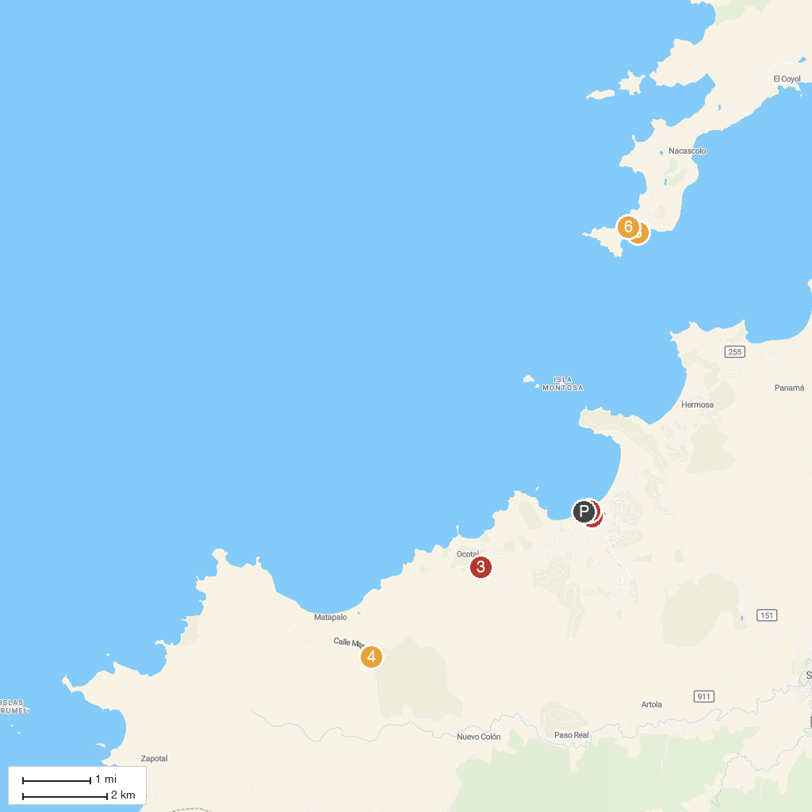
MAP KEY
1. Summer Salt Dive Center | 4. Diamante Eco Adventure Park
2. Papagayo SportFishing | 5. Blanca Beach
3. The Monkey Farm | 6. Virador Beach
P. Cruise port / terminal
Map © MapTiler © OpenStreetMap contributors · cruiseports.org

