Playa Flamingo, Guanacaste, Costa Rica
A secluded Pacific gem where howler monkeys echo over turquoise water and every shoreside hour channels the Pura Vida spirit. Flamingo's arc of white sand, vibrant Marina Flamingo, and easy access to volcanoes and national parks make it a favourite of small-ship luxury lines.
⚓ Tender (anchor off beach) · 🕒 Typical call: 7-9 hrs · 💵 USD & Costa Rican Colón accepted · 🗣️ Spanish (English widely spoken in tourist areas)
✍️ MY DAY IN PORT (FILL IN)
Ship / Date
In port | arrive ______ · all aboard ______
Booked excursion
Notes / meeting point
GETTING ASHORE
- Docking: Tender — ships anchor offshore; tenders and beach landings to Marina Flamingo or Playa Flamingo beach
- Walk to Centre: Steps from tender landing to beach bars, restaurants, and Marina Flamingo village
- Best For: Snorkeling, catamaran sailing, sportfishing, beach relaxation
- Don't Miss: Catamaran tour to Catalinas Islands for manta rays and sea turtles
GETTING AROUND
- 🚕 Taxi: $9–$60 USD — Red taxis with a yellow triangle are the main transport option. Short rides to Brasilito run $9–$16; Tamarindo is roughl
TOP THINGS TO DO
- Catamaran to Catalinas Islands — Sail to the Islas Catalinas — one of Costa Rica's best snorkel spots — where manta rays, sea turtles, and white-tip reef sharks…
- Sportfishing Charter — Playa Flamingo is one of Central America's top sportfishing spots.
- Rincón de la Vieja Volcano & Hot Springs — A full-day trip inland to Rincón de la Vieja National Park delivers fumaroles, mud pots, jungle zip-lines, and volcanic hot…
- Playa Conchal Day — Head ~5 km south (about 25 min via Potrero and Brasilito) to Playa Conchal, a beach made of crushed white shells with calm…
- Las Baulas Marine National Park — Las Baulas protects one of the few nesting sites for giant leatherback sea turtles in the Eastern Pacific.
BEST WALKS
- Flamingo Beach & Marina Village Stroll: 1.5 km · Easy · 30–40 min — Walk the full length of Playa Flamingo's white-sand beach from the tender landing to the north end…
- Flamingo to Playa Potrero: 2 km one-way · Easy · 45 min — A flat road walk north from Flamingo village to the quieter Playa Potrero, a long dark-sand beach…
WEATHER · DAYLIGHT · MONEY
Month | High °F | Low °F | Rainy days
May | 88 | 78 | 24
Jul | 87 | 77 | 20
Sep | 85 | 76 | 29
Daylight: May 5:21AM–5:57PM · Jul 5:29AM–6:09PM · Sep 5:33AM–5:43PM
cruiseports.org/playa-flamingo · Confirm terminal & all-aboard time with your ship

Playa Flamingo, Guanacaste, Costa Rica — Port Map
Red = walkable sights · Amber = excursions farther out · P = cruise terminal
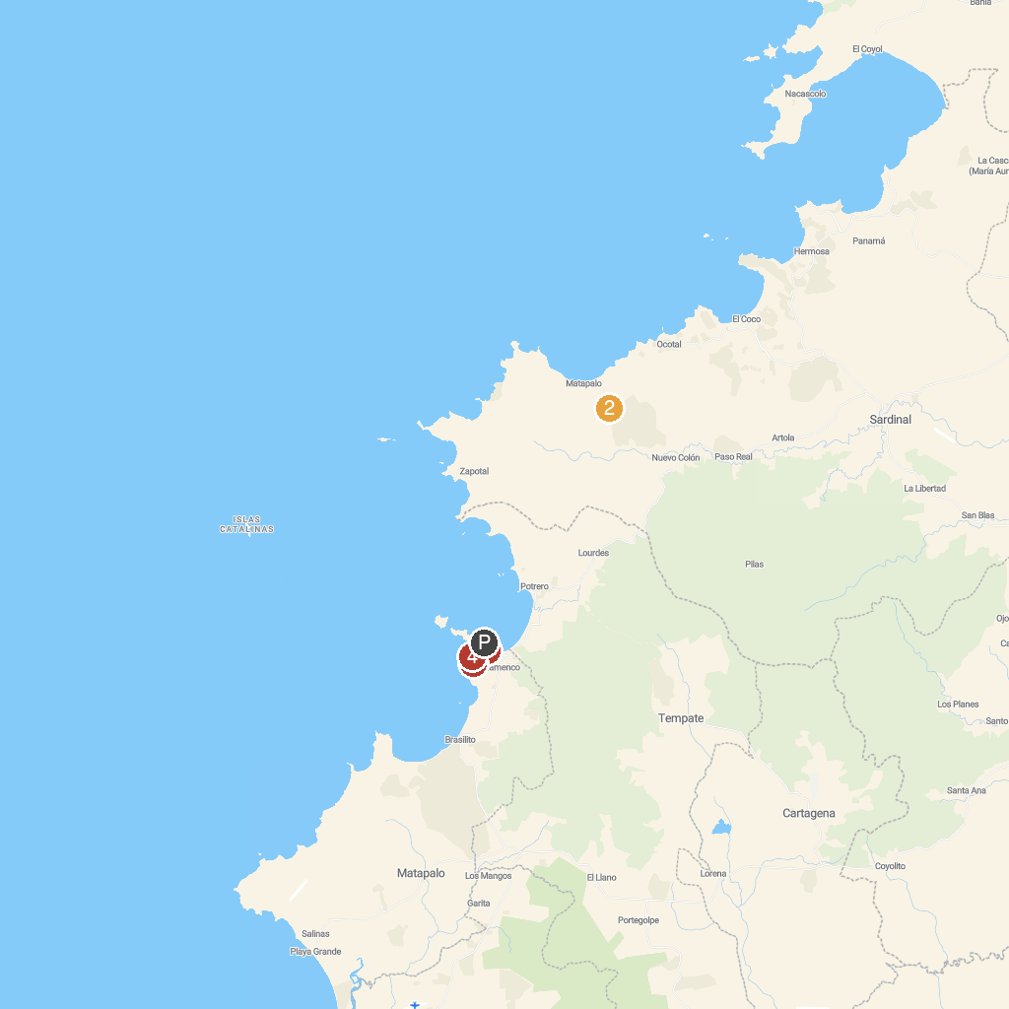
MAP KEY
1. Serendipity Charters | 4. Flamingo, Costa Rica
2. Diamante Eco Adventure Park | 5. Playa Flamingo Guanacaste
3. The Monkey Farm
P. Cruise port / terminal
Map © MapTiler © OpenStreetMap contributors · cruiseports.org

