Playa del Carmen, Quintana Roo, Mexico
Where the jungle meets the Caribbean — Playa del Carmen blends European café culture with Mayan heritage, cenote swims, and one of the most vibrant pedestrian streets in the Americas.
⚓ Mostly via Cozumel ferry or Calica pier · 🕒 Typical call: 8-10 hrs · 💵 Mexican Pesos (USD widely accepted) · 🗣️ Spanish
✍️ MY DAY IN PORT (FILL IN)
Ship / Date
In port | arrive ______ · all aboard ______
Booked excursion
Notes / meeting point
GETTING ASHORE
- Docking: Most ships dock in Cozumel; passengers take a 45-min ferry to PDC. Some ships dock at Calica pier 8 mi south.
- Walk to center: Ferry pier drops you at Parque Fundadores — Quinta Avenida is 2 min on foot. Calica requires taxi (~$15 USD).
- Best For: Beach clubs, cenote swimming, Tulum day trips, street food, shopping
- Don't Miss: Voladores de Papantla ritual at Parque Fundadores and tacos al pastor at El Fogón
GETTING AROUND
- 🚕 Taxi: $10–$15 USD per cab — Official federal taxis wait at Puerto Calica pier (about 8 miles from 5th Avenue). Negotiate fare before boarding; payin
- 📱 Rideshare: ✅ Uber, DiDi, InDrive
TOP THINGS TO DO
- Cenote Swimming (Azul, Cristalino & Eden) — Three stunning freshwater sinkholes clustered 20 minutes south of PDC via Colectivo or taxi.
- Tulum Ruins Day Trip — Perched on a cliff overlooking the turquoise Caribbean, Tulum is the most dramatically sited Mayan ruin in Mexico.
- Xcaret or Xplor Eco-Park — Xcaret blends Mayan cultural shows, wildlife, and underground river snorkeling.
- Rio Secreto Underground Cave — A semi-submerged cave system of stalactites and stalagmites just 15 minutes from PDC.
- Mamitas or Lido Beach Club — Pay a cover (usually redeemable against food/drinks) and claim a lounger on the Caribbean.
BEST WALKS
- Parque Fundadores to Mamitas Beach: 1.5 miles • ~30 min • Easy — Start at the Portal Maya sculpture in Parque Fundadores, turn right onto Quinta Avenida, and walk…
- Ferry Pier to Playacar Beach: 0.3 miles • ~5 min • Easy — Walk south from the ferry pier along the beach path past Señor Frog's into the Playacar residential…
WEATHER · DAYLIGHT · MONEY
Month | High °F | Low °F | Rainy days
May | 85 | 77 | 16
Jul | 87 | 79 | 16
Sep | 86 | 78 | 23
Daylight: May 6:11AM–7:18PM · Jul 6:16AM–7:31PM · Sep 6:35AM–6:50PM
cruiseports.org/playa-del-carmen · Confirm terminal & all-aboard time with your ship

Playa del Carmen, Quintana Roo, Mexico — Port Map
Red = walkable sights · Amber = excursions farther out · P = cruise terminal
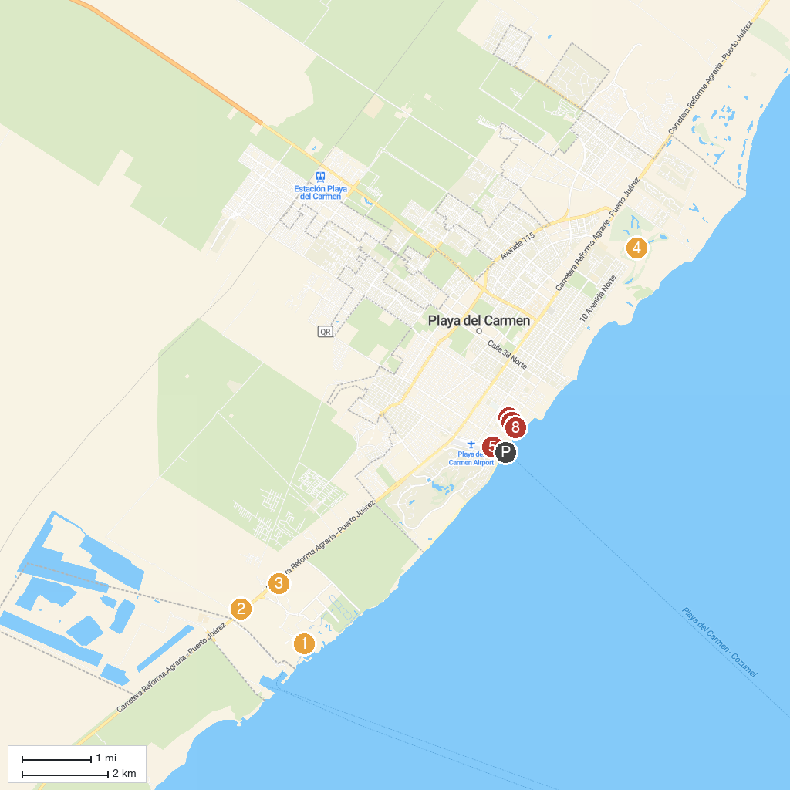
MAP KEY
1. Xcaret Park | 5. Skydive Playa
2. Río Secreto | 6. Grand Riviera Casino
3. Xplor Park | 7. 3D Museum of Wonders
4. Gran Coyote Golf | 8. Museo Frida Kahlo Playa Del Carmen
P. Cruise port / terminal
Map © MapTiler © OpenStreetMap contributors · cruiseports.org

