Pittsburgh, Pennsylvania, USA
Where three rivers converge beneath a skyline of bridges, Pittsburgh greets river cruisers with one of North America's most dramatic arrivals — the Steel City reinvented as a vibrant hub of culture, food, and green hills.
⚓ Docked (no tender) · 🕒 Typical call: 8–10 hrs · 💵 USD · 🗣️ English · 🌉 446 bridges
✍️ MY DAY IN PORT (FILL IN)
Ship / Date
In port | arrive ______ · all aboard ______
Booked excursion
Notes / meeting point
GETTING ASHORE
- Docking: North Shore Riverfront (Allegheny R.) or Station Square (Monongahela R.)
- Walk to Center: ~20 min to Point State Park via pedestrian bridge; free T light rail cuts it to 5 min
- Best For: History, arts, food, iconic skyline views from Mt. Washington
- Don't Miss: Duquesne Incline ride + Mt. Washington overlook, Primanti Bros. sandwich
GETTING AROUND
- 🚕 Taxi: $8–$12 — Taxis are available at Station Square for the short trip to downtown. Fares are metered and the ride typically takes 5–1
- 📱 Rideshare: ✅ Uber, Lyft
- 🚌 Hop-on hop-off: ✅
TOP THINGS TO DO
- Duquesne Incline & Mt. Washington Overlook — Board this 1877 wooden cable car for the ride up the side of Mt.
- The Andy Warhol Museum — Seven floors dedicated to Pittsburgh's most famous son — the largest single-artist museum in North America.
- Senator John Heinz History Center — Smithsonian-affiliated mega-museum tracing Pittsburgh's arc from the French & Indian War through the steel boom to the invention…
- Point State Park & the Three Rivers Fountain — Walk the tip of the 'Golden Triangle' where the Allegheny and Monongahela merge to form the Ohio River.
- Strip District Food Walk — Pittsburgh's historic market district, lined with Italian delis, Polish pierogies, coffee roasters, and street food vendors.
BEST WALKS
- North Shore Riverfront to Point State Park: ~1.5 miles | Easy | 30–40 min — Follow the Three Rivers Heritage Trail east along the Allegheny, cross the Fort Duquesne Bridge…
- Andy Warhol Museum to Randyland Loop: ~1.2 miles | Moderate | 25 min — From the Andy Warhol Museum on Sandusky Street, walk north through the Allegheny neighborhood to…
WEATHER · DAYLIGHT · MONEY
Month | High °F | Low °F | Rainy days
May | 71 | 52 | 15
Jul | 83 | 66 | 15
Sep | 77 | 59 | 10
Daylight: May 6:03AM–8:29PM · Jul 6:03AM–8:48PM · Sep 7:01AM–7:28PM
cruiseports.org/pittsburgh-pa · Confirm terminal & all-aboard time with your ship

Pittsburgh, Pennsylvania, USA — Port Map
Red = walkable sights · Amber = excursions farther out · P = cruise terminal
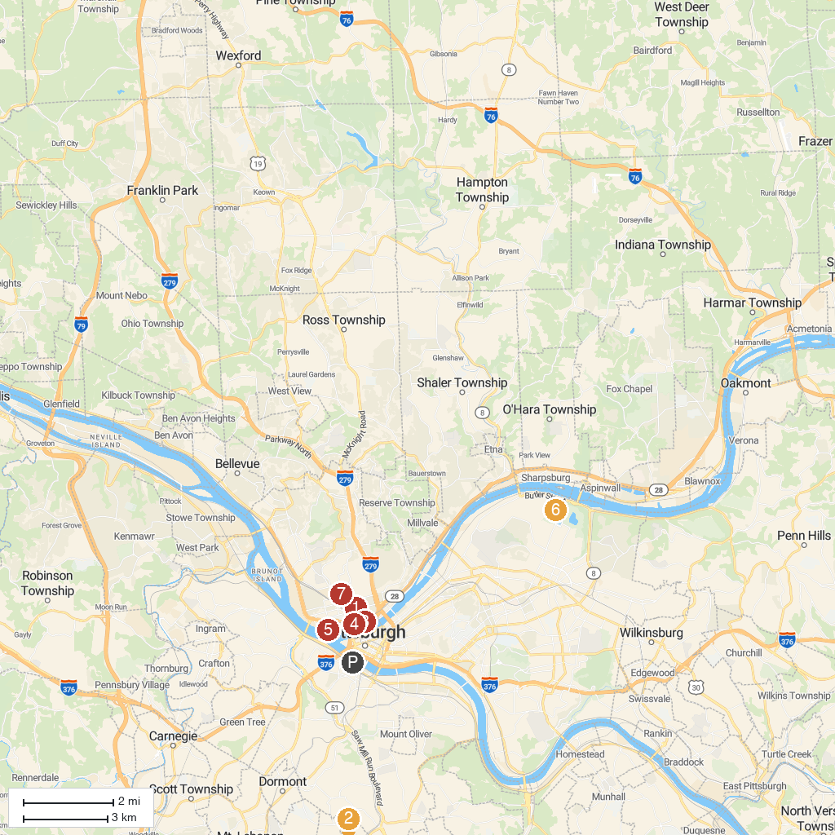
MAP KEY
1. Children's Museum of Pittsburgh | 5. Kamin Science Center
2. Hundred Acres Manor Haunted House | 6. Pittsburgh Zoo & Aquarium
3. The Andy Warhol Museum | 7. Mattress Factory Contemporary Art Museum
4. PNC Park | 8. Kennywood
P. Cruise port / terminal
Map © MapTiler © OpenStreetMap contributors · cruiseports.org

