Pisco (Paracas), Peru
Gateway to Peru's desert coast — where the Humboldt Current delivers wildlife-packed islands, crimson beaches, Inca ruins, and the birthplace of South America's most famous spirit.
⚓ Tender to Paracas dock (Puerto General San Martín) · 🕒 Typical call: 8–10 hrs · 💵 Peruvian Sol (PEN) · some USD accepted · 🗣️ Spanish · limited English outside tours
✍️ MY DAY IN PORT (FILL IN)
Ship / Date
In port | arrive ______ · all aboard ______
Booked excursion
Notes / meeting point
GETTING ASHORE
- Docking: Tender to Paracas / Puerto General San Martín
- To Paracas village: ~5-min tender + short walk
- Best For: Wildlife · Nature · History
- Don't Miss: Ballestas Islands boat tour
GETTING AROUND
- 🚕 Taxi: ~$80 USD one-way — Private taxis are available at the Puerto San Martín pier to transfer passengers to the resort town of Paracas (~15 km,
TOP THINGS TO DO
- Ballestas Islands Speedboat Tour — Zip out to the 'poor man's Galápagos' — rocky islands teeming with Humboldt penguins, South American sea lions, Peruvian boobies…
- Paracas National Reserve — Explore the only protected marine-desert ecosystem in South America.
- Tambo Colorado Inca Administrative Center — Head inland to one of the best-preserved Inca sites on Peru's coast.
- Pisco Distillery Tour & Tasting — Pisco — the grape brandy that gives this port its name — is Peru's national spirit and a source of fierce pride.
BEST WALKS
- Paracas Malecón & Waterfront: 1–2 km · Flat · 30–45 min — Stroll the palm-lined waterfront promenade from the tender pier through the heart of Paracas village.
- El Chaco Beach & Paracas Bay: 2 km · Easy · 45 min — Walk south from the pier along El Chaco beach, a calm arc of sand sheltered by the Paracas Peninsula.
- Julio C. Tello Site Museum: Short walk from pier · 1–1.5 hrs inside — The Paracas culture (800 BCE–100 CE) produced some of the finest textiles in the ancient world, and…
WEATHER · DAYLIGHT · MONEY
Month | High °F | Low °F | Rainy days
May | 75 | 62 | 0
Jul | 70 | 57 | 0
Sep | 71 | 57 | 0
Daylight: May 6:17AM–5:45PM · Jul 6:29AM–5:52PM · Sep 5:59AM–6:00PM
cruiseports.org/pisco · Confirm terminal & all-aboard time with your ship

Pisco (Paracas), Peru — Port Map
Red = walkable sights · Amber = excursions farther out · P = cruise terminal
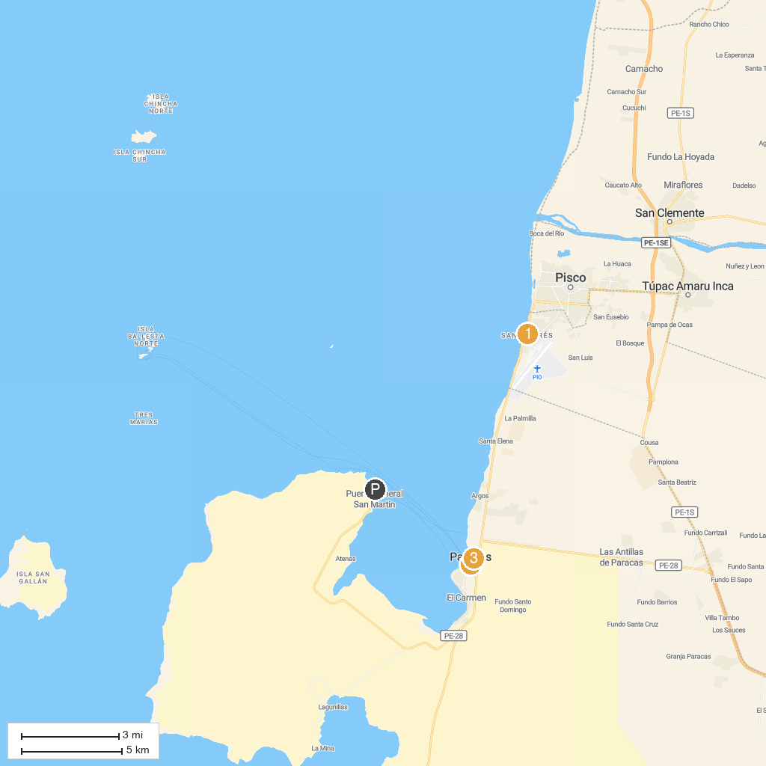
MAP KEY
1. Museo Marino San Andrés | 3. Aventura en Paracas
2. APROTUR Pisco & Adventure´s | 4. El Chaco Paracas
P. Cruise port / terminal
Map © MapTiler © OpenStreetMap contributors · cruiseports.org

