Piran, Slovenian Istria, Slovenia
A miniature Venice perched on a narrow Adriatic peninsula, Piran's medieval walls, Venetian Gothic palaces, and marble-paved Tartini Square are all within a few minutes' walk of the tender dock.
⚓ Tender (small ships may dock) · 🕒 Typical call: 6-8 hrs · 💶 Euro (€) · 🗣️ Slovenian & Italian
✍️ MY DAY IN PORT (FILL IN)
Ship / Date
In port | arrive ______ · all aboard ______
Booked excursion
Notes / meeting point
GETTING ASHORE
- Docking: Tender (large ships); small luxury ships dock at Piran pier
- Walk to center: 2 min flat to Tartini Square
- Best For: History, architecture, Venetian atmosphere, seafood
- Don't Miss: Bell Tower climb for 360° views over the peninsula
GETTING AROUND
- 🚕 Taxi: €7–€15 — Taxis are available at stands and by phone; a short ride within the Piran area runs roughly €7. Fixed-rate transfers to
- 📱 Rideshare: ❌ not available
- 🚌 Hop-on hop-off: ✅
TOP THINGS TO DO
- St. George's Bell Tower Climb — Climb 146 wooden steps up Piran's Venetian campanile for a 360° panorama of the orange-roofed peninsula, the Adriatic, and three…
- Medieval Town Walls — Walk the 15th-century fortifications at the top of the hill for the classic postcard shot of Piran's peninsula jutting into the…
- Sečovlje Salina Nature Park — Slovenia's salt pans have been harvested using a 700-year-old manual method.
- Postojna Cave & Predjama Castle — Slovenia's premier inland attraction: a vast karst cave system with an underground train, paired with a fairy-tale castle built…
- Lipica Stud Farm — The birthplace of the famous Lipizzaner horses, just 40 minutes from port.
BEST WALKS
- Old Town Loop: Harbour to Bell Tower: 1.5 km · 45-60 min · Easy/Moderate (uphill finish) — From the tender pier, stroll along the waterfront to Tartini Square.
- Peninsula Tip Walk to Punta Lighthouse: 1.2 km one-way · 20-30 min · Easy (flat) — Head to the very tip of the Piran peninsula along the seafront promenade.
- Coastal Path to Fiesa Beach: 1.5 km one-way · 20-25 min · Easy (paved path) — Follow the paved coastal footpath behind St.
WEATHER · DAYLIGHT · MONEY
Month | High °F | Low °F | Rainy days
May | 68 | 57 | 14
Jul | 82 | 70 | 9
Sep | 74 | 63 | 10
Daylight: May 5:35AM–8:29PM · Jul 5:31AM–8:51PM · Sep 6:44AM–7:16PM
cruiseports.org/piran · Confirm terminal & all-aboard time with your ship

Piran, Slovenian Istria, Slovenia — Port Map
Red = walkable sights · Amber = excursions farther out · P = cruise terminal
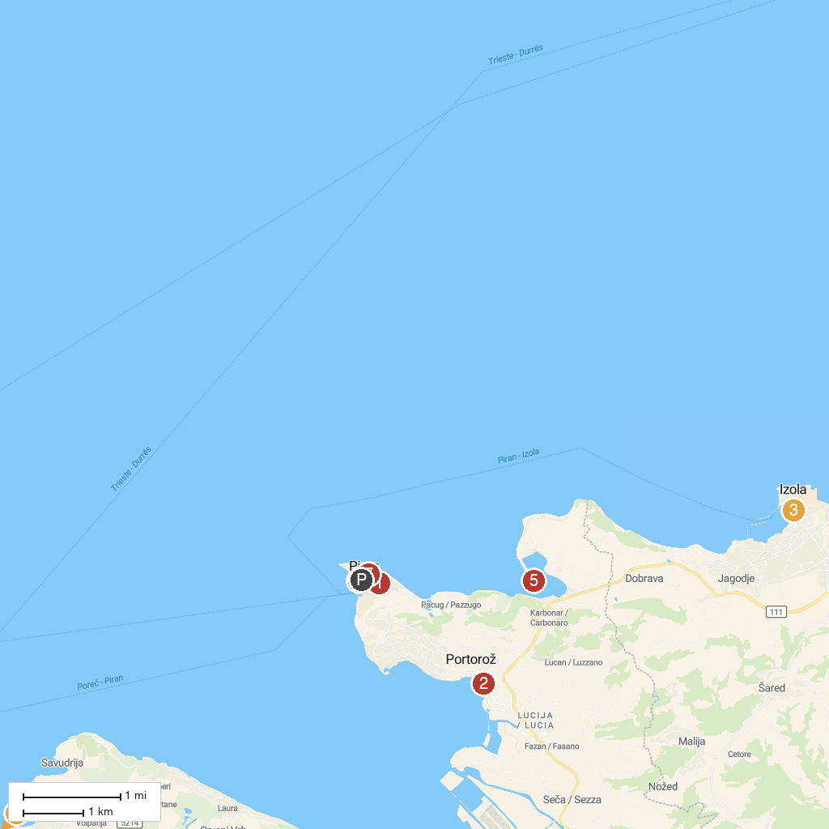
MAP KEY
1. Walls of Piran | 5. Javni zavod krajinski park Strunjan
2. Portorož Beach Central | 6. Akvarij Piran
3. Muzej Izolana - hiša morja | 7. Mediadom Pyrhani
4. Savudrija Lighthouse
P. Cruise port / terminal
Map © MapTiler © OpenStreetMap contributors · cruiseports.org

