Piombino, Tuscany, Italy
Perched on a rocky Tuscan promontory opposite Elba, Piombino hides a walled medieval quarter, Etruscan heritage, and an impossibly wide sea view — all without the crowds of bigger Italian ports.
⚓ Pier (docked) · 🕒 Typical call: 7-9 hrs · 💶 Euro · 🗣️ Italian · 🏛️ History & beaches
✍️ MY DAY IN PORT (FILL IN)
Ship / Date
In port | arrive ______ · all aboard ______
Booked excursion
Notes / meeting point
GETTING ASHORE
- Docking: Pier — all ships berth alongside; no tender required
- Walk to center: ~2 km / 25 min; shuttle usually provided
- Best For: Etruscan archaeology, sea views, quiet Tuscan streets
- Don't Miss: Piazza Bovio cliff terrace & Archaeological Park of Baratti
GETTING AROUND
- 🚕 Taxi: €8–€12 — Taxis are available at the port with a base fare of ~€4.30 plus ~€1.10/km. The 2 km ride to city center typically costs
TOP THINGS TO DO
- Archaeological Park of Baratti & Populonia — Walk among Etruscan tombs set directly on a dark-sand beach, then climb the acropolis of ancient Populonia for panoramic sea views.
- Day Trip to Elba Island — Ferries to Portoferraio depart from the terminal right beside your ship (1 hr crossing).
- Piombino Historic Center Walk — Stroll Corso Italia to the medieval castle (with its da Vinci-designed fortifications), visit the Archaeological Museum's…
- Golfo di Baratti Beach Day — A crescent of dark-iron sand (mineral-rich from ancient Etruscan smelting) framed by a thick pine forest.
- Tuscan Seafood Lunch in Town — Follow Corso Italia to the trattorias near Piazza Bovio for polpo alla Piombinese (braised octopus), cacciucco fish stew, and a…
BEST WALKS
- Torrione Gate to Piazza Bovio: ~1 km one way | 20 min | Easy, flat — Enter through the 13th-century Torrione defensive tower, walk Corso Italia past the castle and…
- Castle & Old Fishing Harbour Loop: ~1.5 km loop | 30-40 min | Easy — From Piazza Bovio, descend to the tiny Porticciolo di Marina fishing harbour tucked below the…
WEATHER · DAYLIGHT · MONEY
Month | High °F | Low °F | Rainy days
May | 69 | 59 | 10
Jul | 83 | 72 | 3
Sep | 77 | 67 | 8
Daylight: May 5:55AM–8:34PM · Jul 5:52AM–8:54PM · Sep 6:57AM–7:27PM
cruiseports.org/piombino · Confirm terminal & all-aboard time with your ship

Piombino, Tuscany, Italy — Port Map
Red = walkable sights · Amber = excursions farther out · P = cruise terminal
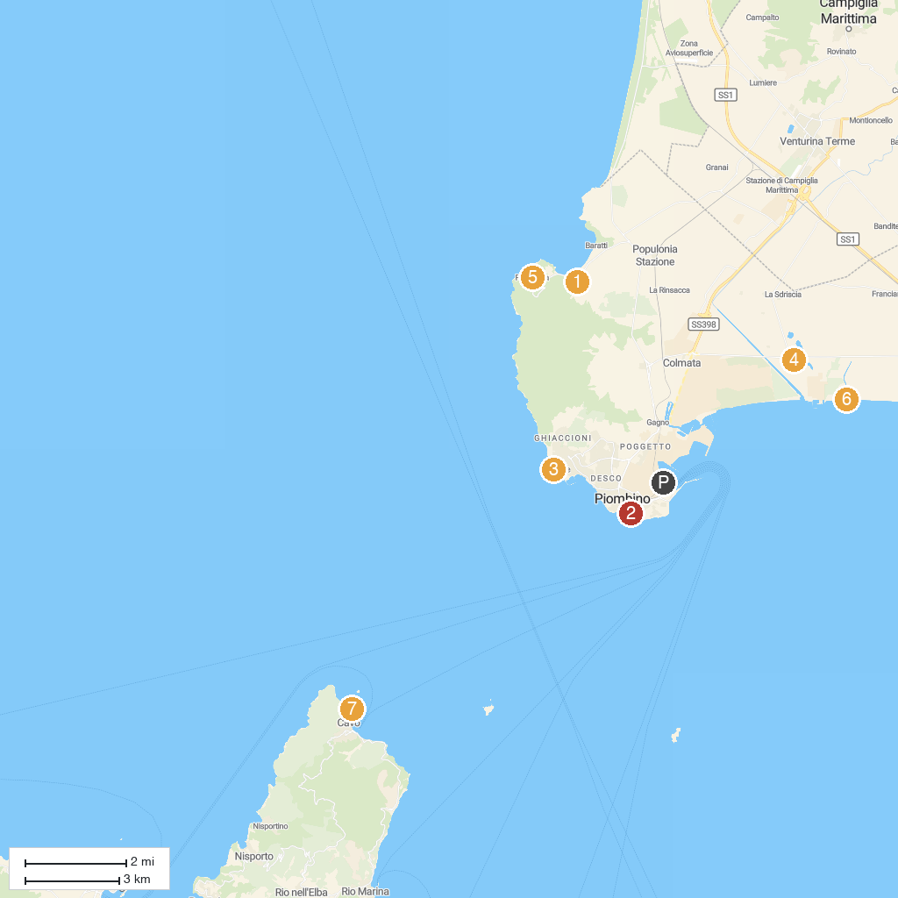
MAP KEY
1. Necropolis of Populonia | 5. Etruscan Museum of Populonia
2. Museo del Castello e delle Ceramiche Medievali | 6. Pasha Glam Dog Beach
3. Parco Punta Falcone | 7. Cala delle Alghe
4. Oasi WWF Padule Orti-Bottagone | 8. Parco Costiero di Rimigliano
P. Cruise port / terminal
Map © MapTiler © OpenStreetMap contributors · cruiseports.org

