Pinhão, Douro Valley, Portugal
Tucked into a bend of the Douro River, Pinhão is the UNESCO-listed valley's most evocative river stop — where centuries of Port wine tradition, terraced schist vineyards, and one of Europe's most beautiful train stations converge just steps from the dock.
⚓ Docked (riverside quay) · 🕒 Typical call: 6–8 hrs · 💶 Euro (EUR) · 🗣️ Portuguese · 🍷 Port wine country
✍️ MY DAY IN PORT (FILL IN)
Ship / Date
In port | arrive ______ · all aboard ______
Booked excursion
Notes / meeting point
GETTING ASHORE
- Docking: Docked at Cais de Pinhão — walk straight off the gangway
- Walk to center: 2–3 min to main street; 5 min to train station
- Best For: Wine estate visits, azulejo art, scenic valley walks
- Don't Miss: The azulejo-covered Pinhão train station — free and unmissable
GETTING AROUND
- 🚕 Taxi: €5–€15 (within village); €35–€45 to broader Douro Valley (28 km) — Taxis are available but scarce in this small village — arrange through your ship or accommodation well in advance. Short
TOP THINGS TO DO
- Pinhão Train Station Azulejos — The station's exterior walls are covered in 24 panels of blue-and-white azulejo tiles created in 1937 by artist J.
- Quinta do Bomfim Wine Tour & Tasting — The Symington Family's Dow's Port home is a 5-minute walk from the pier.
- Quinta das Carvalhas Mountain Viewpoint — Cross the iron bridge and visit one of the valley's largest estates.
- Rabelo Boat Cruise — Board a traditional wooden rabelo boat at the pier for a 1–2 hour cruise further upriver toward Romaneira, where road access ends…
- Quinta de la Rosa Riverside Lunch — A 15-minute flat walk west along the river road, this family-run estate clings to the cliffs above the Douro.
BEST WALKS
- Dock to Train Station & Quinta do Bomfim: 1.5 km · 20–30 min · Flat — Walk east along the waterfront promenade to the famous azulejo-tiled Pinhão Train Station, then…
- Iron Bridge & Quinta das Carvalhas: 1 km · 15 min · Flat to bridge — Cross the 1906 Ponte de Pinhão — designed by a disciple of Eiffel — for the best views back toward…
WEATHER · DAYLIGHT · MONEY
Month | High °F | Low °F | Rainy days
May | 75 | 54 | 8
Jul | 89 | 64 | 2
Sep | 81 | 61 | 6
Daylight: May 6:11AM–8:42PM · Jul 6:11AM–9:01PM · Sep 7:11AM–7:38PM
cruiseports.org/pinhao · Confirm terminal & all-aboard time with your ship

Pinhão, Douro Valley, Portugal — Port Map
Red = walkable sights · Amber = excursions farther out · P = cruise terminal
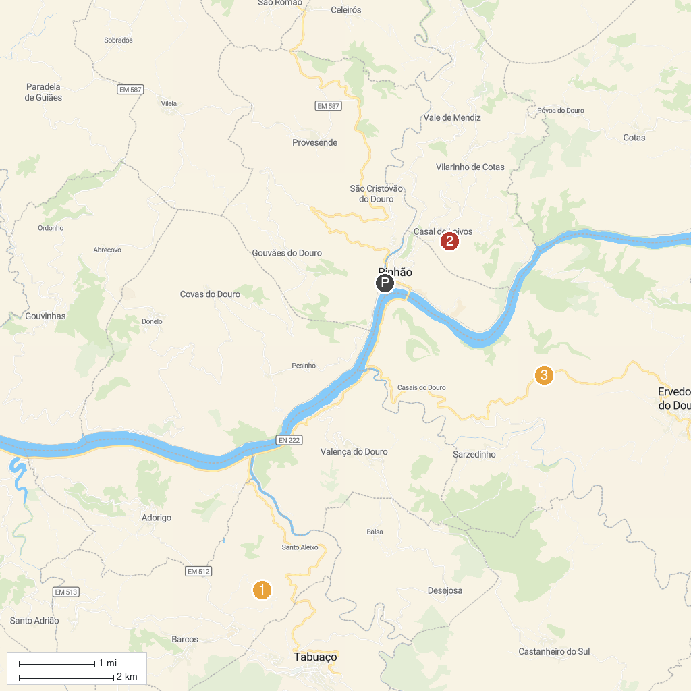
MAP KEY
1. Miradouro São Leonardo de Galafura | 3. Miradouro Casal De Loivos
2. Quinta do Monte Travesso | 4. Miradouro Coração do Douro
P. Cruise port / terminal
Map © MapTiler © OpenStreetMap contributors · cruiseports.org

