Pico Island, Azores, Portugal
Portugal's highest peak rises dramatically from the Atlantic here — a volcanic island of black basalt vineyards, sperm whales offshore, and an authenticity that mass tourism hasn't touched.
⚓ Tender (large ships) / Docked (small ships) · 🕒 Typical call: 6-8 hrs · 💵 Euro (€) · 🗣️ Portuguese · 🌋 Volcanic / UNESCO Heritage
✍️ MY DAY IN PORT (FILL IN)
Ship / Date
In port | arrive ______ · all aboard ______
Booked excursion
Notes / meeting point
GETTING ASHORE
- Docking: Madalena port: small/expedition ships dock; larger cruise ships tender ashore
- Walk to center: You step off directly into Madalena town — main square under 5 min
- Best For: Whale watching, volcanic scenery, UNESCO vineyard walks, local wine tasting
- Don't Miss: Whale-watch from Madalena harbour; walk the Criação Velha UNESCO vineyards
GETTING AROUND
- 🚕 Taxi: €19–€27 cross-island; €100–€150 for half/full-day tours (up to 4 passengers) — Taxis wait at the main stand in front of the Madalena dock. Agree on a price before departure; no meters for longer trip
- 📱 Rideshare: ❌ not available
TOP THINGS TO DO
- Whale & Dolphin Watching — Pico's waters host over 20 cetacean species year-round, including sperm whales and blue whales.
- Gruta das Torres Lava Tube — Portugal's longest lava tube stretches over 5 km underground.
- UNESCO Vineyard Landscape & Wine Tasting — The Criação Velha vineyard is a UNESCO World Heritage Site — thousands of black basalt stone corrals (currais) sheltering vines…
- Museu dos Baleeiros (Whalers' Museum) — Housed in 19th-century boathouses in Lajes do Pico, this museum tells the story of open-boat sperm whale hunting — which…
- Volcanic Landscapes & Natural Swimming Pools — Pico has no sandy beaches, but its natural lava-rock pools (piscinas naturais) are stunning.
BEST WALKS
- Madalena Waterfront & Town: 30-45 min · Flat · Free — A gentle stroll from the port along the waterfront, past the twin-towered Igreja de Santa Maria…
- Criação Velha UNESCO Vineyard Trail: 2-3 hrs · Easy · Free — Walk or taxi 2-3 km south of Madalena to the Criação Velha trail.
WEATHER · DAYLIGHT · MONEY
Month | High °F | Low °F | Rainy days
May | 66 | 57 | 14
Jul | 73 | 66 | 9
Sep | 72 | 66 | 14
Daylight: May 6:43AM–9:00PM · Jul 6:38AM–9:15PM · Sep 7:30AM–8:00PM
cruiseports.org/pico-island-azores · Confirm terminal & all-aboard time with your ship

Pico Island, Azores, Portugal — Port Map
Red = walkable sights · Amber = excursions farther out · P = cruise terminal
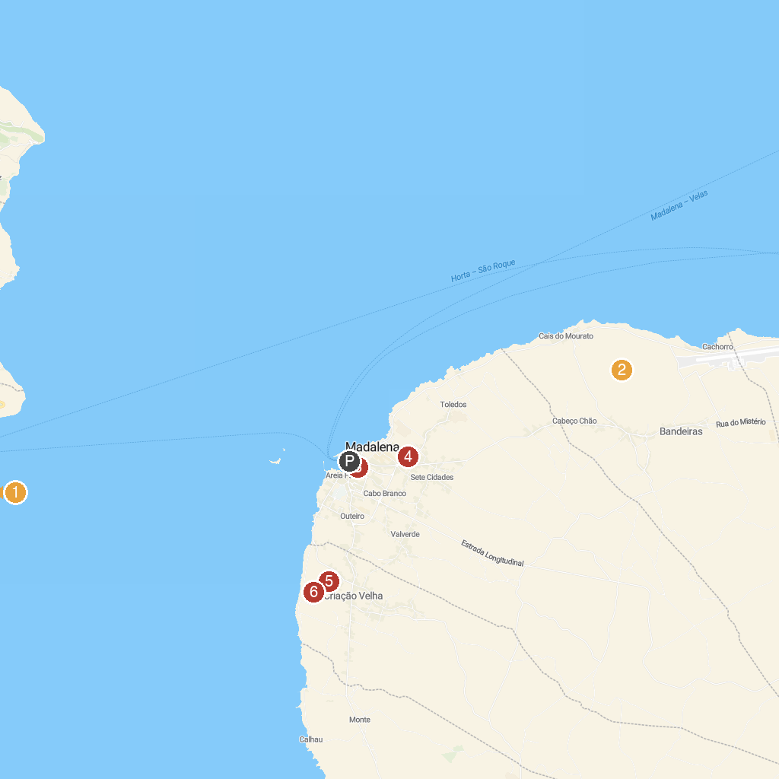
MAP KEY
1. Naturalist - Science & Tourism | Whale Watching | 4. WineMuseum
2. Paisagem da Cultura da Vinha da Ilha do Pico | 5. Lajido da Criação Velha
3. Church of Holy Mary Magdalene | 6. Paisagem da Vinha de Criação Velha
P. Cruise port / terminal
Map © MapTiler © OpenStreetMap contributors · cruiseports.org

