Phu Quoc Island, Kien Giang, Vietnam
Known as Vietnam's Pearl Island, Phu Quoc blends powdery white beaches and dense jungle with a surreal Italian-replica coastline and some of Asia's most revered fish sauce.
⚓ Mixed: pier + tender · 🕒 Typical call: 8-10 hrs · 💵 Vietnamese Dong (VND) · 🗣️ Vietnamese
✍️ MY DAY IN PORT (FILL IN)
Ship / Date
In port | arrive ______ · all aboard ______
Booked excursion
Notes / meeting point
GETTING ASHORE
- Docking: Mostly tender (Duong Dong harbour); new international pier can dock mega-ships
- Walk to centre: 5-10 min from Duong Dong tender pier to market & temple
- Best For: Beaches, cable car, local seafood & cultural markets
- Don't Miss: Hon Thom Cable Car, Dinh Cau Temple, Bún Quậy noodles
GETTING AROUND
- 🚕 Taxi: ~180,000–250,000 VND (– USD) per trip — Mai Linh, Vinasun, and Xanh SM are reputable metered taxi companies. Use the app or request a meter to avoid inflated fl
- 📱 Rideshare: ✅ Grab, Be, Xanh SM
TOP THINGS TO DO
- Hon Thom Cable Car & Sun World — Board the world's longest non-stop three-wire cable car for a 7.9 km glide over turquoise water to Pineapple Island.
- Sao Beach & Khem Beach — Two of Vietnam's most beautiful beaches are a short drive south.
- Duong Dong Market & Old Town Walk — From the tender pier, explore Dinh Cau Dragon King Temple perched on a sea rock, wander the chaotic Duong Dong wet market, and…
- Vinpearl Safari & National Park — Vietnam's largest semi-wild conservation safari park sits in the north amid Phu Quoc National Park.
- Pepper Farm & Fish Sauce Tasting — Phu Quoc produces EU-protected fish sauce and some of Asia's most fragrant black pepper.
BEST WALKS
- Duong Dong Town Centre Walk: 1-2 km · Easy · 45-60 min — From the Duong Dong tender pier, walk west along the river to Dinh Cau Temple, then loop back…
WEATHER · DAYLIGHT · MONEY
Month | High °F | Low °F | Rainy days
May | 86 | 79 | 27
Jul | 83 | 77 | 30
Sep | 83 | 77 | 28
Daylight: May 5:42AM–6:18PM · Jul 5:50AM–6:29PM · Sep 5:54AM–6:04PM
cruiseports.org/phu-quoc-island-vietnam · Confirm terminal & all-aboard time with your ship

Phu Quoc Island, Kien Giang, Vietnam — Port Map
Red = walkable sights · Amber = excursions farther out · P = cruise terminal
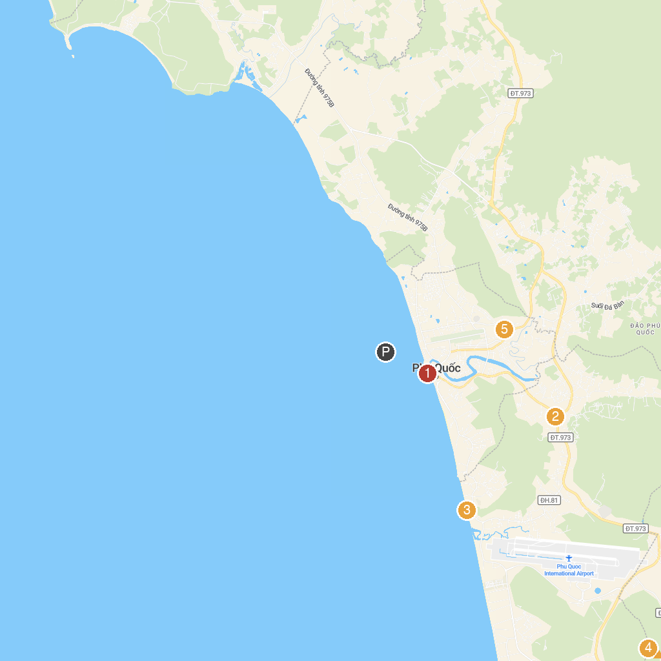
MAP KEY
1. Dinh Cậu | 4. Ben Pha Thanh Thoi - Cang Bai Vong
2. Vườn Tiêu Đức Thạnh | 5. Quảng trường Hồ Chí Minh
3. Bãi Trường
P. Cruise port / terminal
Map © MapTiler © OpenStreetMap contributors · cruiseports.org

