Phnom Penh, Cambodia
Cambodia's capital sprawls across the confluence of three rivers, its gilded palace towers glinting over a waterfront promenade where tuk-tuks jostle and locals do aerobics at sunset — a city that has survived tragedy and come out vivid.
⚓ Docked (river pier) · 🕒 Typical call: 1-2 days · 💵 USD (Riel for change) · 🗣️ Khmer / English widely spoken · 🌏 River cruise port
✍️ MY DAY IN PORT (FILL IN)
Ship / Date
In port | arrive ______ · all aboard ______
Booked excursion
Notes / meeting point
GETTING ASHORE
- Docking: Docked at Passenger Terminal TS1, Sisowath Quay — no tender required
- Walk to Centre: Steps from the pier; Royal Palace ~20 min walk
- Best For: History, Khmer culture, riverside dining, dark tourism
- Don't Miss: Tuol Sleng Genocide Museum and the Silver Pagoda inside the Royal Palace
GETTING AROUND
- 🚕 Taxi: $20–40 — Half- or full-day private car hire is available for deeper exploration. Book via Grab, PassApp, or through your ship's s
- 📱 Rideshare: ✅ Grab, PassApp
- 🚌 Hop-on hop-off: ✅
TOP THINGS TO DO
- Tuol Sleng (S-21) & Killing Fields — The former Khmer Rouge prison S-21 and the Choeung Ek memorial are essential, sobering visits that contextualise modern Cambodia.
- Royal Palace & Silver Pagoda — The King's official residence features gleaming Khmer rooflines and the Silver Pagoda, whose floor is laid with over 5,000 silver…
- National Museum of Cambodia — A beautiful terracotta pavilion next to the Royal Palace housing the world's finest collection of Khmer sculpture and Angkorian…
- Khmer Street Food & Central Market — Phnom Penh's 1937 Art Deco Central Market (Psar Thmei) is worth a visit for the architecture alone.
- Sisowath Quay Sunset & Rooftop Bars — The Riverside promenade comes alive at dusk.
BEST WALKS
- Riverside Promenade to Royal Palace: 2 km · 25 min · Easy · Flat — Head south along Sisowath Quay from the pier, passing riverside cafés and the Colonial-era FCC…
- Pier to Wat Phnom: 1 km · 10 min · Easy · Flat — Walk north along the quay to the small wooded hill of Wat Phnom — the founding temple of the city.
WEATHER · DAYLIGHT · MONEY
Month | High °F | Low °F | Rainy days
May | 93 | 79 | 24
Jul | 90 | 78 | 24
Sep | 88 | 77 | 28
Daylight: May 5:37AM–6:16PM · Jul 5:44AM–6:28PM · Sep 5:49AM–6:01PM
cruiseports.org/phnom-penh · Confirm terminal & all-aboard time with your ship

Phnom Penh, Cambodia — Port Map
Red = walkable sights · Amber = excursions farther out · P = cruise terminal
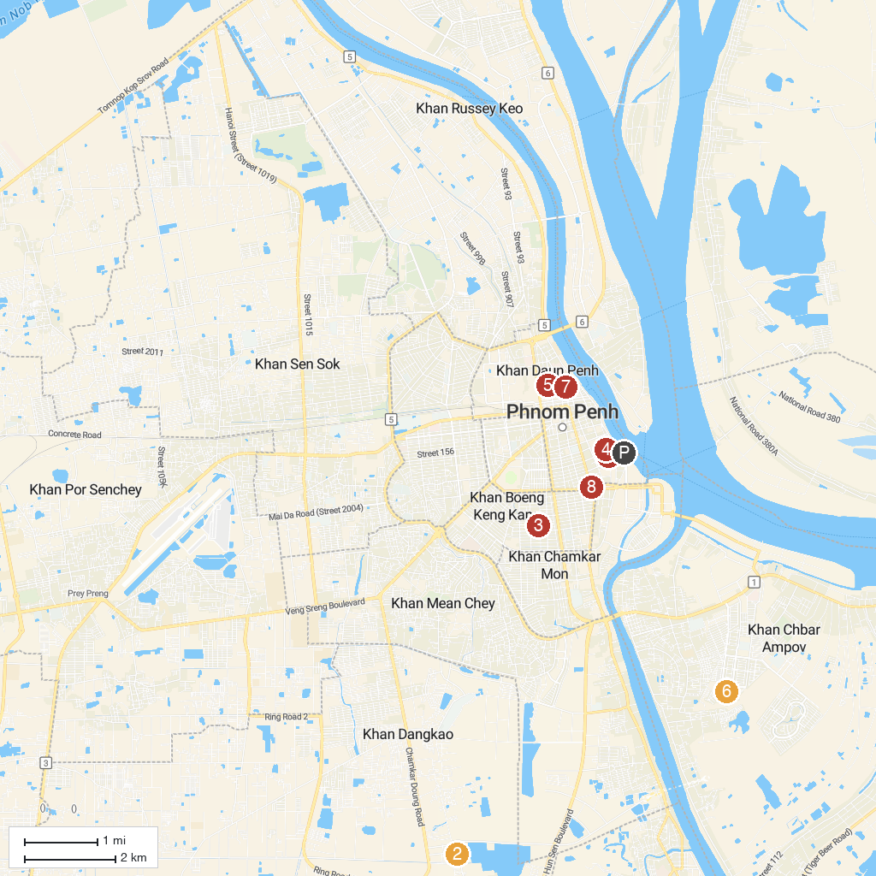
MAP KEY
1. Silver Pagoda | 5. National Library
2. Choeung Ek Genocidal Center | 6. PH Euro Park
3. Tuol Sleng Genocide Museum | 7. Wat Phnom Daun Penh
4. Royal Palace of Cambodia | 8. Independence Monument
P. Cruise port / terminal
Map © MapTiler © OpenStreetMap contributors · cruiseports.org

