Phillip Island, Victoria, Australia
Rugged surf coastline meets extraordinary wildlife on this island at the mouth of Western Port Bay. Home to the world's smallest penguins and one of Australia's largest fur seal colonies, Phillip Island rewards every shore day with something genuinely wild.
⚓ Tender (no pier) · 🕒 Typical call: 6-8 hrs · 💵 Australian Dollar (AUD) · 🗣️ English · 🐧 Wildlife destination
✍️ MY DAY IN PORT (FILL IN)
Ship / Date
In port | arrive ______ · all aboard ______
Booked excursion
Notes / meeting point
GETTING ASHORE
- Docking: Tender to Cowes Jetty
- Walk to center: 2 min — jetty lands in Cowes town
- Best For: Wildlife, nature walks, scenic coastline
- Don't Miss: Koala Conservation Reserve & The Nobbies
GETTING AROUND
- 🚕 Taxi: A–22 (Rhyll to Cowes) — 13cabs operates on Phillip Island with very limited vehicles — pre-booking is strongly advised. The ride from Rhyll to C
- 📱 Rideshare: ✅ Uber
- 🚌 Hop-on hop-off: ✅ Local Way Tours – Phillip Island Explorer
TOP THINGS TO DO
- Koala Conservation Reserve — Walk raised boardwalks through eucalyptus canopy to spot wild koalas at eye level.
- The Nobbies Boardwalk & Seal Rocks — Clifftop boardwalk on the island's western tip with dramatic Bass Strait views, a natural blowhole, and distant Seal Rocks — home…
- Antarctic Journey at The Nobbies — Interactive multimedia exhibition at The Nobbies visitor centre exploring the Southern Ocean and Antarctica, with VR experiences…
- Churchill Island Heritage Farm — Step back to the 19th century at this working historic farm accessed via a small bridge.
- Cape Woolamai Coastal Walk — Victoria's most dramatic surf beach backed by pink granite cliffs and ancient sand dunes.
BEST WALKS
- Cowes Esplanade & Front Beach Stroll: Easy · 30-45 min · Free — From the tender jetty, head along the Esplanade past Cowes Front Beach — a calm, north-facing bay…
- The Nobbies Boardwalk: Easy · 45-60 min · Free · 20 min drive from Cowes — Park at The Nobbies car park and walk the clifftop boardwalk to the blowhole lookout.
WEATHER · DAYLIGHT · MONEY
Month | High °F | Low °F | Rainy days
May | 60 | 53 | 13
Jul | 55 | 48 | 14
Sep | 59 | 50 | 14
Daylight: May 7:14AM–5:16PM · Jul 7:33AM–5:17PM · Sep 6:19AM–6:09PM
cruiseports.org/phillip-island · Confirm terminal & all-aboard time with your ship

Phillip Island, Victoria, Australia — Port Map
Red = walkable sights · Amber = excursions farther out · P = cruise terminal
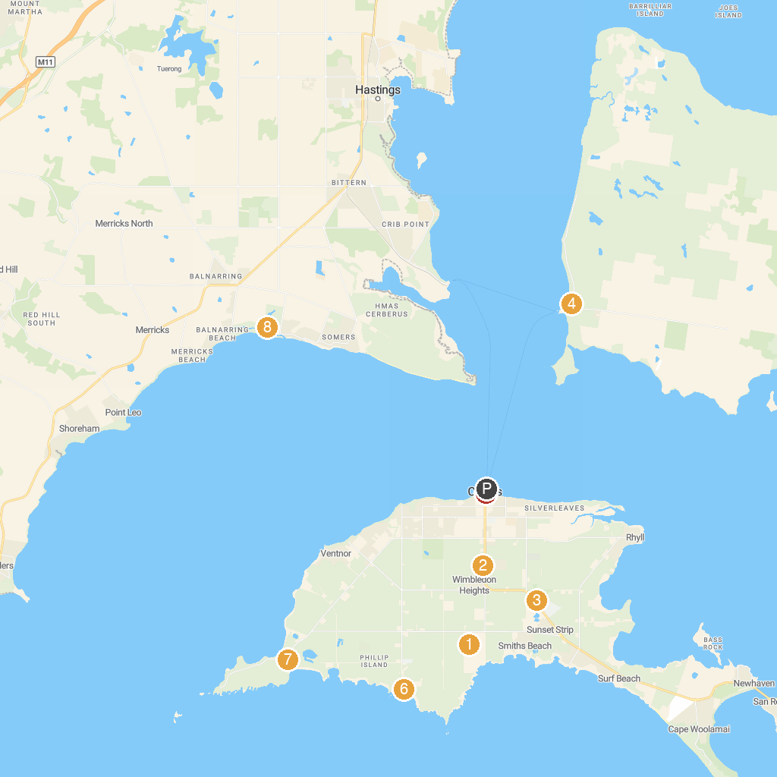
MAP KEY
1. Phillip Island Grand Prix Circuit | 5. Wildlife Coast Cruises - Cowes
2. Phillip Island Wildlife Park | 6. Berrys Beach
3. Koala Conservation Reserve | 7. Penguin Parade
4. French Island National Park | 8. Coolart Wetlands & Homestead (Parks Victoria)
P. Cruise port / terminal
Map © MapTiler © OpenStreetMap contributors · cruiseports.org

