Pesaro, Marche, Italy
Rossini's hometown rewards small-ship cruisers with a flat, walkable Adriatic city: Blue Flag beaches steps from the tender dock, a grand Renaissance piazza, opera museums, and a bike-path network unlike anywhere else in Italy.
⚓ Tender (most ships) / Docked (small vessels) · 🕒 Typical call: 7-9 hrs · 💶 Euro (€) · 🗣️ Italian · 🎼 Italian Capital of Culture 2024
✍️ MY DAY IN PORT (FILL IN)
Ship / Date
In port | arrive ______ · all aboard ______
Booked excursion
Notes / meeting point
GETTING ASHORE
- Docking: Tender for most cruise ships; small vessels (under ~80m) may dock at Porto di Pesaro
- Walk to Center: 15–20 min (1.2 km) via flat Viale della Repubblica from the harbor
- Best For: Music lovers, beach days, art, Italian culture without the cruise crowds
- Don't Miss: Casa Rossini museum, Sfera Grande sculpture on the seafront, Piazza del Popolo
GETTING AROUND
- 🚕 Taxi: €8–€12 — Taxis are available at the port. The short 2 km ride to city center typically costs €8–€12; fixed-rate private transfers
TOP THINGS TO DO
- Casa Rossini & Teatro Rossini — Visit the birthplace of Gioachino Rossini, now an interactive museum of his life, operas, and famous culinary obsessions.
- Musei Civici — Bellini & Renaissance Ceramics — Palazzo Mosca houses Giovanni Bellini's masterpiece 'Coronation of the Virgin' and a superb collection of Renaissance majolica…
- Roman Domus in Via dell'Abbondanza — Step into a 1st-century AD Roman home preserved beneath the city, complete with floor mosaics and 3D virtual reconstructions of…
- Monte San Bartolo Nature Reserve — Just north of the port, this coastal nature reserve offers panoramic clifftop walks above the Adriatic with views of the green…
- Day Trip to Urbino — With a long port call (8+ hrs), taxi or join a shore excursion to Urbino — a UNESCO World Heritage Renaissance hill town 45…
BEST WALKS
- Port to Piazza del Popolo: 1.2 km · 15–20 min · flat — Walk straight up Viale della Repubblica from the harbor basin to Pesaro's grand Renaissance heart.
- Seafront Promenade & Pomodoro Sphere: 1.5 km one way · 20 min · flat seafront — Head east from the port along the seafront boulevard to find Arnaldo Pomodoro's giant bronze Sfera…
WEATHER · DAYLIGHT · MONEY
Month | High °F | Low °F | Rainy days
May | 70 | 58 | 11
Jul | 84 | 71 | 6
Sep | 76 | 64 | 8
Daylight: May 5:42AM–8:27PM · Jul 5:40AM–8:48PM · Sep 6:47AM–7:18PM
cruiseports.org/pesaro · Confirm terminal & all-aboard time with your ship

Pesaro, Marche, Italy — Port Map
Red = walkable sights · Amber = excursions farther out · P = cruise terminal
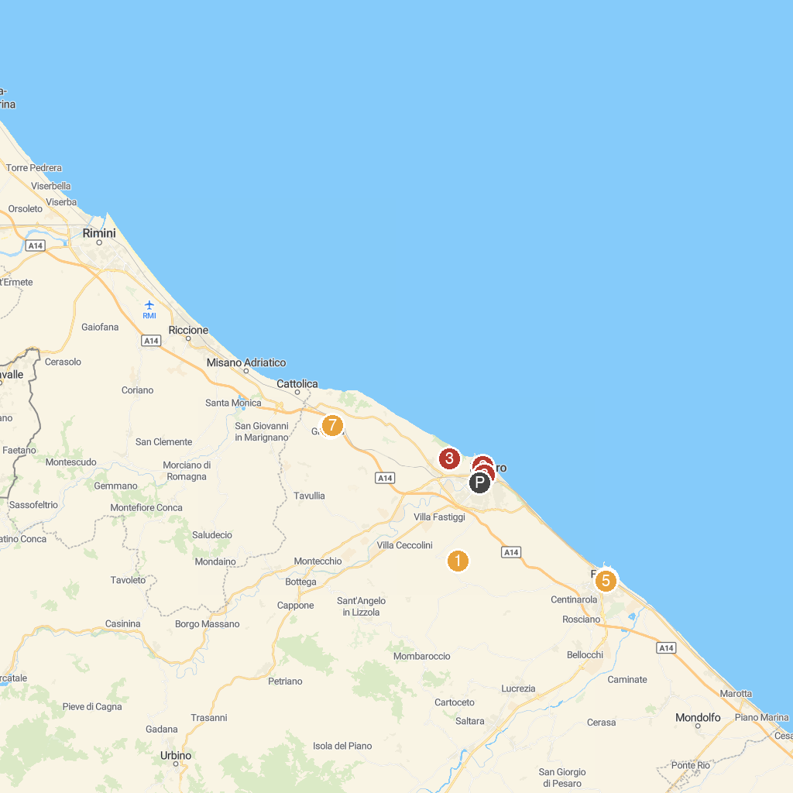
MAP KEY
1. Pro Loco Candelara | 5. Statue of Fortuna
2. Museo della Marineria Washington Patrignani C 12 | 6. Museo Storico di Gradara
3. Villa Imperiale Pesaro | 7. Il Teatro dell'Aria
4. Museo Archeologico e Pinacoteca del Palazzo Malatestiano di Fano | 8. Chiesa del Nome di Dio - Pesaro- quartiere centro storico
P. Cruise port / terminal
Map © MapTiler © OpenStreetMap contributors · cruiseports.org

