Percé, Quebec, Canada
A dramatic limestone monolith, a colony of roughly 50,000 nesting pairs of gannets, and some of Canada's best lobster — all packed into one compact Gaspé fishing village. This is one of the Gulf of St. Lawrence's most rewarding stops.
⚓ Tender port · 🕒 Typical call: 6-8 hrs · 💵 Canadian Dollar (CAD) · 🗣️ French (English widely spoken) · 🌊 UNESCO Global Geopark
✍️ MY DAY IN PORT (FILL IN)
Ship / Date
In port | arrive ______ · all aboard ______
Booked excursion
Notes / meeting point
GETTING ASHORE
- Docking: Tender — ships anchor in the bay; tenders land at Quai de Percé
- Walk to center: 2-5 min from wharf to village shops and restaurants
- Best For: Wildlife, geology, scenic walks, seafood
- Don't Miss: Bonaventure Island gannet colony (~50,000 nesting pairs)
GETTING AROUND
- 📱 Rideshare: ❌ not available
TOP THINGS TO DO
- Bonaventure Island Gannet Colony — A narrated boat cruise circles Percé Rock, then drops you on Bonaventure Island.
- Percé UNESCO Global Geopark — Explore 500 million years of geology via the Tektonik multimedia pavilion, hiking trails, and a suspended glass platform on Mont…
- Promenade de la Grave Heritage Walk — Follow this historic shoreside circuit past restored 19th-century buildings of the Charles Robin Company — the cod-fishing…
- Gaspé Lobster & Craft Beer Lunch — Percé is famous for Gaspé lobster (Homard de la Gaspésie), prized for its sweetness in cold, clean Gulf waters.
- Sea Kayaking Around Percé Rock — Paddle close to the iconic arch of Percé Rock under your own power.
BEST WALKS
- Village Waterfront & Boardwalk: 1-2 hrs • Easy • Flat — Stroll the La Promenade boardwalk from the wharf for unobstructed views of Percé Rock and…
- Mont-Joli Lookout: 45 min round-trip • Easy-moderate • Uphill — A short climb (about 10-15 min from the wharf) to this historic lookout delivers the classic…
WEATHER · DAYLIGHT · MONEY
Month | High °F | Low °F | Rainy days
May | 51 | 38 | 12
Jul | 69 | 58 | 12
Sep | 62 | 51 | 11
Daylight: May 4:36AM–7:51PM · Jul 4:32AM–8:13PM · Sep 5:54AM–6:28PM
cruiseports.org/perce-qc · Confirm terminal & all-aboard time with your ship

Percé, Quebec, Canada — Port Map
Red = walkable sights · Amber = excursions farther out · P = cruise terminal
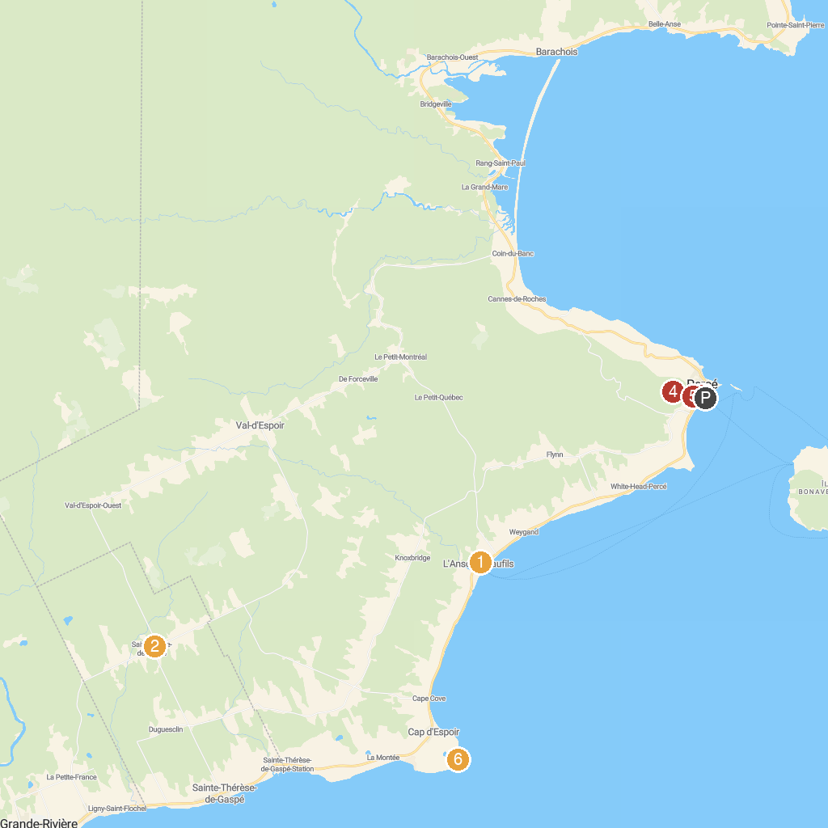
MAP KEY
1. Magasin Général Historique Authentique 1928 | 4. Plateforme Vitrée Suspendue
2. Chalet du Pont Rouge | 5. Geopark - Pavilion Tektonik
3. Bonaventure Island National Park and Percé Rock | 6. Phare Cap-d'Espoir
P. Cruise port / terminal
Map © MapTiler © OpenStreetMap contributors · cruiseports.org

