Peoria, Illinois, USA
Oldest European settlement in Illinois and once the whiskey capital of the world, Peoria delivers a walkable riverfront, heavyweight museums, and Midwestern hospitality straight off the gangway.
⚓ Pier dock (riverfront) · 🕒 Typical call: 6–9 hrs · 💵 USD · 🗣️ English · 🌊 Illinois River
✍️ MY DAY IN PORT (FILL IN)
Ship / Date
In port | arrive ______ · all aboard ______
Booked excursion
Notes / meeting point
GETTING ASHORE
- Docking: Pier — ships tie directly to downtown Peoria Riverfront seawall
- Walk to Center: 5 min to Riverfront Museum; 10–15 min to Warehouse District
- Best For: American history, industrial heritage, craft food & drink
- Don't Miss: Caterpillar Visitors Center and the Richard Pryor bronze statue
GETTING AROUND
- 🚕 Taxi: $10–$30 — Local taxis such as MC Cabs operate in the area, charging approximately $4 base plus $4/mile. Short downtown trips typic
- 📱 Rideshare: ✅ Uber, Lyft
TOP THINGS TO DO
- Caterpillar Visitors Center — Climb inside a two-story CAT mining truck, run heavy-equipment simulators, and explore the engineering legacy of one of America's…
- Peoria Riverfront Museum — A Smithsonian-affiliated multidisciplinary museum with fine art, Illinois history, science exhibits, a giant-screen theater, and…
- Grandview Drive Scenic Tour — President Theodore Roosevelt called this "the world's most beautiful drive" in 1910.
- Richard Pryor Statue & Historic Downtown — A striking bronze memorial to Peoria's most famous son stands at State and Washington Streets.
- Forest Park Nature Center — Forested river bluffs just 15 minutes by car offer well-marked hiking trails through an 800-acre natural area — a peaceful…
BEST WALKS
- Riverfront to Warehouse District: 1.2 miles · Flat · 25 min — Head south along the Riverfront Trail past public sculptures and gardens, then cut west into the…
- Downtown Culture Walk: 0.8 miles · Flat · 20 min — Walk from the pier to the Caterpillar Visitors Center, then continue uphill to the Richard Pryor…
WEATHER · DAYLIGHT · MONEY
Month | High °F | Low °F | Rainy days
May | 74 | 53 | 11
Jul | 86 | 66 | 9
Sep | 78 | 56 | 8
Daylight: May 5:42AM–8:08PM · Jul 5:40AM–8:28PM · Sep 6:39AM–7:08PM
cruiseports.org/peoria-il · Confirm terminal & all-aboard time with your ship

Peoria, Illinois, USA — Port Map
Red = walkable sights · Amber = excursions farther out · P = cruise terminal
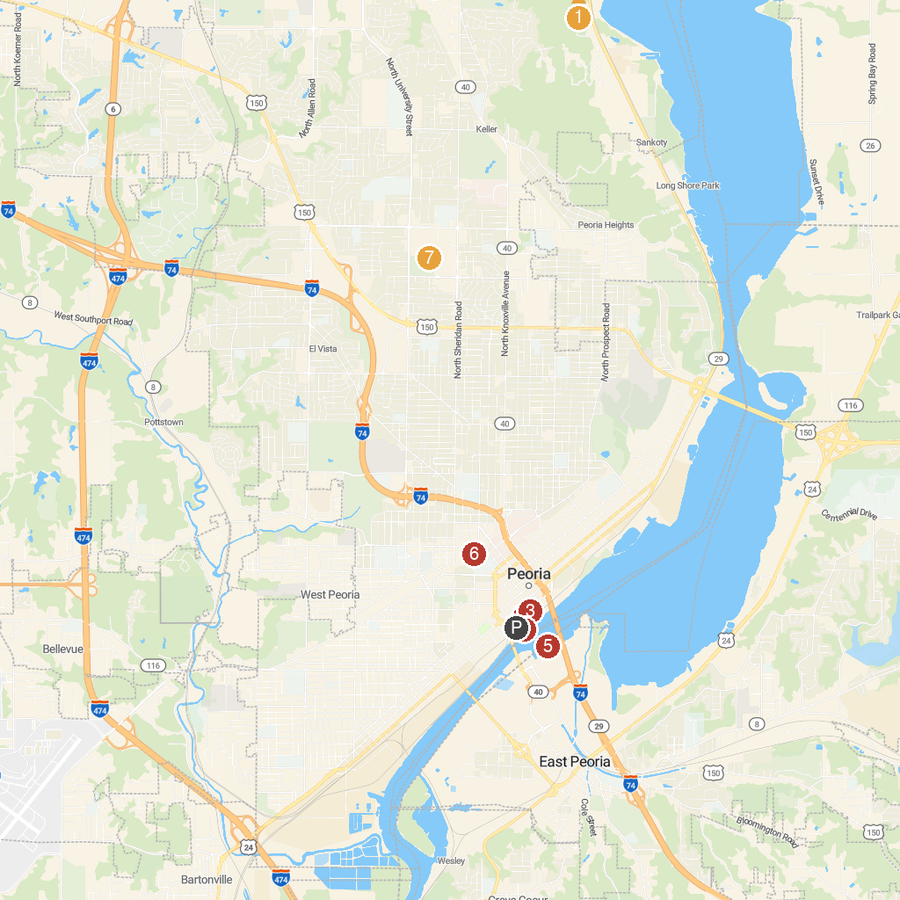
MAP KEY
1. Detweiller Park | 5. Liberty Park
2. Peoria Riverfront Museum | 6. East Peoria River Front Park
3. Harry Lahood Park | 7. Giant Oak Park
4. Caterpillar Visitors Center | 8. Lakeview Park
P. Cruise port / terminal
Map © MapTiler © OpenStreetMap contributors · cruiseports.org

