Penzance, Cornwall, England
The far west of England, where sub-tropical gardens meet granite cliffs and a tidal island castle dominates the bay. Penzance punches well above its size for a single day ashore.
⚓ Mixed — pier or tender by ship size · 🕒 Typical call: 6–8 hrs · 💷 British Pounds (GBP) · 🗣️ English / Cornish bilingual signs
✍️ MY DAY IN PORT (FILL IN)
Ship / Date
In port | arrive ______ · all aboard ______
Booked excursion
Notes / meeting point
GETTING ASHORE
- Docking: Small ships (under 90 m) berth at South Pier; larger vessels anchor in Mount's Bay and tender ashore
- Walk to centre: 5–10 min from harbour to Chapel Street and town centre
- Best For: St Michael's Mount, cliff theatre, art, Cornish food, coastal walking
- Don't Miss: The causeway walk to St Michael's Mount (tide permitting) — book tickets in advance
GETTING AROUND
- 🚕 Taxi: £10–£20 — Local taxis are available near Penzance train station (a short walk from the harbor). Pre-booking is advised on busy cru
TOP THINGS TO DO
- St Michael's Mount — Cornwall's most famous landmark — a medieval castle and chapel perched on a tidal island 3 miles east in Marazion.
- Minack Theatre & Porthcurno — An open-air theatre carved into granite cliffs above a turquoise bay — one of Britain's most dramatic performance venues.
- St Ives by Scenic Railway — Catch the branch train from Penzance to St Erth, then ride the legendary St Ives Bay line — one of England's most scenic rail…
- Chapel Street & Penzance Town Walk — Penzance's most atmospheric street is lined with 18th-century merchants' houses, the flamboyant Egyptian House (1835), antique…
- Jubilee Pool & Seafront Stroll — Grade II-listed Art Deco saltwater lido on the Penzance promenade — the largest seawater pool in the UK, with a geothermally…
BEST WALKS
- Harbour to Newlyn via Promenade: 3 km • 25–30 min one-way • Flat & easy — Head west from the pier along the Penzance seafront promenade.
- Chapel Street Historic Loop: 1.5 km • 30–45 min • Easy with gentle hill — From the harbour walk up Market Jew Street (the main shopping street) to the domed Market House…
WEATHER · DAYLIGHT · MONEY
Month | High °F | Low °F | Rainy days
May | 57 | 50 | 12
Jul | 65 | 58 | 14
Sep | 63 | 57 | 14
Daylight: May 5:35AM–9:02PM · Jul 5:29AM–9:25PM · Sep 6:58AM–7:35PM
cruiseports.org/penzance · Confirm terminal & all-aboard time with your ship

Penzance, Cornwall, England — Port Map
Red = walkable sights · Amber = excursions farther out · P = cruise terminal
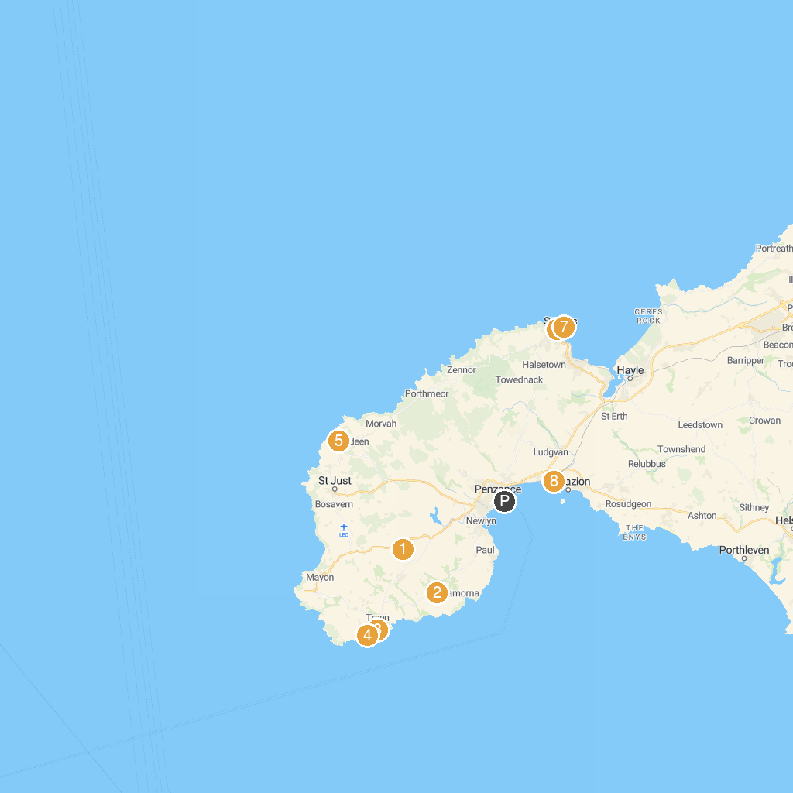
MAP KEY
1. Boscawen-un Stone Circle | 5. Geevor Tin Mine Museum
2. The Merry Maidens Stone Circle | 6. Tate St Ives
3. Pedn Vounder Beach | 7. St. Ives Museum
4. The Minack Theatre | 8. RSPB Marazion Marsh
P. Cruise port / terminal
Map © MapTiler © OpenStreetMap contributors · cruiseports.org

