Peñíscola, Castellón, Spain
A 13th-century fortress perched 64 metres above the Mediterranean, Peñíscola is Spain's most dramatic walled town — once a Papal seat, later a Hollywood backdrop, and still entirely walkable from the tender dock.
⚓ Tender (no pier) · 🕒 Typical call: 6-8 hrs · 💶 Euro (€) · 🗣️ Spanish / Valencian · 🎬 Game of Thrones filming location
✍️ MY DAY IN PORT (FILL IN)
Ship / Date
In port | arrive ______ · all aboard ______
Booked excursion
Notes / meeting point
GETTING ASHORE
- Docking: Tender — ships anchor in the bay; boats land at Puerto de Peñíscola
- Walk to castle: ~20 min uphill from tender pier through cobbled old-town streets
- Best For: History lovers, beach days, photography, Game of Thrones fans
- Don't Miss: Castle rooftop views, El Bufador blowhole, Playa Norte promenade
GETTING AROUND
- 🚕 Taxi: €5–€10 — Local taxis are available near the port for short trips within town. Fares are metered; the short ride to the castle are
TOP THINGS TO DO
- Peñíscola Castle (Castillo de Papa Luna) — Built by the Knights Templar in the 13th century and later the exile palace of Antipope Benedict XIII, the castle offers…
- Old Town Walking Tour — Wander the whitewashed alleyways, spot the Casa de las Conchas (a façade encrusted with sea shells), pass through Portal Fosc and…
- Playa Norte Beach Day — A 5 km Blue Flag beach of fine golden sand stretches north of the old town with sunbed hire, showers, lifeguards, and a promenade…
- Morella Medieval Village Day Trip — Perched on a hilltop about 75 km inland, Morella is one of Spain's best-preserved walled medieval towns, dominated by a Gothic…
- Coves de Sant Josep (Underground River) — Europe's longest navigable underground river, located about 105 km south near La Vall d'Uixó.
BEST WALKS
- Old Town & Castle Loop: 2.5 km · ~1.5 hrs · Moderate (steep cobbles) — From the tender pier, follow the harbour promenade north to Portal de Sant Pere, climb through the…
- Playa Norte Promenade Stroll: 2 km one way · ~25 min · Easy (flat) — Head north along the seafront promenade from the fishing harbour past Playa Sur to Playa Norte.
WEATHER · DAYLIGHT · MONEY
Month | High °F | Low °F | Rainy days
May | 72 | 57 | 6
Jul | 84 | 70 | 2
Sep | 79 | 66 | 9
Daylight: May 6:42AM–9:07PM · Jul 6:41AM–9:26PM · Sep 7:39AM–8:06PM
cruiseports.org/peniscola · Confirm terminal & all-aboard time with your ship

Peñíscola, Castellón, Spain — Port Map
Red = walkable sights · Amber = excursions farther out · P = cruise terminal
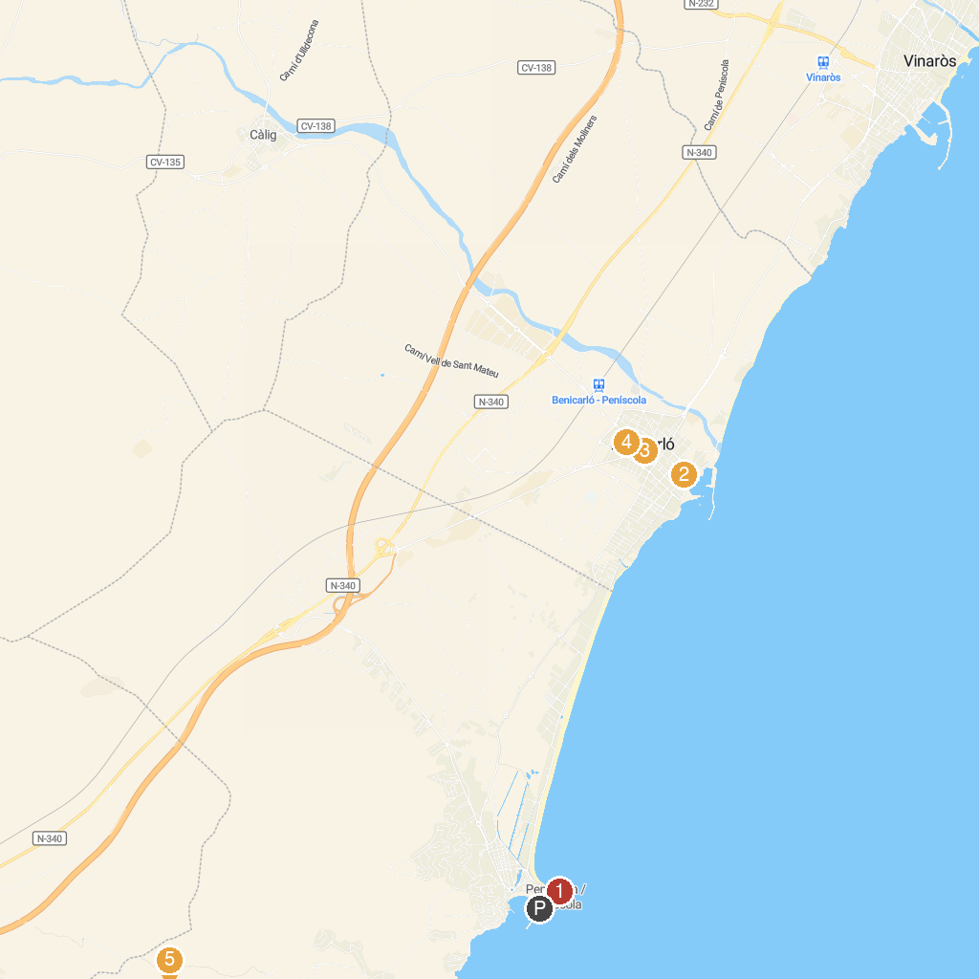
MAP KEY
1. Lighthouse of Peñiscola | 4. MucBe Benicarló
2. Parròquia Sant Pere | 5. Cala Mundina
3. Parròquia Sant Bartomeu | 6. Parc Natural de la Serra d'Irta
P. Cruise port / terminal
Map © MapTiler © OpenStreetMap contributors · cruiseports.org

