Pembroke Dock, Pembrokeshire, Wales
A Victorian dockyard town where the Millennium Falcon was secretly built, WWII flying boats once roared off the river, and a Tudor king's birthplace sits just two miles inland.
⚓ Docked (alongside quay) · 🕒 Typical call: 7-9 hrs · 💷 British Pound (GBP) · 🗣️ English (Welsh bilingual signs)
✍️ MY DAY IN PORT (FILL IN)
Ship / Date
In port | arrive ______ · all aboard ______
Booked excursion
Notes / meeting point
GETTING ASHORE
- Docking: Alongside quay at Pembroke Port — no tender required
- Walk to center: 15–20 min walk to Pembroke Dock town; Pembroke Castle ~2 miles (taxi recommended)
- Best For: Medieval castles, Pembrokeshire coast beaches, WWII history, Harry Potter film sites
- Don't Miss: Pembroke Castle (birthplace of Henry VII) and Freshwater West beach (Dobby's Grave)
GETTING AROUND
- 🚕 Taxi: £8–£12 — Local taxis (Dan's Cabs, MD Taxi) run from the port to Pembroke town center in about 5 minutes. Pre-booking recommended
TOP THINGS TO DO
- Pembroke Castle — The birthplace of King Henry VII is one of Wales's best-preserved medieval fortresses.
- Pembroke Dock Heritage Centre & Star Wars Exhibition — Housed in the beautifully restored Royal Dockyard Chapel, this small but fascinating museum covers the town's naval history, WWII…
- Tenby & Castle Beach — Tenby is a pastel-painted Georgian seaside town with medieval walls, a working fishing harbor, and some of the best beaches in…
- Freshwater West — Harry Potter Beach — A wild, windswept Atlantic beach famous for surfing and its film connections — Dobby's Grave from Harry Potter and the Deathly…
- St Davids Cathedral & Bishop's Palace — Visit the UK's smallest city — a 12th-century cathedral of extraordinary spiritual and architectural beauty, set in a hidden…
BEST WALKS
- Pembroke Dock Waterfront & Defensible Barracks: ⏱ 1 hr · 🚶 Easy, flat · 📏 ~1.5 miles — Walk from the pier along the waterfront to the landmark Front Street Gun Tower — one of two 1851…
WEATHER · DAYLIGHT · MONEY
Month | High °F | Low °F | Rainy days
May | 59 | 48 | 12
Jul | 67 | 57 | 14
Sep | 63 | 54 | 14
Daylight: May 5:27AM–9:05PM · Jul 5:19AM–9:30PM · Sep 6:55AM–7:33PM
cruiseports.org/pembroke-dock · Confirm terminal & all-aboard time with your ship

Pembroke Dock, Pembrokeshire, Wales — Port Map
Red = walkable sights · Amber = excursions farther out · P = cruise terminal
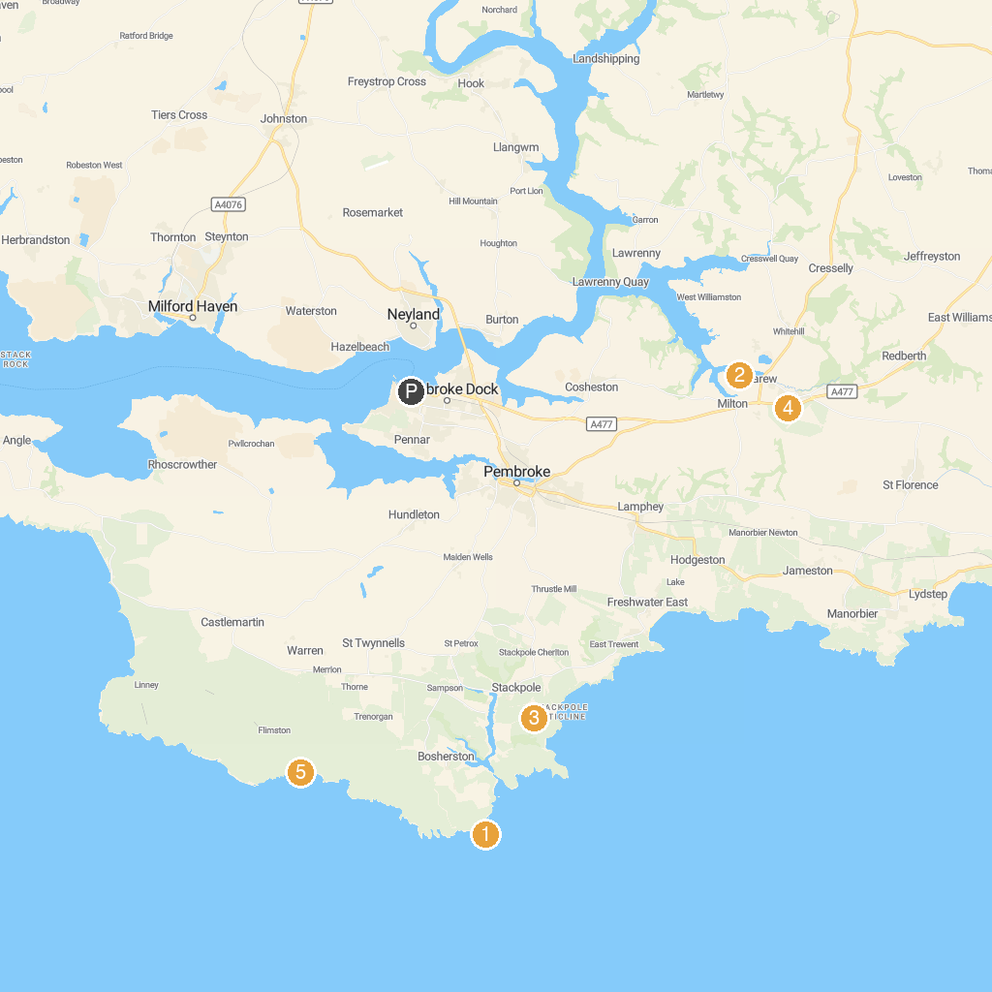
MAP KEY
1. St Govans Head | 5. National Trust - Stackpole
2. The Dinosaur Park Tenby | 6. Carew Cheriton Control Tower
3. Blue Lagoon Water Park (Open to Residents of Bluestone only) | 7. The Cauldron
4. Carew Tidal Mill | 8. Manor Wildlife Park
P. Cruise port / terminal
Map © MapTiler © OpenStreetMap contributors · cruiseports.org

