Peine, Lower Saxony, Germany
Germany's 'Owl Town' lines the Mittellandkanal with cobbled lanes, Fachwerk facades, and the scent of Härke Pilsner — a quiet canal call with genuine small-town character.
⚓ Docked (canal port) · 🕒 Typical call: 5–7 hrs · 💶 Euro · 🗣️ German (some English in centre)
✍️ MY DAY IN PORT (FILL IN)
Ship / Date
In port | arrive ______ · all aboard ______
Booked excursion
Notes / meeting point
GETTING ASHORE
- Docking: Alongside at Hafen Peine on the Mittellandkanal, north of the town centre
- Into centre: ~2 km to Marktplatz; scheduled public buses link the port and town
- Best For: Canal town strolls, brewery visits, Rausch chocolate shopping
- Don't Miss: Burgpark hilltop & the brass Eulenpfad owl trail through the old town
GETTING AROUND
- 🚕 Taxi: ~€6–10 — Short taxi ride from Hafen Peine to the Marktplatz. Licensed taxis queue near the port on arrival days; fares are metere
- 📱 Rideshare: ✅ Uber, Bolt
TOP THINGS TO DO
- Owl Trail & Old Town Walk — Follow the brass owl plaques of the Eulenpfad self-guided trail through Peine's half-timbered old town, passing St.
- Härke Beer Tasting & Taproom — Brewing put Peine on the map: the BrauManufaktur Härke dated to 1890 and its Härke Pils is a local icon.
- Rausch Chocolate Factory Outlet — Germany's premium chocolatier Rausch has made fine chocolate in Peine (Stederdorf) since 1982.
- Kreismuseum Peine — The district museum traces Peine's history from its medieval castle and the Bishop-Duke conflicts to its 19th-century steel…
BEST WALKS
- Hafen Peine to Marktplatz: ~2 km · 25–30 min · Flat — A straightforward walk from Hafen Peine on the Mittellandkanal through residential streets into the…
- Eulenpfad Old Town Loop: 2.5 km · 45–60 min · Flat — Follow brass owl plaques in the pavement from the Marktplatz to St.
WEATHER · DAYLIGHT · MONEY
Month | High °F | Low °F | Rainy days
May | 64 | 48 | 11
Jul | 75 | 59 | 12
Sep | 68 | 53 | 10
Daylight: May 5:23AM–9:07PM · Jul 5:15AM–9:33PM · Sep 6:53AM–7:33PM
cruiseports.org/peine · Confirm terminal & all-aboard time with your ship

Peine, Lower Saxony, Germany — Port Map
Red = walkable sights · Amber = excursions farther out · P = cruise terminal
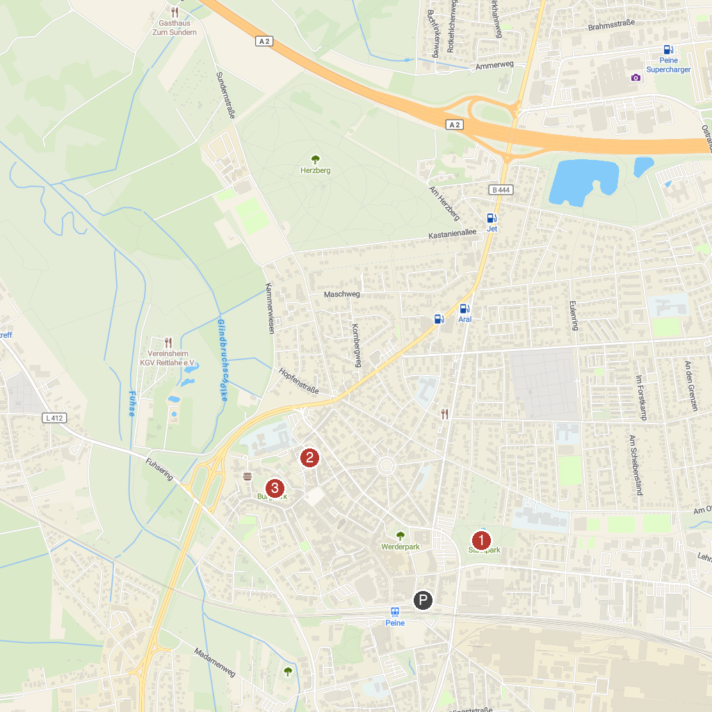
MAP KEY
1. Stadtpark | 3. Kreismuseum Peine
2. Gut Steinhof | 4. Burg Park
P. Cruise port / terminal
Map © MapTiler © OpenStreetMap contributors · cruiseports.org

