Paxos Island, Ionian Islands, Greece
Greece's smallest main Ionian island, Paxos rewards cruise visitors with neon-blue sea caves, a car-free Venetian harbor town, and the legendary white-sand beaches of neighboring Antipaxos — all accessed by tender into the heart of Gaios.
⚓ Tender (no cruise pier) · 🕒 Typical call: 6–8 hrs · 💶 Euro · 🗣️ Greek
✍️ MY DAY IN PORT (FILL IN)
Ship / Date
In port | arrive ______ · all aboard ______
Booked excursion
Notes / meeting point
GETTING ASHORE
- Docking: Tender to Gaios old harbor
- Walk to center: Immediate — tender drops in Gaios
- Best For: Blue Caves boat tour, Antipaxos day trip
- Don't Miss: Taxi boat to Voutoumi Beach, Antipaxos
GETTING AROUND
- 🚕 Taxi: €8–15 per trip — Only about 5 taxis serve the entire island. A ride from Gaios to Loggos or Lakka runs roughly €10–15; advance booking is
- 📱 Rideshare: ❌ not available
TOP THINGS TO DO
- Blue Caves Boat Tour — The sea caves on Paxos's rugged west coast — the largest and most famous being Ypapanti — glow with surreal neon-blue water where…
- Antipaxos & Voutoumi Beach — A 15-minute taxi-boat ride brings you to Antipaxos, where Voutoumi Beach's powder-white sand and electric-turquoise water rival…
- Self-Drive Motorboat Hire — No license needed for engines under 30hp.
- Gaios Old Town & Venetian Harbor — Wander the car-free lanes of Gaios past pastel Venetian facades, the main square (Plaka), and the tiny islet of Agios Nikolaos…
- Tripitos Natural Arch — One of Greece's most dramatic coastal features — a massive limestone arch rising above the sea on the island's southwest coast…
BEST WALKS
- Gaios Harbor & Old Town Loop: 1 km · Flat · 20–30 min — From the tender dock in the old harbor, stroll the waterfront past the Agios Nikolaos islet, turn…
- Gaios to Tripitos Arch: 4.5 km one-way · Easy–Moderate · ~1 hr each way — Head south along the coastal path and olive-grove tracks from Gaios, via Ozias, to the Tripitos…
- Gaios to Giannas Beach: 0.8 km · Flat · 10 min — Walk north from the harbor along the coastal road to Giannas, a small pebbly beach with clear…
WEATHER · DAYLIGHT · MONEY
Month | High °F | Low °F | Rainy days
May | 67 | 63 | 6
Jul | 79 | 75 | 1
Sep | 77 | 73 | 7
Daylight: May 6:26AM–8:45PM · Jul 6:25AM–9:04PM · Sep 7:20AM–7:47PM
cruiseports.org/paxos-island · Confirm terminal & all-aboard time with your ship

Paxos Island, Ionian Islands, Greece — Port Map
Red = walkable sights · Amber = excursions farther out · P = cruise terminal
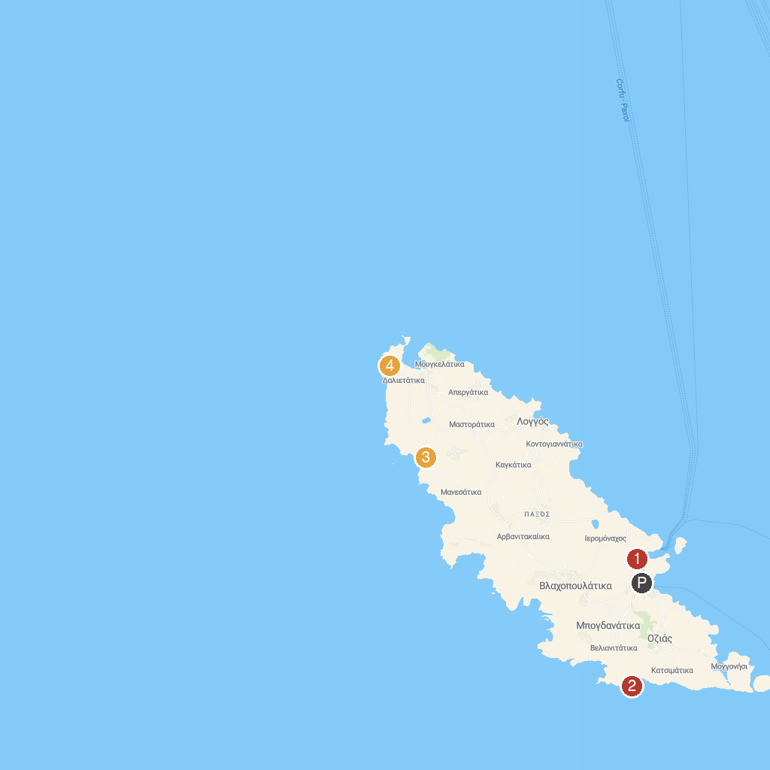
MAP KEY
1. Gaios viewpoint | 3. Ypapanti's Cave
2. Tripitos Arch | 4. Lakka's Lighthouse
P. Cruise port / terminal
Map © MapTiler © OpenStreetMap contributors · cruiseports.org

