Pattaya, Chonburi, Thailand
A Thai city that defies expectations — from a towering all-wood temple on the ocean to golden Buddhas carved into cliffs, Pattaya delivers genuine wonder alongside its famous beach-resort energy.
⚓ Pier (Laem Chabang) · 🕒 Typical call: 8-10 hrs · 💵 Thai Baht (THB) · 🗣️ Thai (English widely spoken in tourist areas) · 🚌 30 km shuttle/taxi to Pattaya
✍️ MY DAY IN PORT (FILL IN)
Ship / Date
In port | arrive ______ · all aboard ______
Booked excursion
Notes / meeting point
GETTING ASHORE
- Docking: Pier at Laem Chabang International Terminal, ~30 km from Pattaya; smaller ships occasionally tender to Bali Hai Pier
- Walk to center: Not walkable — shuttle, taxi, or ship excursion required from Laem Chabang
- Best For: Temple culture, beach day on Koh Larn, botanical gardens, street food
- Don't Miss: Sanctuary of Truth — a 105m all-wood hand-carved temple on the sea
GETTING AROUND
- 🚕 Taxi: ฿180–฿1,200 — Metered taxis are available outside the terminal but many drivers prefer a negotiated flat fare around ฿1,200 for the po
- 📱 Rideshare: ✅ Grab, Bolt
- 🚌 Hop-on hop-off: ✅
TOP THINGS TO DO
- Sanctuary of Truth — A 105-meter all-wooden temple covered in intricate Buddhist and Hindu carvings — still under construction after 40 years.
- Koh Larn (Coral Island) — 45 minutes by public ferry from Bali Hai Pier (note: ferry departs from Pattaya, not from Laem Chabang).
- Nong Nooch Tropical Botanical Garden — A 500-acre award-winning park with French garden terraces, dinosaur valley, Stonehenge replica, and daily Thai cultural shows.
- Buddha Mountain (Khao Chi Chan) — A 109-meter Buddha image laser-etched in gold leaf onto a massive limestone cliff, surrounded by serene gardens.
- Wat Phra Yai — Big Buddha Temple — An 18-meter golden Buddha atop Pratumnak Hill with sweeping views over Pattaya Bay.
BEST WALKS
- Pattaya Beach Road to Big Buddha: 3 km | Easy | 45 min walk or 5 min songthaew — Stroll south along Beach Road past the crescent beach, then take a blue songthaew up Pratumnak Hill…
- Sanctuary of Truth Coastal Walk: 1.5 km | Easy | 20 min — After visiting the Sanctuary of Truth, walk south along the beach path past fishing boats toward…
WEATHER · DAYLIGHT · MONEY
Month | High °F | Low °F | Rainy days
May | 90 | 81 | 20
Jul | 87 | 80 | 23
Sep | 86 | 78 | 24
Daylight: May 5:51AM–6:34PM · Jul 5:58AM–6:46PM · Sep 6:05AM–6:17PM
cruiseports.org/pattaya · Confirm terminal & all-aboard time with your ship

Pattaya, Chonburi, Thailand — Port Map
Red = walkable sights · Amber = excursions farther out · P = cruise terminal
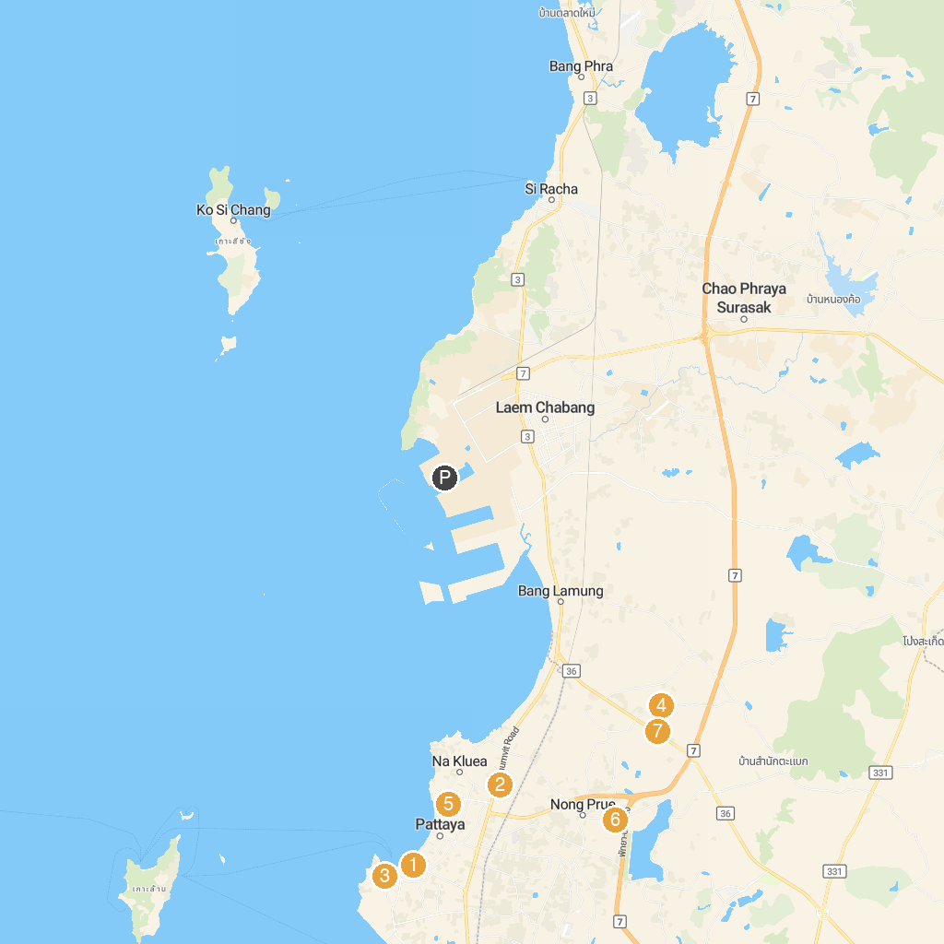
MAP KEY
1. Wat Chai Mongkron | 5. Wat Santikham
2. Mini Siam | 6. Art In Paradise Pattaya
3. Wat Tha Kradan | 7. Wat Nong Prue
4. Prince of Chumphon Monument | 8. Big Bee Farm Pattaya
P. Cruise port / terminal
Map © MapTiler © OpenStreetMap contributors · cruiseports.org

