Patreksfjörður, Westfjords, Iceland
One of Iceland's most remote cruise calls, Patreksfjörður is the gateway to cliffs at the edge of Europe, million-seabird colonies, and a waterfall that looks like a bridal veil draped over a mountain.
⚓ Pier (small ships) / Tender (large ships) · 🕒 Typical call: 8–10 hrs · 💳 Cashless — cards & contactless only · 🗣️ Icelandic / English widely spoken · 🐦 Puffin season: May–mid-Aug
✍️ MY DAY IN PORT (FILL IN)
Ship / Date
In port | arrive ______ · all aboard ______
Booked excursion
Notes / meeting point
GETTING ASHORE
- Docking: 230 m pier for ships up to ~200 m; larger ships tender (5–10 min)
- Walk to center: 10 min from cruise pier; town is small and flat
- Best For: Bird cliffs, waterfalls, geothermal pools, remote wilderness
- Don't Miss: Látrabjarg puffin cliffs or Dynjandi waterfall — book excursions early
GETTING AROUND
- 🚕 Taxi: ~$160–200 to Látrabjarg (56 km) — Taxis are extremely limited and must be pre-arranged. Vitos.is offers taxi and day-tour service in the Westfjords; rates
- 📱 Rideshare: ❌ not available
TOP THINGS TO DO
- Látrabjarg Bird Cliffs & Puffins — Europe's westernmost point is also one of its greatest wildlife spectacles.
- Dynjandi Waterfall — The 'Jewel of the Westfjords' — a series of seven cascades that fan out down a mountainside like a massive bridal veil.
- Rauðasandur Red Sand Beach — Unlike Iceland's famous black-sand beaches, Rauðasandur stretches 10 km and shifts from golden to rose-red depending on the light.
- Garðar BA 64 Shipwreck — Iceland's oldest steel ship, built in 1912 and grounded in 1981 as a monument.
- Patreksfjarðarlaug Geothermal Pool — A hillside outdoor pool with hot tubs and a steam bath, overlooking the fjord.
BEST WALKS
- Waterfront Promenade: 2 km · 30 min · Flat · Free — Follow the paved coastal path along the fjord shore from the cruise pier through town.
- Town Church & Hill: 1.5 km loop · 25 min · Easy · Free — Walk up to the 1907 concrete Patreksfjarðarkirkja church — one of Iceland's oldest concrete…
WEATHER · DAYLIGHT · MONEY
Month | High °F | Low °F | Rainy days
May | 45 | 37 | 14
Jul | 55 | 47 | 12
Sep | 49 | 42 | 19
Daylight: Sep 6:57AM–8:02PM
cruiseports.org/patreksfjordur · Confirm terminal & all-aboard time with your ship

Patreksfjörður, Westfjords, Iceland — Port Map
Red = walkable sights · Amber = excursions farther out · P = cruise terminal
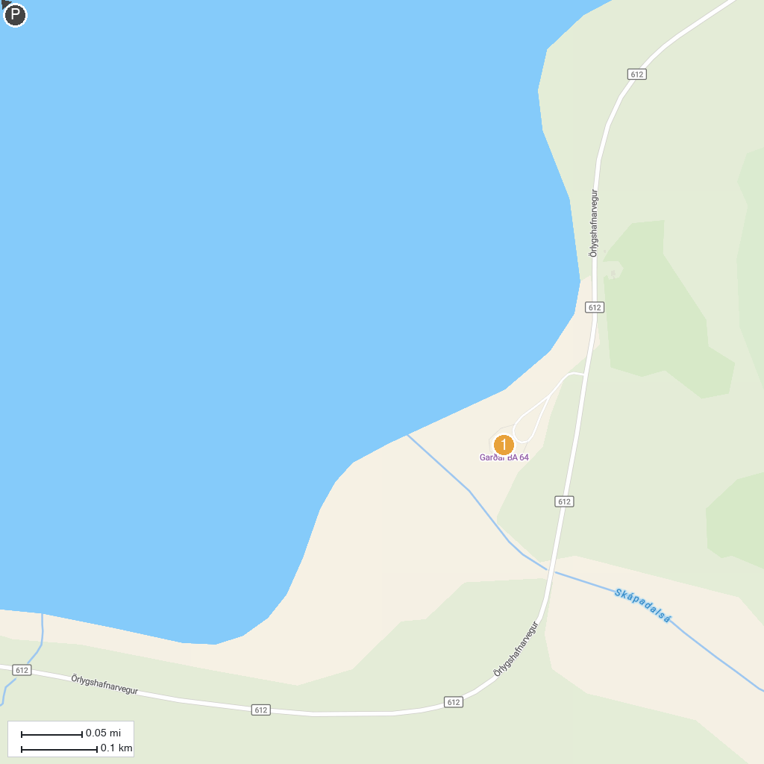
MAP KEY
1. Garðar BA 64 | 2. Rauðasandur Beach
P. Cruise port / terminal
Map © MapTiler © OpenStreetMap contributors · cruiseports.org

