Patras, Peloponnese, Greece
Greece's gateway to the Ionian Sea, Patras packs a Byzantine castle, the country's grandest church, a celebrated winery, and the closest pier to Ancient Olympia into one lively port call.
⚓ Pier (always docked) · 🕒 Typical call: 7-9 hrs · 💶 Currency: Euro (€) · 🗣️ Language: Greek · 🏛️ Gateway to Ancient Olympia
✍️ MY DAY IN PORT (FILL IN)
Ship / Date
In port | arrive ______ · all aboard ______
Booked excursion
Notes / meeting point
GETTING ASHORE
- Docking: Always pier — no tendering. Larger ships use the South Port (3.5 km from center); smaller ships may dock at the Old Port (Molos), steps from the city.
- Walk to Center: Old Port: 5-10 min on foot. South Port: take the ship shuttle, a taxi (€8-12), or City Bus 18.
- Best For: History, culture, Greek city life, day trip to Ancient Olympia
- Don't Miss: St. Andrew's Basilica (Greece's largest church) and the panoramic view from Patras Castle
GETTING AROUND
- 🚕 Taxi: €9–€12 — Metered taxis run from Patras New Port to the city center (~4 km, ~5 min). Day rate is approximately €9; night rate (mid
TOP THINGS TO DO
- Ancient Olympia Day Trip — The birthplace of the Olympic Games sits 100 km south of Patras — the closest major port to this UNESCO World Heritage site.
- Patras Castle & Upper Town Walk — The 6th-century Byzantine castle built by Emperor Justinian crowns the hill above the city, offering sweeping views of the Gulf…
- Achaia Clauss Winery Tour — Founded in 1861, this iconic hillside winery is one of Greece's oldest — and still makes Mavrodaphne, the sweet fortified red…
- St. Andrew's Basilica & Rio Bridge — The largest church in Greece houses the relics of St.
- Rio Beach & Bridge Views — A pebbly Ionian beach 8 km north of the port, right under the spectacular Rio-Antirrio Bridge.
BEST WALKS
- Lower Town: Waterfront to Georgiou Square: 1.5 km · 25 min · Flat · Free — Start at the Old Port, walk along the promenade to the Cathedral of St.
- Upper Town: Stone Stairways & Patras Castle: 2 km · 45-60 min · Hilly · Low cost — Take the iconic Patreos Steps from the lower town up through the historic Upper Town (Ano Poli) to…
WEATHER · DAYLIGHT · MONEY
Month | High °F | Low °F | Rainy days
May | 78 | 57 | 5
Jul | 94 | 68 | 1
Sep | 84 | 64 | 4
Daylight: May 6:23AM–8:37PM · Jul 6:21AM–8:56PM · Sep 7:14AM–7:42PM
cruiseports.org/patras · Confirm terminal & all-aboard time with your ship

Patras, Peloponnese, Greece — Port Map
Red = walkable sights · Amber = excursions farther out · P = cruise terminal
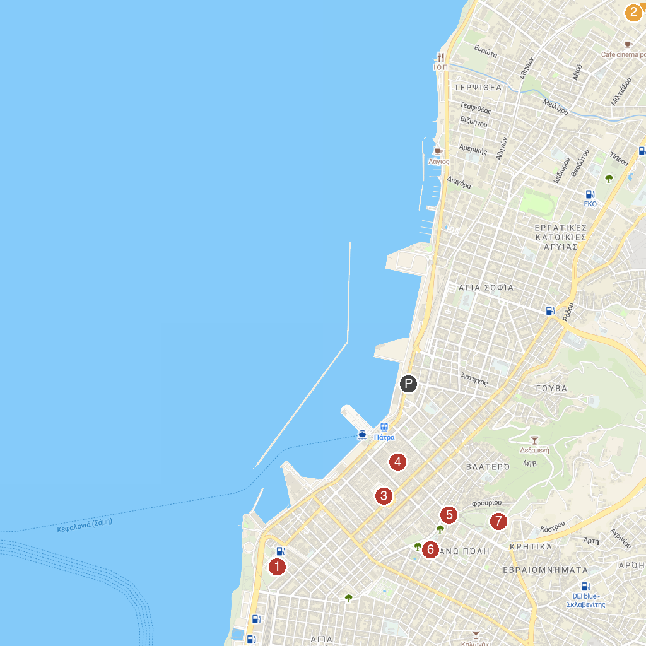
MAP KEY
1. Church of Saint Andrew | 5. St. Nicholas Stairway
2. Museum of Science and Technology | 6. Roman Odeon
3. King George Ι Square | 7. Patras Castle
4. Πεζόδρομος Αγίου Νικολάου
P. Cruise port / terminal
Map © MapTiler © OpenStreetMap contributors · cruiseports.org

