Passau, Bavaria, Germany
The 'City of Three Rivers' is where Danube, Inn and Ilz collide in a swirl of colors — and where the world's largest cathedral organ booms daily at noon across ancient cobblestones.
⚓ Docked (river pier) · 🕒 Typical call: 8–10 hrs (often embark/debark) · 💶 Euro (€) · 🗣️ German
✍️ MY DAY IN PORT (FILL IN)
Ship / Date
In port | arrive ______ · all aboard ______
Booked excursion
Notes / meeting point
GETTING ASHORE
- Docking: River quay — always docked, no tender. Old Town piers are steps from the center; the outlying Racklau berth is ~2 km downriver with shuttle.
- Walk to center: 1–5 min from Altstadt piers; ~25 min (or free shuttle) from the Racklau berth
- Best For: Architecture, organ music, river scenery, Bavarian food & beer
- Don't Miss: Noon organ concert at Dom St. Stephan — book early, largest cathedral organ in the world
GETTING AROUND
- 🚕 Taxi: €10–€20 — Taxis are metered (base €4.80 + €2.80/km). From outlying docks like Lindau piers (~4km) or Winterhafen (~2km), expect €1
- 📱 Rideshare: ✅ Uber
TOP THINGS TO DO
- Dom St. Stephan Noon Organ Concert — St.
- Veste Oberhaus Fortress — The 13th-century hilltop fortress looms over the river confluence with spectacular panoramic views and a well-curated medieval…
- Dreiflüsseeck — Three Rivers Corner — Walk to the peninsula's eastern tip where the milky-green Inn, the dark Ilz, and the blue-brown Danube visibly refuse to mix…
- Glass Museum Passau — The world's largest collection of Bohemian glass — from Baroque to Art Nouveau — filling 35 rooms of the historic Hotel Wilder…
- Danube Cycle Path Ride — Passau sits at the start of the famous Donauradweg.
BEST WALKS
- Old Town Loop: 1.5 km · 30–40 min · Easy (mostly flat) — Stroll the heart of Passau's peninsula: the Baroque cathedral, the Rathaus flood markers, Höllgasse…
- Fortress Hike: 1.2 km uphill · 20–25 min each way · Moderate — Climb the Ludwigsteig forest path from the old town up to Veste Oberhaus for sweeping views over…
- Mariahilf Pilgrimage Steps: 321 steps · 15 min · Moderate — Cross the Inn River bridge and climb the covered Wallfahrtstiege staircase to the pilgrimage church…
WEATHER · DAYLIGHT · MONEY
Month | High °F | Low °F | Rainy days
May | 64 | 49 | 15
Jul | 76 | 60 | 13
Sep | 67 | 53 | 11
Daylight: May 5:25AM–8:40PM · Jul 5:20AM–9:03PM · Sep 6:43AM–7:18PM
cruiseports.org/passau · Confirm terminal & all-aboard time with your ship

Passau, Bavaria, Germany — Port Map
Red = walkable sights · Amber = excursions farther out · P = cruise terminal
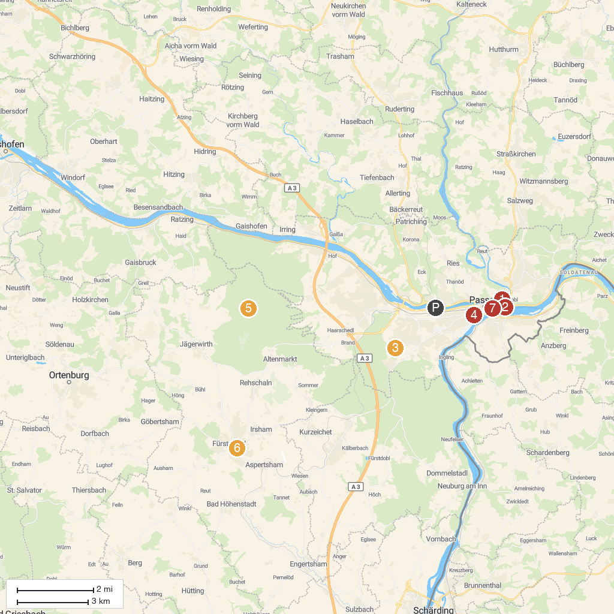
MAP KEY
1. Veste Oberhaus | 5. Heiligenbrunn
2. MMK Passau - Museum of Modern Art Wörlen Passau | 6. Kloster Fürstenzell
3. peb - ​​Passauer Erlebnisbad | 7. St. Stephan's Cathedral
4. youexit
P. Cruise port / terminal
Map © MapTiler © OpenStreetMap contributors · cruiseports.org

