Pascagoula, Mississippi, USA
The Flagship City sits where the Pascagoula River meets the Mississippi Sound — a working port town with 300 years of history, mysterious singing waters, and deep-south seafood worth the detour.
⚓ Pier (docked) · 🕒 Typical call: 6-8 hrs · 💵 US Dollar (USD) · 🗣️ English · 🎸 Jimmy Buffett's birthplace
✍️ MY DAY IN PORT (FILL IN)
Ship / Date
In port | arrive ______ · all aboard ______
Booked excursion
Notes / meeting point
GETTING ASHORE
- Docking: Pier alongside — no tendering required
- Walk to center: ~0.5 mi from Riverfront Park docks; industrial berths need a shuttle
- Best For: History lovers, nature & birding, Southern seafood
- Don't Miss: LaPointe-Krebs House (1757) — oldest standing structure in Mississippi
GETTING AROUND
- 🚕 Taxi: $13–$20 — Local taxis (Port City Cab & Sedan, Blue Eyes Taxi) serve the port area. Downtown Pascagoula is roughly 3–5 miles away.
- 📱 Rideshare: ✅ Uber, Lyft
TOP THINGS TO DO
- LaPointe-Krebs House & Museum — Built around 1757 (confirmed by dendrochronology), this French Colonial structure is the oldest standing structure in Mississippi…
- Pascagoula River Audubon Center — Gateway to the largest free-flowing (undammed, unlevied) river system in the lower 48 states.
- Gulf Coast Gator Ranch Airboat Tour — Just north of Pascagoula in Moss Point, this ranch sends you screaming across gator-filled swamplands on a high-speed airboat.
- Downtown Scranton Walking Tour — Pascagoula's historic Scranton district is a designated Main Street community with over 30 National Register buildings, the River…
- Round Island Lighthouse — Originally built offshore on Round Island, this 1859 lighthouse was battered by hurricanes and finally reassembled in Pascagoula…
BEST WALKS
- Riverfront to Scranton Historic District: ~1 mile • Easy • 20-30 min one way — From the Riverfront Park dock, walk into the Scranton district past Victorian homes, the River Art…
- Lighthouse Park & Beach Walk: ~2.5 miles from downtown • Easy • Best by taxi/Uber — Head south to Lighthouse Park (home of the UFO abduction marker), then continue along the…
WEATHER · DAYLIGHT · MONEY
Month | High °F | Low °F | Rainy days
May | 81 | 69 | 12
Jul | 87 | 77 | 19
Sep | 85 | 73 | 14
Daylight: May 6:00AM–7:41PM · Jul 6:03AM–7:57PM · Sep 6:39AM–6:59PM
cruiseports.org/pascagoula-ms · Confirm terminal & all-aboard time with your ship

Pascagoula, Mississippi, USA — Port Map
Red = walkable sights · Amber = excursions farther out · P = cruise terminal
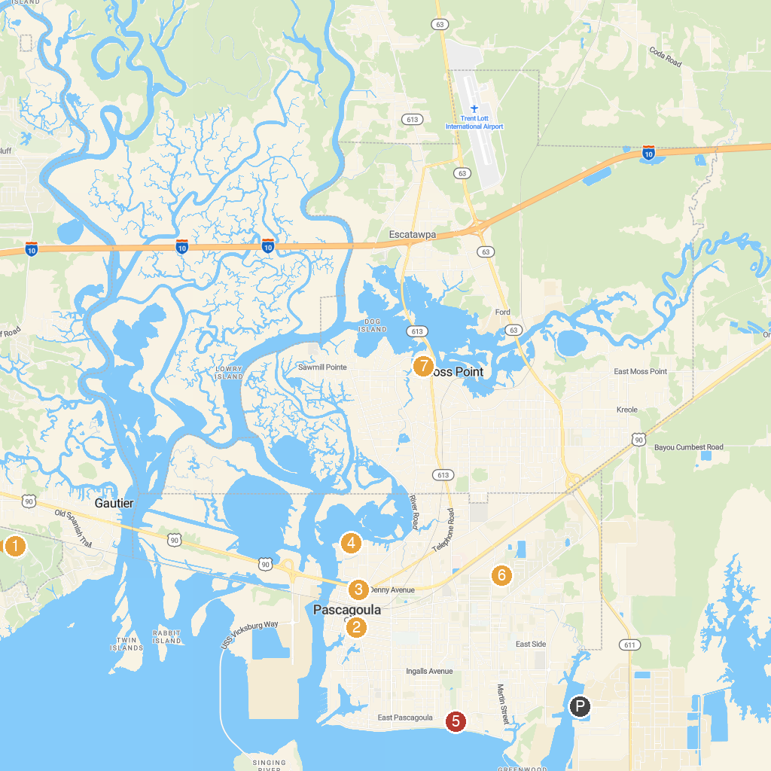
MAP KEY
1. Shepard State Park | 5. La Pointe - Krebs Museum
2. Gulf Coast Gator Ranch & Tours | 6. Pascagoula Beach Park
3. Pascagoula Parks & Recreation | 7. Keith's Park
4. Round Island Lighthouse | 8. Pascagoula River Audubon Center
P. Cruise port / terminal
Map © MapTiler © OpenStreetMap contributors · cruiseports.org

